College of Education and Human Development

DEpartment of Educational Psychology
Graduate STudent Handbook

Division of School Psychology
Ph.D. Program
2024-2025

Texas A&M University

Table of Contents

Graduate Student Handbook 1
Table of Contents 2
Department Introduction 6
Division Introduction………………………………………………………………………………………..7
Program Philosophy and Goals…………………………………………………………………………………………….7
Prevention Science Model…………………………………………………………………………………………………….8
Program Goals for Student Outcomes………………………………………………………………………………….9
Model and Mission of the School Psychology Program……………………………………………………..18
Getting Started Guide for Educational Psychology (EPSY) Graduate Students 20
College & Department Leadership 20
Graduate and Professional School (GPS) Governance 20
Division of SPSY Faculty………………………………………………………………………………………………………21
Graduate Student Association (GSA) 22
Transportation & Parking 22
Howdy Portal & Resources 22
TAMU NetID 22
TAMU Email 22
Registering for Classes 23
MyRecord 23
Online Learning Platform (Learning Management Systems) 23
Other Important Information & Resources 23
Student Mailboxes…………………………………………………………………………………………………………..23
Purchase Software 23
MyAggieCard 23
Medical Insurance 23
Aggie Ring 23
Important Resource Websites 24
Registration & Enrollment 25
Class Registration 25
Temporary Faculty Advisor 25
Role of Student’s Doctoral Chair and Committee……………………………………………………………….26
Enrollment Status 27
Add/Drop 27
Q-Drop 27
Withdrawal 27
Certificate Enrollment: Advanced Research Methods (ARM) 28
Financial Aid, Tuition, & Fees 29
Financial Aid 29
General Program Cost Information 29
Payment of Tuition and Fees 29
Obligation to Pay Tuition & Fees 29
Graduating Students Financial Obligation 30
Installments 30
Fees and Costs of Cancelling Your Registration 30
Cancellation for Nonpayment of Tuition or Fees 31
Distance Education and Nontraditional Fees 31
EPSY Graduate Student Travel Grants & Guidelines ……………………………………………………….….31
Purpose 31
Guidelines 31
Funding Preference 32
Extent of Awards 32
Application Procedure 32
PhD Awards and Scholarships……………………………………………………………………………………………..32
Academic Policies 34
Honor Code 34
Scholastic Requirements 34
Academic Probation & Dismissal 35
Academic Honesty 35
Plagiarism …………………………………………………………………………………………………………………………..35
Grievance Procedures 35
Changing Program Areas within EPSY 37
Changing Committee Chair or Committee Members 37
APA & Reference Document Style 38
Research and Data Ethics 39
Introduction 39
Responsible conduct of research policy 39
Necessary pre-requisites to dissertation, thesis, or record of study defense 40
Ombuds Officer 41
The Ombuds Officer can: 41
The Ombuds Officer cannot: 41
You might want to contact the Ombuds Officer when: 41
Some common concerns include 42
Ombuds Officer contact information 42
Ombuds Officer for Graduate and Professional School………………………………………………………42
Department Head………………………………………………………………………………………………………………..42
Graduate Student Advising 44
Degree Plans 44
Student Petitions 44
Proposal/Exam Forms 45
Student Degree Evaluations in Howdy 46
Academic Program Advisors……………………………………………………………………………………………….46
Faculty Entering Advisor……………………………………………………………………………………………………..47
Graduate Assistantships 48
EPSY Graduate Assistantship Guidelines ……………………………………………….……………………………48
Assistantship Plan…………………………………………………………………………………………………………….48
Graduate Assistant Categories and Duties 49
Graduate Assistant – Teaching (GAT) 49
Graduate Assistant Non-Teaching (GANT) 50
Graduate Assistant Research (GAR) 50
Teaching Assistant Institute (TAI) 50
Explicit Understandings……………………………………………………………………………………………………50
Requirements for Graduate Assistants ……………………………………………………………………………51
Mentoring, Advising, and Coaching Guidelines 51
Syllabus and Attendance Certification………………………………………………………………………….….52
International students please note 52
Minimum Syllabus Requirements 52
HR Department 52
Office Key, Copier Code, and Weekend Access……………………………………………………………….52
Department Laptops for Graduate Assistants………………………………………………………………….52
School Psychology Degree Plan and Requirements…………………………………….…………53
EPSY Degree Plan…………………………………………………………………………………………………………...……53
Transfer of Credit for Doctoral Degrees 53
Petitions 54
SPSY Degree Program and Plan………………………………………………………………………………….….……54
Prior Graduate Coursework and Direct to Doctorate………………………………………………………55
Summary of the Major Steps…………………………………………………………………………………......……56
Course Requirements for SPSY…………………………………………………………………………………..….…….60
Sequence of Courses…………………………………………………………………………………………………….….…64
Practicum/Externship Registration……………………………………………………………………………….……...67
Elective Practicum/Externship Experiences………………………………………………………………………….69
SPSY Research Expectations……………………………………………………………………………………………...…71
University Travel Documentation……………………………………………………………………………………...…72
Core requirements……………………………………………………………………………………………………….……...72
Focus Areas…………………………………………………………………………………………………………………….…...75
Additional Program Requirements…………………………………………………………………………………...…79
Year by Year Expectation for Degree Completion……………………………………………………………….80
Residence Requirements 84
Distance Education Restrictions ……………………………………………………………………………………...84
Course Time Limit 84
99-Hour Cap on Doctoral Degrees 84
Student’s Advisory Committee 84
Doctoral Portfolio (Electronic Format) 86
Purpose 86
Procedures 86
Advance to Doctoral Candidacy…………………………………………………………...……………87
Preliminary Examination for Doctoral Students 88
Preliminary Examination Format 88
Preliminary Examination Policy 89
Preliminary Examination Scheduling 89
Report of Preliminary Examination 89
Retake of Failed Preliminary Examination 90
Research Proposal ………………………………………………………………………………………………………………90
Admission to Candidacy………………………………………………………………………………………………………90
Final Examination for Doctoral Students 90
Report of Final Examination 91
Dissertation 92
Pre-Defense Publication of Dissertation Material 92
Use of Classified and Proprietary Information in Dissertation 92
Letter of Completion 92
PhD Graduation Rubric 93
Graduation 93
Student Rights and Responsibilities……………………………………………………………………………………93
Annual Review of Ethical, and Professional Expectations of Students…………………………………94
Student Safety Plan 96
Definition of an Emergency…………………………………………………………………………………………….96
Emergency Procedures for SPSY Program Faculty………………………………………………………….96
For Medical Emergencies………………………………………………………………………………………………..97
For Mental Health Emergencies……………………………………………………………………………………...97
Zoom Meeting Checklists………………………………………………………………………………………………..99
Harassment, Discrimination, and Sexual Misconduct……………………………………………………100
Reporting Online & Anonymous Reporting………………………………………………………………….100
Reporting Incidents of Hate/Bias…………………………………………………………………………………..100
Appendix 101

Department Introduction

The Department of Educational Psychology (EPSY) encompasses students, faculty, and staff whose scholarship and interests center on the many distinct aspects of academics, teaching, and classroom education. EPSY’s mission is to create experiences that advance teaching, research, grantsmanship, and service through the application of knowledge in the preparation and development of quality researchers and educators. EPSY places high value on collaboration, diversity, critical thinking, creativity, democratic governance, and global leadership.

The Graduate Student Handbook is an informational guide for potential and current students in EPSY at Texas A&M University. The handbook should serve as a supplement to the Texas A&M University Graduate Catalog and to the Texas A&M University Student Rules, which contain the policies of the Graduate and Professional School (GPS) and those of the university.

At the graduate level, the Department of Educational Psychology offers the Master of Education (online and traditional), Master of Science, and Doctor of Philosophy degrees. The diploma and transcript will only list your official degree title and Texas Higher Coordinating Board-approved degree programs. The academic program area and area of emphasis on student studies are not denoted in any official documentation. Graduate students can apply and study in one of the following Academic Program Areas: Bilingual/ESL Education (BESL), Counseling Psychology (CPSY), Learning Sciences (LS), Research, Measurement, & Statistics (RMS), School Psychology (SPSY), or Special Education (SPED).

In addition to its graduate programs, the department offers undergraduate courses designed to assist prospective educators and other students to understand creativity, bilingual education, human learning and development, special education, and statistics. These courses are taken by students who are majoring in various fields of study other than educational psychology, students who are minoring in Creativity Studies, students who are majoring in Childhood Professional Services, or who require these courses for teacher certification with the Texas Education Agency or similar agencies in other states.

One of the four departments in the College of Education and Human Development, EPSY, is currently home to over 300 undergraduate students, 400 graduate students, 49 faculty members and 32 staff members. EPSY administrative offices are located on the 8th floor, and faculty offices are in Harrington Tower. The EPSY Graduate Advising Office is currently located in Harrington Tower, 7th floor.

Division Introduction

Program Philosophy and Goals

The TAMU doctoral-level School Psychology Program endorses and subscribes to the scientist-practitioner model for the training of professional health service psychologists. The primary goal of the program is the preparation of psychologists capable of contributing to the academic, emotional, and social-behavioral well-being of children and adolescents through direct and indirect services, as well as to the science that informs psychological practice. The interaction of science and practice embraces the idea that practice needs to be evidence based, and that the evidence base needs to be informed by practice.

The program’s philosophy and goals are based on a developmental system and a prevention science model of school psychological practice (see Figure 1). Through the identification of risk factors and maladaptive behaviors indicative of unhealthy outcomes or negative developmental trajectories, prevention science seeks the development of systems to mitigate risk and promote healthy development. Prevention science is uniquely relevant to school psychology because school psychology draws from diverse disciplines in the identification, prevention, and remediation of problems in learning, social and emotional functioning, and mental health as well as in the promotion of resiliency at the child, family, and system levels. The School Psychology Training Schema can be seen in Figure 2.

Figure 1. Prevention Science Model

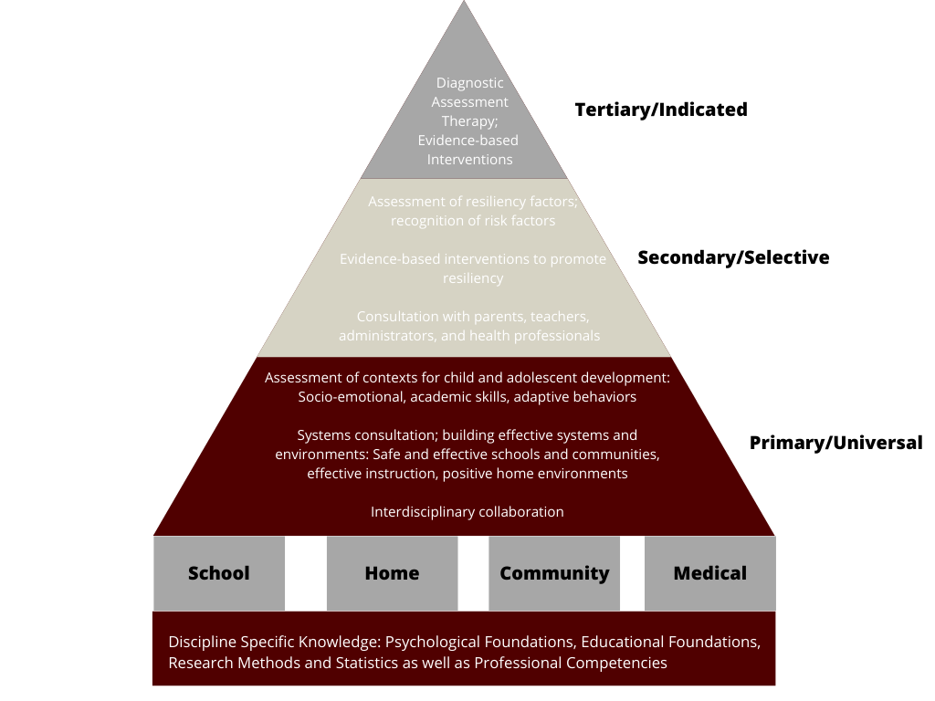

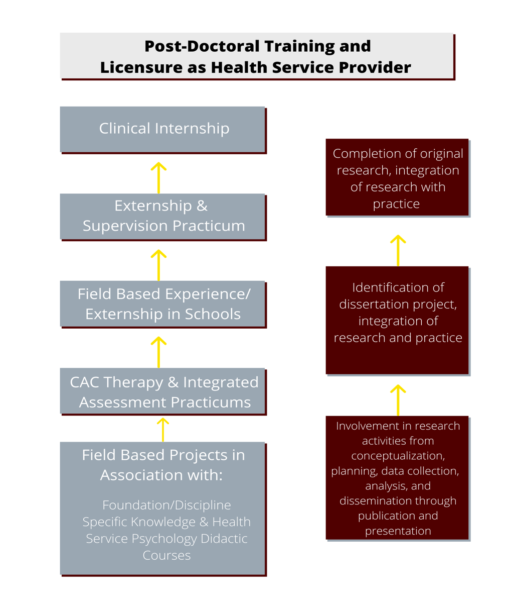
Figure 2. PhD in School Psychology Training Schema

Prevention Science Model
Training school psychologists under a prevention science model emphasizes the development of skills needed to be effective and indispensable service providers across settings and across the tiers of prevention and treatment (i.e., primary, secondary, and tertiary). School psychology training within the primary tier targets a comprehensive understanding of child and adolescent development, including the systems and environments that promote healthy trajectories in areas such as socio-emotional development, academic skills, and learning-related behaviors. At the secondary tier, training emphasizes assessment skills to recognize resiliency factors as well as risk indicators, and the effective implementation of consultation and other intervention strategies to promote resiliency and prevent problem escalation. Training of school psychologists within the tertiary tier emphasizes skills in comprehensive assessment as well as direct and indirect interventions to mitigate and reduce effects of the most significant educational and behavioral problems illustrative of child psychopathology.

A related component to prevention science is implementation science. Throughout the course of training, particular attention is devoted to the identification and evaluation of evidence-based interventions, as well as evidence-based assessment practices that translate directly to intervention strategies, data-based decision-making, and skills in working effectively with key stakeholders across school, home, community, and medical settings. Implementation science addresses the ‘how’ of adopting evidence-based practices in various settings, including schools with consideration of context and culture. Implementation science has special significance to school psychology because of the nature of delivery of school psychology services, including use of evidence-based practice for assessment, intervention, and consultation; the diverse populations in schools, medical and clinical settings, and communities; and the significance of organizational characteristics and climate to the ability of school psychologists to function effectively.

The specialization in school psychology reflects the belief that effective services to children, youth, and families can best be provided within a training model that reflects an integrative, systems based, approach to mental health. Under this model of combined practice, it is assumed that psychologists are educated and trained in the science and practice of psychology, education, and child development. Both prevention and implementation science are key to improving children’s outcomes and what is evidence-based relies on good science. Within the prevention science model, the need for research to inform practice, as well as practice to inform research is emphasized. Rigorous academic standards are maintained, and teaching and research experiences are provided so students may successfully compete for academic positions at colleges and universities throughout the country.

Program Goals for Student Outcomes
To this end, the program’s primary goals for student outcomes reflect the dual emphasis on research and practice:
- Students will demonstrate an understanding of basic content areas in psychology, as well as professional issues, including ethical, legal, individual, and cultural diversity, communication, and quality assurance principles necessary for professional competencies in assessment, intervention, consultation, and supervision; and
- Students will demonstrate scientific knowledge and methods specific to research, and the integration of the science of psychology within the contextual framework that science and practice are interconnected.
With these two goals in mind, the discipline-specific training objectives and profession-wide competencies (i.e., learning outcomes) of students in the program, consistent with the APA Standards of Accreditation

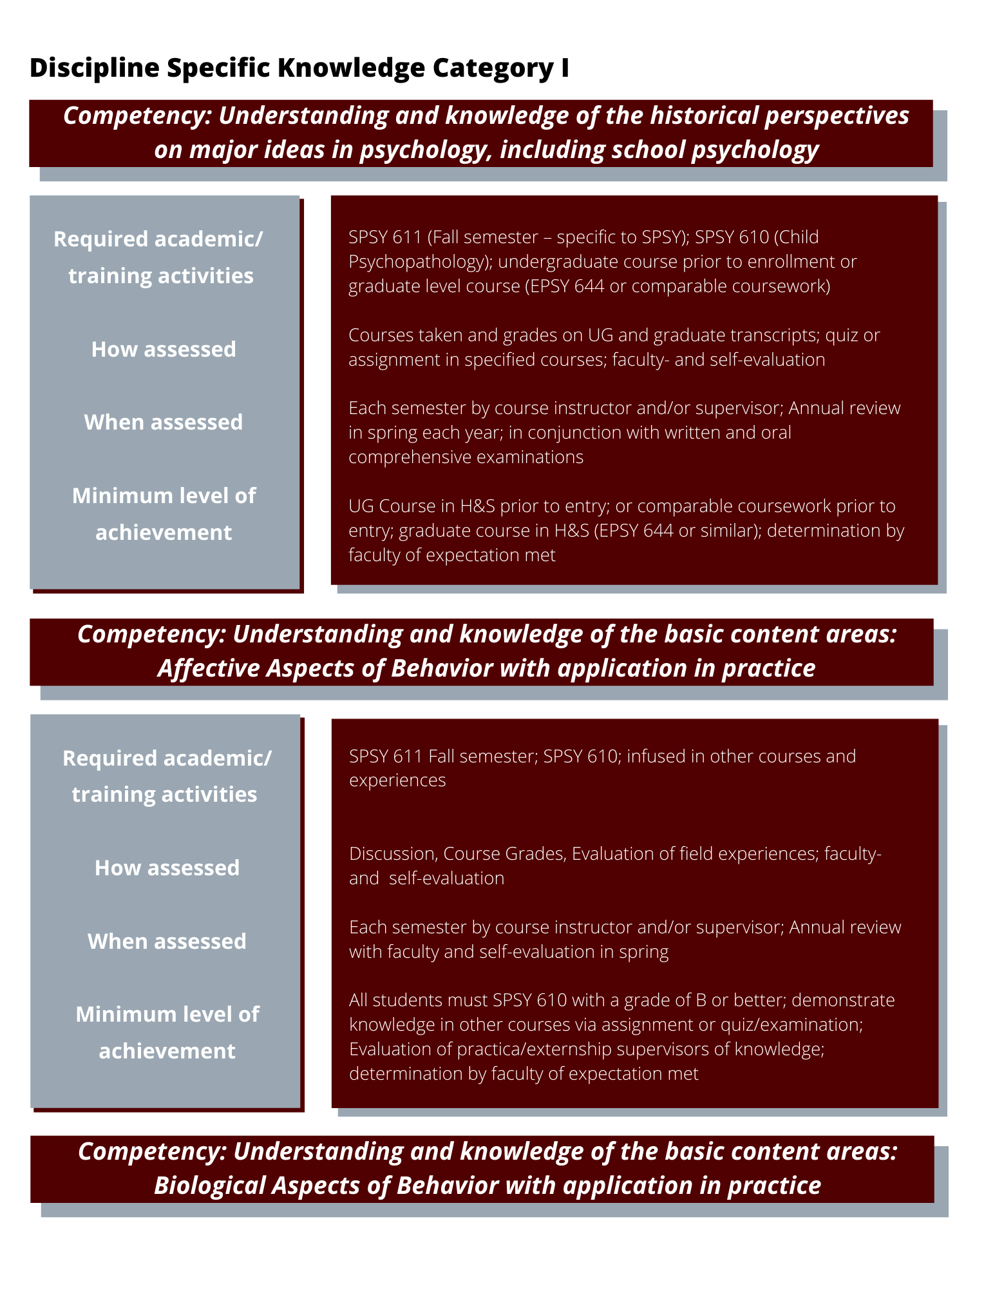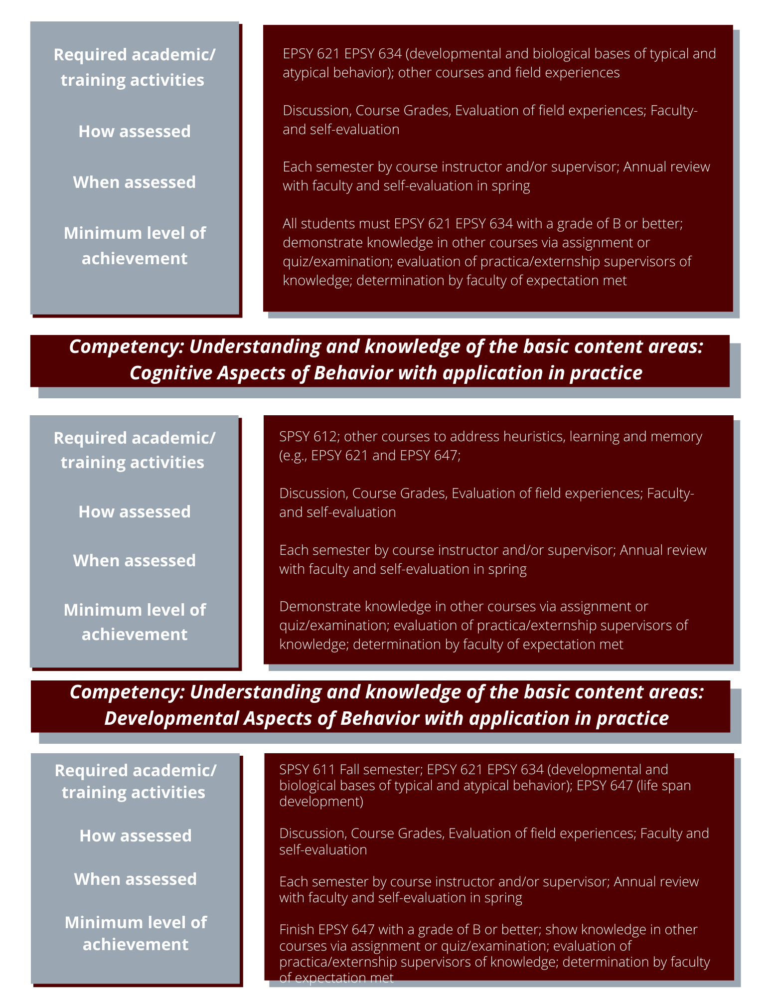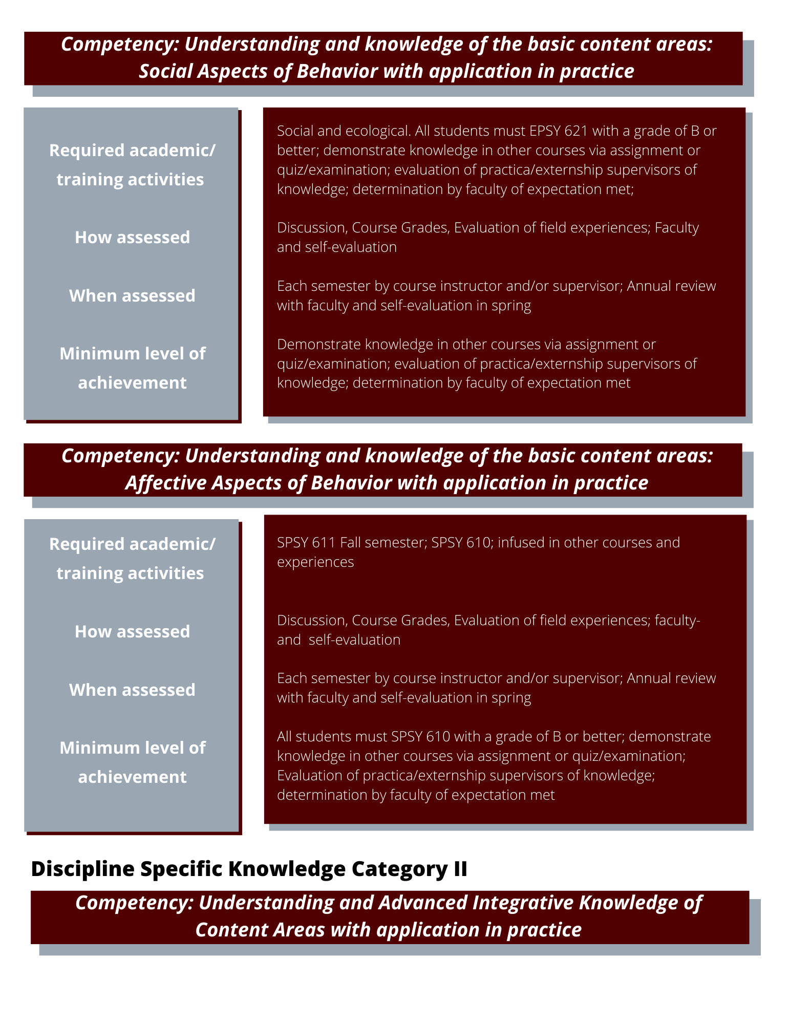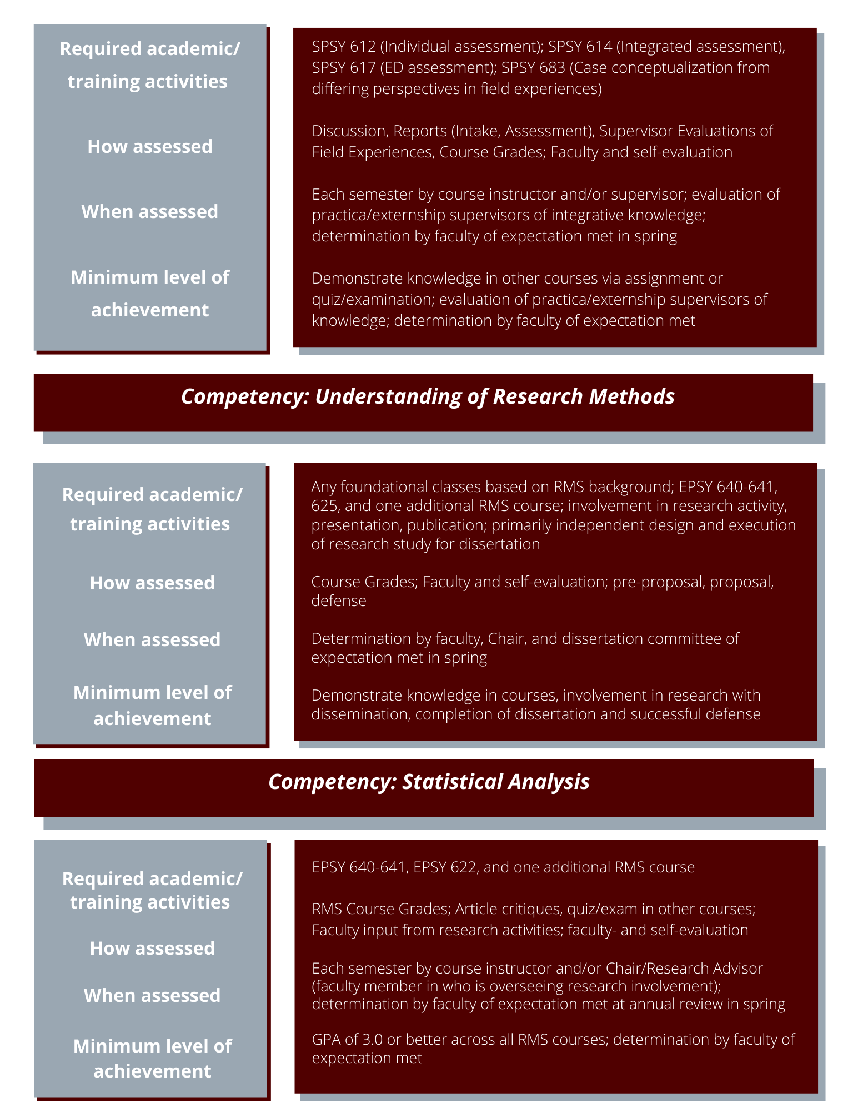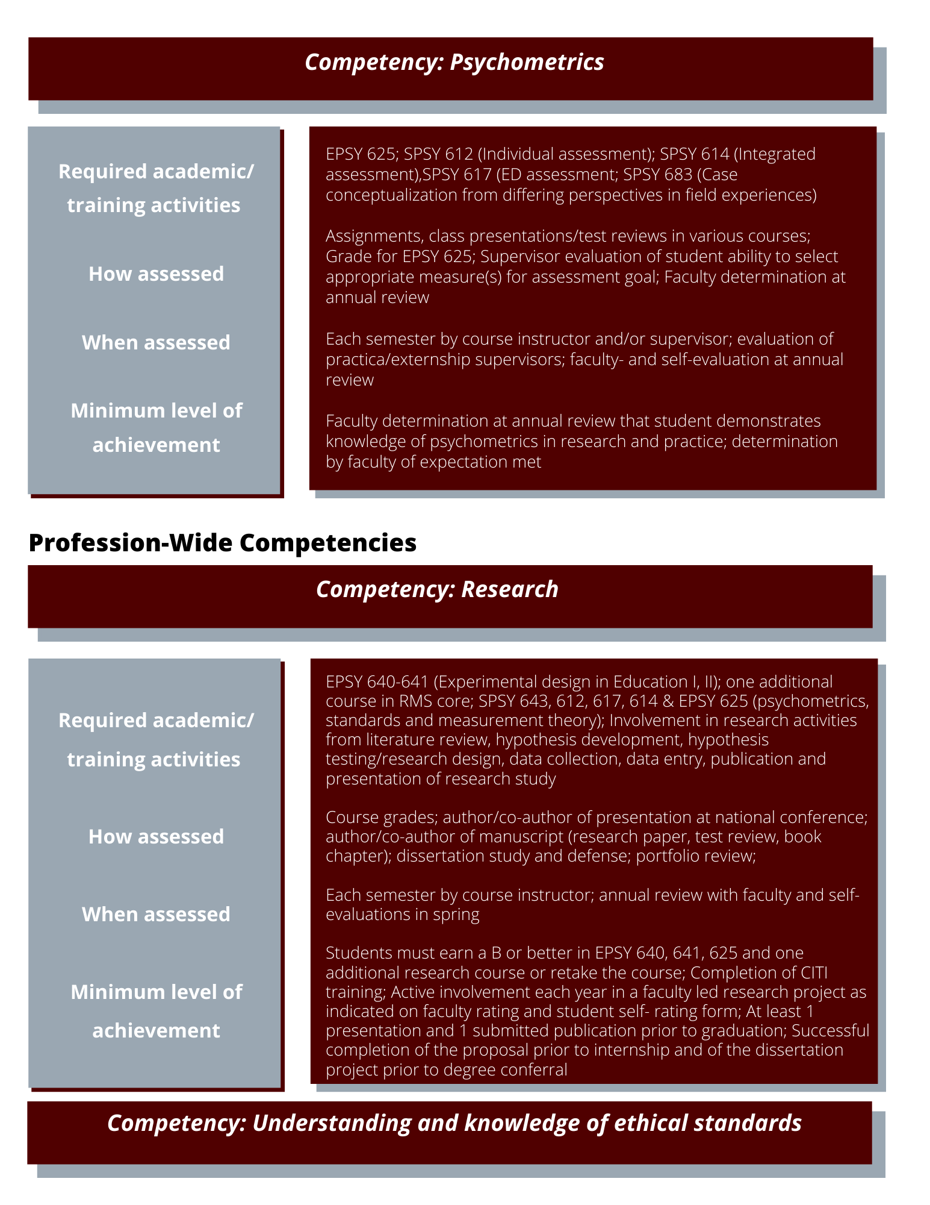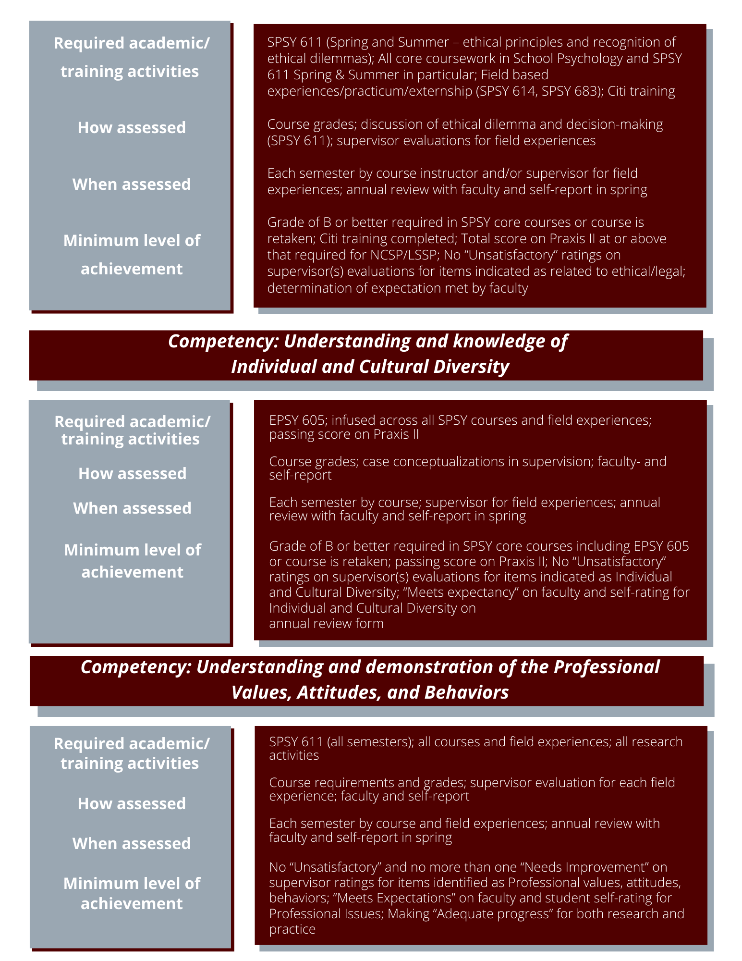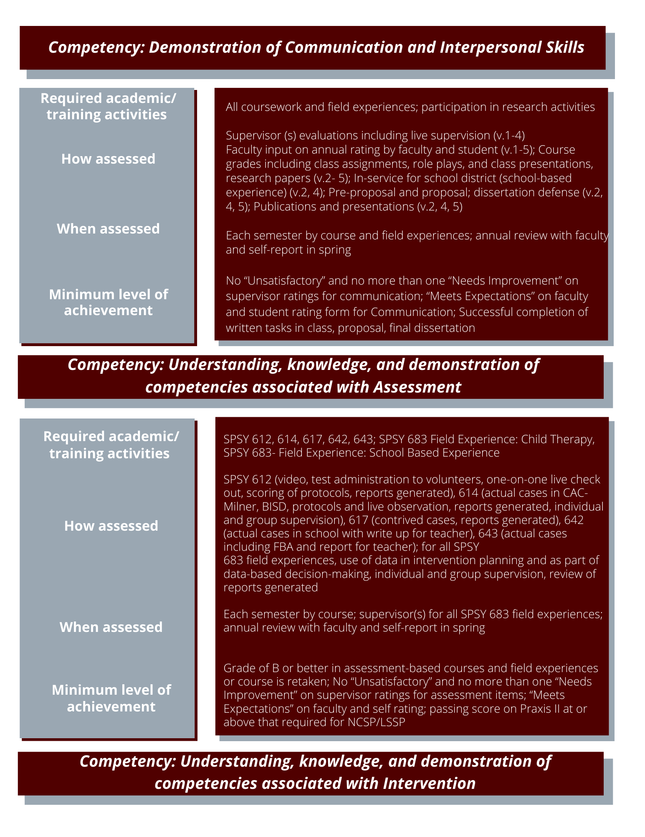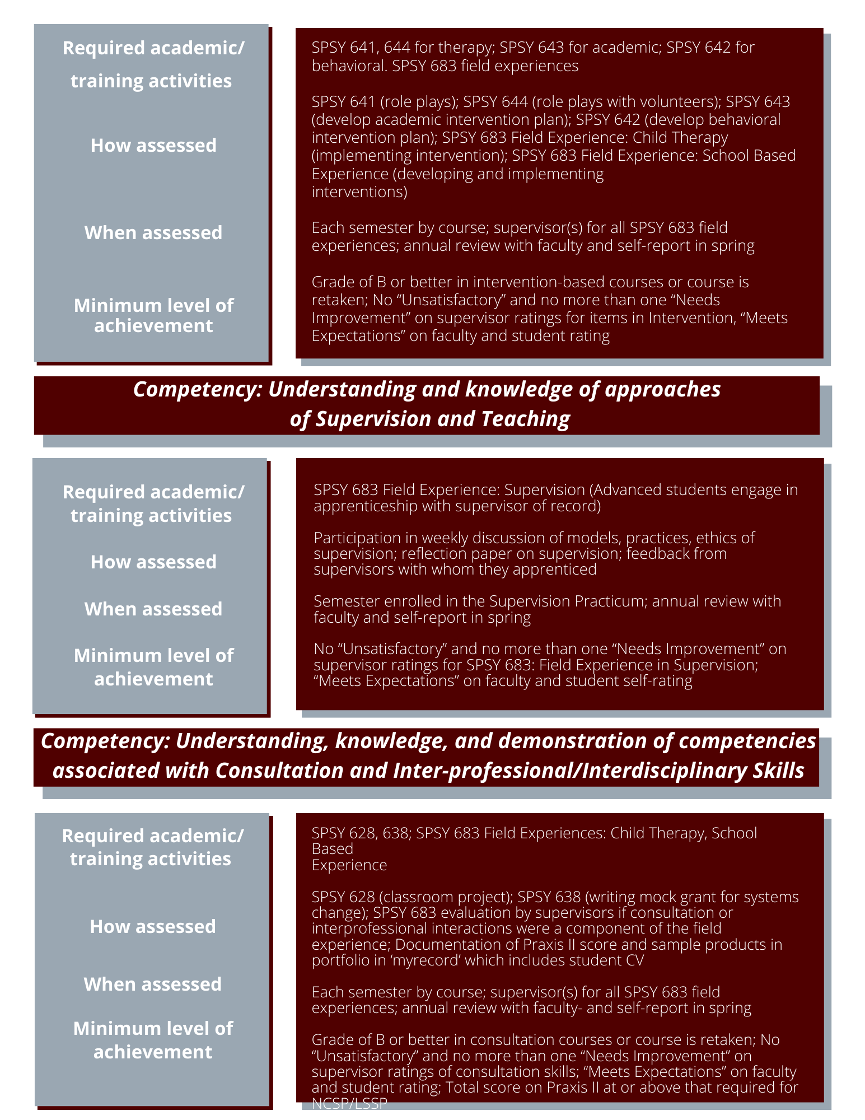

Model and Mission of the School Psychology Program (Adopted January 1996; Revised May 2013)

The Ph.D. program in School Psychology at Texas A&M University prepares its graduates for careers as Scientist Practitioners, following the traditional "Boulder Conference" model of education and training. We subscribe to a School Psychology training emphasis that promotes an integrated and coordinated health service delivery model, which includes universal, selective, and indicated interventions, both preventive and responsive. We expect our graduates to pursue careers in academic or applied practice settings not limited to schools, to be health service providers for children, youth and families, both in and out of schools, and to contribute to the knowledge base of School Psychology by conducting and publishing empirically based research products. We seek to prepare psychologists capable of facilitating growth in the development, learning, and behavior of children, youth and families. We view children's learning and adjustment as reflecting the reciprocal nature of behavior that includes the school environment, home, community, and cultural context in multiple and complex, interacting systems. Our approach to training endorses the view that children and youth are our primary clients, with the understanding that they can be best served with a knowledge of, and involvement by, the multiple and interacting components of the various systems (macro to micro) in which children function. This leads to a service delivery model that can be applied across numerous settings. Although the school may be the primary service delivery setting, homes, clinics, hospitals, and community-based agencies will often be service targets. Additionally, while the child is the client of interest, skills in problem- solving, systems consultation, family and organizational interventions are also addressed. Finally, our approach requires a knowledge of the importance of diversity (including age, culture, disability, ethnicity, gender, gender identity, language, national origin, race, religion, sexual orientation, and socioeconomic status) among individuals and groups, and of the importance of cross-cultural competence in understanding human behavior and change.
Our program reflects our belief that effective services to children, youth, and families can best be provided within a training model that reflects an integrative approach to mental health. Under this model of combined practice, it is assumed that psychologists are educated and trained in the science and practice of psychology and child development. An emphasis on schools is critical for two reasons. One, as a location, schools are routinely the site for delivery of services that are consumer driven, accessible, coordinated, family-centered, and comprehensive (including primary prevention) and are often the de facto source of mental health services for many children and youth. Two, as a content area, a knowledge of school-based systems involves additional expertise in educational and instruction learning processes, as well as critical factors in health development for children and youth. As health service psychologists, graduates of the training program can apply their knowledge of schools and educational issues, along with their knowledge of systems, to improve the outcomes of children and youth in any setting.

At the same time, it is recognized that children and families may be encountered in a variety of settings. Through coursework, practica, and research, the program:

  - Emphasizes students’ ability to work effectively with diverse populations and multicultural competence related to the practice of psychology across settings
  - Addresses achievement and mental health disparities among diverse populations across courses
  - Provides opportunities to work with individuals from diverse backgrounds in field experiences to the extent possible
  - Maintains rigorous academic standards with courses incorporating empirical research, research critique, related primary readings, original empirical research, and various instructional approaches in addition to the foundations laid by books or chapters
  - Equips students to work in a variety of private and institutional settings, in addition to private and public schools
  - Provides teaching and research experiences so students may compete for academic positions at colleges and universities throughout the country
  - Provides opportunities for experience in supervision so that they can take on leadership positions and provide supervision in whatever setting they are in

Getting Started Guide for SPSY
Graduate Students

College & Department Leadership

College of Education and Human Development (CEHD)
Dean: | Dr. Michael de Miranda
Senior Associate Dean of Academic Affairs: | Dr. Beverly j. Irby
Department of Educational Psychology (EPSY)
Interim Department Head: | Dr. Jeffrey Liew
Associate Department Head for Graduate  Academic Affairs: | Dr. Daniel Hajovsky
Associate Department Head for Research and Faculty Development: | Dr. Wen Luo
Associate Department Head for Undergraduate Academic Affairs: | Dr. Melissa Fogarty
Academic Advisor: | Peggy Brigman

Graduate and Professional School Governance
The Graduate and Professional School (GPS) is a global leader in graduate education, committed to the pursuit of knowledge and the power of intellect. Through exceptional service and commitment to the highest standards, GPS advocates for graduate education at Texas A&M and throughout Texas. The Graduate and Professional School is committed to a diverse campus climate, enhancement of the graduate experience and the development of all students as global citizens.
GPS serves Texas A&M graduate students as an advocate for their graduate education and houses the Ombudsperson for University Graduate Education. This office:
- establishes procedures to guarantee the highest quality educational experience at the graduate level;
- fosters and facilitates interdisciplinary/intercollegiate graduate programs and research activities; and
- strives to maintain and enhance an environment conducive to creative scholarship and scientific inquiry.

Graduate students must become very familiar with the GPS office webpage at http://GPS.tamu.edu/. GPS oversees degree plans, official deadlines, calendars for graduate students, petitions, graduation, Ombuds office (see Ombuds section), and processes all official documentation of a graduate student’s degree. Prior to going to the GPS, please contact your department advisor.

Division of School Psychology (SPSY) Faculty

School Psychology Faculty | Brief Information | Professional and Research Interests
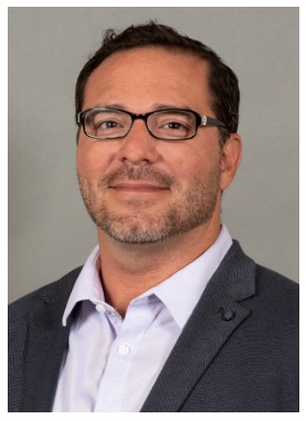  Justin Allen, Ph.D., LSSP, NCSP | University of Kansas (2016)  Email: justin.allen@tamu.edu | Team-Based Decision Making  Manifestation Determination Reviews  Behavioral Interventions  Systematic Reviews
  Sara Castro-Olivo, Ph.D., LSSP, NCSP | University of Oregon (2007)  Email: s.castro-olivo@tamu.edu  704J Harrington Office Building | Culturally Responsive Social-Emotional  Behavioral Interventions  Resilience in CLD populations  Issues in Bilingual School Psychology
  Daniel Hajovsky, Ph.D., NCSP | University of Kansas (2015)  SPSY Division Chair  Director of Clinical Training (DCT)  Email: dhajovsky@tamu.edu  712 Harrington Office Building | Assessment  Child Intelligence  Specific Learning Disabilities  Teacher-Student Relationships
  David Kahn, Ph.D., LSSP, NCSP | Texas A&M University (2011)  Director of Counseling and Assessment Clinic (CAC)  Email: david.kahn@tamu.edu | Clinical Practice  Pediatric Psychology  Etiology of Differential Diagnoses

Graduate Student Association (GSA)
The Educational Psychology Student Organization (EPSO) is the EPSY GSA, an active cadre of graduate students in various disciplines of education, all a part of the Department of Educational Psychology, and at Texas A&M University. EPSO strives to assist our fellow students in the completion of masters and doctoral level studies, helping them to acclimate to Texas A&M University, as well as to find success in their studies. In addition, EPSO provides several social and professional development meetings during the academic year for students--for the purpose of networking and advancing EPSO's work at TAMU. All students are strongly encouraged to join EPSO, including online MEd and EdD students. Web conferencing tools and technologies are available to facilitate distance participation. Please reach out to the Graduate Advising Office for EPSO contact information. EPSO dues are $20 per academic year.

Transportation & Parking
Parking permits are required for all lots at all times. Permits can be purchased during registration as an additional fee option, or you can purchase one online. Visit http://transport.tamu.edu for more information. Parking is also available for an hourly fee in garages located in various parts of campus. The nearest parking garage to the EPSY office is the Northside Parking Garage. There are many free TAMU bus routes to get you to and around campus. Visit http://transport.tamu.edu/transit.aspx for the most up-to-date schedules and routes.

Howdy Portal & Resources
Students will become very familiar with the Howdy Portal, http://howdy.tamu.edu. The Howdy Portal encompasses information regarding Financial Aid, paying your bill, Registration, Withdrawal, Grades, Transcripts, Personal Data, Parking Permits, Graduation Application, Academic Calendar, Degree Audit and Evaluation, Single Sign On (SSO), and Access to Canvas, Student email, Google Drive, Academic Services, Student Writing Center, TAMU Libraries, and so much more. This will be your primary source for university and student information.

TAMU NetID
http://gateway.tamu.edu Your NetID is the main log on to access information at A&M. Your NetID will also serve as your TAMU email address. Email can be accessed via http://google.tamu.edu , TAMU Homepage (www.tamu.edu), or Howdy Main Portal (http://howdy.tamu.edu).

TAMU Email
Your @tamu email address will serve as your official email address for all TAMU communications, including those from faculty and staff. Texas A&M student rule 61 requires you read this email daily: https://student-rules.tamu.edu/rule61/

Registering for Classes
Newly admitted graduate students should contact their faculty advisor for assistance in course selections. Course registration is done through the Howdy portal, under the MyRecord tab.

MyRecord
MyRecord in the Howdy Portal provides access to all your records in one place. Students can check for holds, view schedule, grades, unofficial transcript, degree evaluation, and register at http://howdy.tamu.edu

Online Learning Platform (Learning Management Systems)
Canvas provides access to online learning and instructional resources. Your Canvas
log-in is your TAMU NetID and password. Your Canvas account is linked to your TAMU email account. Information about getting set up in Canvas can be found here: https://lms.tamu.edu/. Students are required to check their TAMU email account daily. This is the only official means of communication across the Department, College, and University. Students are held responsible for any information sent to their official TAMU email account.

Other Important Information & Resources

Student Mailboxes

Student mailboxes for LS Graduate students are located in Harrington Tower, 7th floor, outside of Room 701G.

Purchase Software

As a student at A&M you can purchase software, such as Microsoft office, at greatly reduced prices. Log onto the site with your NetID and password, and you will see the software you are authorized to purchase. https://software.tamu.edu

MyAggieCard
The Aggie Card is your official ID at Texas A&M University. It shows your status as a member of the Aggie family. It is important for you to keep your Aggie Card on you at all times. It will allow you to access numerous campus services such as your assigned residence hall, the Rec Center, the library, dining halls, and much more. For information on obtaining your card, please go to https://myaggiecard.tamu.edu/.

Medical Insurance
All students are eligible for graduate student insurance. Please visit http://tamu.myahpcare.com/ for more information.

Aggie Ring
You are eligible to order an Aggie Ring towards the end of your graduate studies. You can check your eligibility and find out more at http://www.aggienetwork.com/Ring/.

Important Resource Websites

  - College of Education Human Development: http://www.education.tamu.edu/
  - SEHD Faculty and Staff Directory: https://directory.SEHD.tamu.edu/
  - Department of Educational Psychology: https://epsy.tamu.edu/
  - International Student Services: http://iss.tamu.edu
  - Tuition: https://sbs.tamu.edu/billing-payments/make-payment/index.html
  - Library resources: http://library.tamu.edu
  - Childcare: http://studentlife.tamu.edu/agoss.childcare
  - Dining on Campus: https://dineoncampus.com/tamu/
  - Student Counseling Services: https://scs.tamu.edu/
  - Veteran’s Services: https://veterans.tamu.edu/
  - Disability Services: https://disability.tamu.edu/
  - Student Business Services: https://sbs.tamu.edu/
  - Student Assistance Services, including LGBTQ+ services: https://studentlife.tamu.edu/sas/
  - Department of Multicultural Services: https://dms.tamu.edu/
  - Women’s Resource Center: https://studentlife.tamu.edu/wrc/

Registration & Enrollment

Class Registration
Registration begins in April for the fall and summer semesters and in November for the spring semester. The specific dates will be noted on the Official University Calendar and on the main portal: http://howdy.tamu.edu. This is also the website where students are able to view the course schedule and register. Students should use Howdy (approximately mid to late March for Summer/Fall, and mid-late October for Spring) to view their assigned registration times.
Distance Education students must update their “Distance Education Location” in Howdy each semester. Otherwise, registration cannot be completed.

Students must clear all holds through outside departments such as the Registrar’s Office, Admissions, Student Affairs, Student Business Services, and Financial Aid prior to registration. Students must contact these offices for the holds to be removed. The department is unable to remove any holds except those placed by EPSY.

All students who fail to pay tuition and fees by the payment date listed on the registration website will be dropped from all courses. Students who register late will be assessed a financial penalty.

Temporary Faculty Advisor
Upon acceptance in EPSY, all graduate students are assigned a temporary faculty advisor. For campus-based students, the temporary advisor is a graduate faculty member in one of the emphasis areas.
The role of the temporary faculty advisor is:
- To assist you with your first year’s course work; and
- To respond to questions that you have about the graduate program in EPSY

Once you receive the name of your faculty advisor, contact him/her immediately. If you do not hear from your faculty advisor in a reasonable amount of time, you may contact the advising office at epsyadvisor@tamu.edu or (979) 845-1831. Once you contact your temporary faculty advisor, please provide him/her with your TAMU email address to contact you.

Upon admission to the School Psychology Program, each Ph.D. student is assigned a faculty advisor. It is expected that this advisor will be the Chair for the student to completion, but that is not always the case. The faculty advisor will provide advisement for student course registration for the first year and into the second year at which time a doctoral Chair will be identified. For those who need to obtain the M.Ed., the assigned advisor will be the Chair for this committee. The assigned advisor also will facilitate the process of obtaining waivers of required courses for those students entering with advanced standing. Throughout the first year, it is recommended that students meet with their faculty advisor on a regular basis, particularly if the student is encountering any difficulty or needs to obtain the M.Ed.

By the end of the first year, or in fall of the second year, the student and the initial advisor will discuss the designation of a permanent advisor or Chair for the student’s Doctoral Committee. The assigned advisor usually becomes the permanent advisor/Chair. It is the responsibility of the student to initiate this conversation and ask faculty to serve on their committee with the input of the selected doctoral Chair. Again, this should be completed during the spring of the second year so that a doctoral degree plan is in place at the end of the second year.

Role of Student’s Doctoral Chair and Committee
The Chair of the student’s doctoral committee and the student will select the remainder of the student’s Doctoral Advisory Committee. The student’s Doctoral Advisory Committee will consist of not fewer than four members (including the Chair) of the graduate faculty of the student’s field of study and research; one of the members must be from a department other than the student’s major department (i.e., outside of Educational Psychology). All committee members must meet the TAMU and SEHD criteria for graduate faculty status. The Chair must be a tenure-track faculty member. Clinical Faculty for the School Psychology Program may serve as a co-Chair.
Occasionally, a student will choose a Chair from outside the School Psychology faculty, usually because of mutual research interests. In this case one School Psychology faculty member is required to serve on the committee as co-Chair. This person will be responsible for guiding the student’s academic program in School Psychology and ensuring that clinical competencies are met. Faculty from other programs or departments can serve as co-Chairs based on mutual research interests as well. When co- Chairs are in place, it is important for the student to communicate with both of these individuals on all aspects of program completion, as well as the dissertation research project. It is recommended that there be clear roles for each of the co-Chairs. The student and the co-Chairs should draft a written document outlining what each chair’s responsibility is for guiding the student’s academic program and dissertation project. this document should also explain how the student should communicate his/her progress to co- Chairs and the frequency in which these communications should occur. A copy of this agreement should be shared with the co-Chairs, student, and placed in the student’s file in the EPSY Academic Advising Office.
The student’s Doctoral Advisory Committee has the responsibility for guiding and directing the entire academic program of the student and for initiating or addressing all academic actions concerning the student. The Chair of the Advisory Committee, who usually has immediate supervision of the student’s research and dissertation, has the responsibility for calling required meetings of the Advisory Committee, and for calling meetings at any other time considered desirable. The duties of the Advisory Committee include responsibility for the degree program, research proposal, the preliminary examination (written and oral), the dissertation, and the final examination. In addition, the Advisory Committee as a group and as individual members are responsible for counseling the student on academic matters, and, in the case of academic deficiency, with review by the SPSY program faculty, making recommendations to the Office of Graduate and Professional Studies (OGAPS). The Doctoral Advisory Committee can add courses to the minimum required by the SPSY program, require a student to complete a Major Area Paper (MAP), or require additional components to the Written Preliminary Examination. It is important for the student to determine if any committee member requires additional components to the Written Preliminary Examination in a timely manner.

Enrollment Status

Full-time | Half-time
A graduate student (domestic or international) is considered full-time when registered for a minimum of: | A graduate student (domestic or international) is considered half-time and eligible for financial aid, but not department or grant support, when  registered for a minimum of:
9 semester credit hours during a fall or spring semester | 6 semester credit hours during a fall or spring semester
6 semester credit hours in a summer | 3 semester credit hours in a summer

Add/Drop
When students need to add or drop a course, it is the student’s responsibility to consult with a faculty advisor to identify reasonable substitutions and to complete the add/drop substitutions within Howdy by the deadline each semester. Cohorted students are assigned to schedules that cannot be changed. The Add/Drop period runs through the first five days of the semester. See the Academic Calendar for deadlines. After the fifth-class day, a Q-drop will be required. A Q grade before the 12th class day does not count toward the certification of enrollment status.

Q-Drop
Students may drop a course with no academic penalty (Q-Drop) during the official Q-Drop period; however, there are financial consequences. Students will become financially responsible for all tuition and fees. Students who drop below full-time status and are on graduate assistantship will forfeit the assistantship. The forms are available on the Registrar’s Office website. The form will need to be submitted to the EPSY Graduate Advising Office. A grade of Q will be recorded on the student’s transcript. It is the student’s responsibility to make certain the course is officially dropped by the deadline. Failure to do so may result in the record of a failing grade. Students must consult with the course instructor and faculty advisor before submitting the Q-drop form to the Graduate Advising Office.

Withdrawal
A student who drops all courses in a given term will be required to withdraw from the university for the semester. An official withdrawal is initiated by the student in Howdy and routed to the student’s Dean or designee for approval. A student may not initiate a withdrawal after the Q- drop period ends (see Q-drop periods). However, the student’s Dean or designee may, in certain circumstances, initiate a request to the registrar to withdraw a student after the deadline. For additional information about withdrawing from the University, see Part I, Section 17 of the Texas A&M University Student Rules. Students are reminded that withdrawing from the University does not dismiss the tuition and fees or repayment of student loans borrowed and may impact payment and grace periods. For questions, contact Scholarships & Financial Aid at (979) 845- 3236.

Certificate Enrollment: Advanced Research Methods (ARM)
The Advanced Research Methods (ARM) Certificate is a stand-alone graduate-level certificate in Education & Social Sciences Advanced Research Methods (ARM), offered by the College of
Education and Human Development at Texas A&M University. The program allows graduate and non-degree seeking students the opportunity to gain additional training in research methodology, and to obtain academic validation for their efforts. The Certificate testifies to a student’s successful mastery of advanced competencies in education and social sciences research methods, with emphasis on quantitative or qualitative approaches. The ARM certificate facilitates students' initiation into the academic publication process and allows them to become more 'marketable' in today's competitive hiring practices, especially in the context of Research Universities with Very High Research Activity. It is a 12-hour certificate that can be added to your curriculum. This certificate may require additional courses outside of degree plan coursework. Prior to starting the coursework Students must submit Intent & Additional Curriculum forms to the Graduate Advising Office and their Faculty Advisor for approval. The intent form will then need to be submitted online. For requirements and detailed information, please visit https://education.tamu.edu/degrees-programs/advanced-research-methods-certificate/
If you have questions or interest in this certificate, please contact the Graduate Advising Office or email ARMcertificate@tamu.edu

Financial Aid, Tuition & Fees

Financial Aid
Texas A&M University offers many financial aid options to help you pay for School costs, including scholarships and loans. Offices for financial aid are located in the General Services Complex, and they can be contacted via phone at 979-847-1787. Additional information about Financial Aid can be accessed at https://financialaid.tamu.edu/. Students should consult the Department of Student Financial Aid if seeking financial assistance for tuition or other fees. All scholarships, grants and loans are applied to any outstanding charges before installments are calculated. Students who receive Veteran’s benefits need to contact the Veteran Financial Aid Office and communicate immediately with the EPSY Graduate Advising Office.

A limited number of EPSY Scholarships, Fellowships, and Graduate Assistantships are available for PhD students. For application information, please contact the EPSY Graduate Advising Office.
More information about the Graduate Assistantship is in its own section below.

General Program Cost Information
Educational expenses for the months of enrollment will vary according to course of study. For details on the basic budget for a particular graduate or professional program, please visit http://financialaid.tamu.edu. Scholarships and Financial Aid considers tuition and fees, books and supplies, transportation, room, and board, incidental and living expenses in the cost of attendance for programs. All tuition and fee amounts provided herein represent the most accurate figures available at the time of publication and are subject to change without notice. University Rules in place at the time of publishing are reflected here. All are subject to change. The most current information available will be maintained on the Student Business Services website http://sbs.tamu.edu.

Payment of Tuition and Fees
A student must meet all financial obligations to the University by the due dates to avoid late penalties. Failure to pay amounts owed may result in cancellation of the student’s registration and being barred from future enrollment and receiving official transcripts. A student who wishes to pay fees in installments can select the option on the website http://howdy.tamu.edu. The Emergency Tuition and Fees Loan is available to help students pay their Texas A&M University tuition and required fees. The Emergency Tuition and Fees Loans are for required tuition and fees only. The online process can be accessed at http://financialaid.tamu.edu.

Obligation to Pay Tuition & Fees
By registering for classes, a student agrees to pay all tuition and required fees associated with his/her registration, optional services and other fees, whether paying in full or utilizing the installment payment option. Failure to pay tuition, fees, and other charges may result in penalties, late registration fees, and/or possible cancellation of classes.

Graduating Students Financial Obligation
According to Texas A&M University Student Rules and Chapter § 54.007 (d) of the Texas Education Code, all financial obligations to the University must be paid by the end of the semester. Failure to settle all financial obligations will result in withholding a student’s diploma at
graduation. Additionally, a block will be placed on the student’s account that will prohibit registration in subsequent semesters and receipt of official transcripts.

Citations:

Section 14.15 of the Texas A&M University Rules states, “The student must have settled all
financial obligations to the University.”

Chapter § 54.007 (d) of the Texas Education Code states, “A student who fails to make full payment of tuition and fees, including any incidental fees, by the due date may be prohibited from registering for classes until full payment is made. A student who fails to make full payment prior to the end of the semester or term may be denied credit for the work done that semester or term.”

Installments
Tuition, most required fees, room, board, and parking are payable in full, or in two to four equal installments. A $35 per semester service charge to cover the cost of handling will be assessed to each student who chooses to use the installment plan. The service charge is not refundable once a payment is made under the installment plan or after the first installment due date.

Fees and Costs of Cancelling Your Registration
Once a student has registered for classes, he/she must select one course of action from the following to remain in good standing with the University:

- pay all amounts due by the specified due date;
- prior to the first day of classes, use the online registration system to drop all classes
; or
- after the first day of classes, use the online withdrawal system to request official withdraw from the University; withdrawals must be approved through his/her College Dean’s office

Following this procedure is especially important for a student who has been awarded scholarships or financial aid since the aid may automatically pay tuition and fees and cause the registration to be held even though the student has decided not to attend. Failure to drop all classes or withdraw from unwanted registration may result in grades of F or I in all courses for the semester. The student will be required to reimburse the University for scholarships and other financial aid applied to his or her account and will be held responsible for paying all fees for the semester, regardless of whether he or she attended classes.

Cancellation for Nonpayment of Tuition or Fees
The University reserves the right to cancel a registration not paid by the due date, or the official census date for a semester or summer term, to comply with state laws requiring payment of tuition and fees, to free the classroom spaces for other students, and to ensure the most efficient use of university resources.

Distance Education and Nontraditional Fees
Distance education students are required to pay tuition, some fees, and a distance education cost differential for their coursework. The SEHD distance education cost differential is $225 per credit hour in addition to any tuition and fees charged by the university.
Distance education students are exempt from paying the following fees: Cooperative Education Fees, Health Center Fee, Recreational Sports Fee, and the University Center Complex Fee.

Required Tuition and Fees | Distance Education Students
Tuition | Yes
University Advancement Fee | Yes
Cooperative Education Fee | No
Distance Learning Fee | Yes
Equipment Access Fees | Yes
Field Trip Fees | Yes
Health Center Fee | No
International Student Services Fee | Yes
Laboratory Fees | Yes
Property Deposit | Yes
Recreational Sports Fee | No
Sponsored International Student Fee | Yes
University Center Complex Fee | No

EPSY Graduate Student Travel Grants & Guidelines

Purpose

The Educational Psychology Student Organization (EPSO) provides travel support for EPSY graduate students presenting scholarly papers, research posters, research driven presentations, round table discussions, and other forms of scholarship dissemination at domestic and international professional meetings and symposia.

Guidelines

Active members of EPSO may be eligible for the Travel Scholarship if monies are made available for said scholarship by the department. EPSO will determine how to divide the available funds across two payment times during the academic year. Travel awards will be offered to students once in the Spring and once in the Fall semester. For conferences held July 1-Dec 31st, paperwork (i.e., Travel Scholarship form and receipts) is ALWAYS due the 2nd Friday of the Spring Semester. For conferences Jan. 1-June 30th, paperwork is ALWAYS due the 2nd Friday of the Fall Semester.

Funding Preference

To be eligible to apply for a Travel Scholarship, the following criterion must be met:

• Be an EPSY (LS, SPSY, EDTC, CPSY, SPED, Bilingual; Masters or PhD; traditional or distance) student during the semester in which they attended the conference.

• Be an active EPSO member who has paid their dues in full before/when they submit their travel scholarship application.

• Present proof of involvement as a presenter, such as a program page listing your name and the title of your presentation.

• Turn in receipts for expenses incurred as a direct result of traveling to or attending the conference.

Extent of Awards

Scholarship amounts vary depending on the number of applications for funds, rigor of conference, and participation in EPSO/EPSY sponsored events. Generally, EPSO seeks to support all eligible applicants to some degree; this may entail a certain percentage of everyone’s request being disbursed. EPSO will promptly notify Scholarship recipients as to their award amount (by letter in their mailbox, as well as by email) within a week of the Committee’s decision. Decisions about award amounts and notification should occur no more than 3 weeks after the paperwork due date.

Application Procedure

The EPSY Academic Program Advisors will notify students via email with specific application instructions each semester. Check your official student email regularly for updates and deadlines for EPSO travel award opportunities.

PhD Awards and Scholarships

There are many awards and scholarships available to PhD students based on specific criteria. Some of these awards currently available are listed in the matrix below. Faculty members nominate PhD students for these awards. If you believe that you might be eligible for any of these awards, please speak with a faculty member. The Graduate Advising Office does not have information on these awards. If you would like more information, please visit the available websites listed below and/or speak to a faculty member: Additionally, please check with your Department for other competitive Departmental Scholarships.

Award | Due Date | Origination
PEO Fellowship  awarded by GPS SEHD nomination | Sept/Oct | GPS
Dissertation Fellowship Awards Awarded by GPS https://grad.tamu.edu/knowledge-center/funding-and-benefits/dissertation-fellowships | November | GPS
Buck Weirus Spirit Award https://www.aggienetwork.com/buckweirus/ | Late Dec/Early Feb | TAMU
Graduate Merit Fellowship awarded by GPS from SEHD nominations | January | GPS

Pathways to the Doctorate Program awarded by GPS https://grad.tamu.edu/knowledge-center/funding-and-benefits/pathways-to-the-doctorate-collaboration-grants-and-fellowships | January | GPS
Aviles Johnson Fellowship awarded by GPS  https://grad.tamu.edu/knowledge-center/funding-and-benefits/what-is-the-aviles-johnson-fellowship | February | GPS
AFS Distinguished Student Award for Research and Teaching  https://grad.tamu.edu/knowledge-center/funding-and-benefits/distinguished-graduate-student-award | February | AFS
Gramm Fellows Award awarded by GPS from SEHD nominations https://grad.tamu.edu/knowledge-center/funding-and-benefits/u-s-senator-phil-gramm-doctoral-fellowship-information | February | GPS
George W. Kunze awarded by GPS from SEHD nominations. https://grad.tamu.edu/knowledge-center/funding-and-benefits/texas-a-m-distinguished-dissertation-award-information | April | GPS
Lohman/Heep Fellowship SEHD award | June | SEHD
Jane and Collie Conoley Fellowship SEHD award | June | SEHD
Thornberry Fellowship SEHD award | June | SEHD
Lechner Graduate Grant | June | GPS

Academic Policies

Honor Code
"An Aggie does not lie, cheat or steal, or tolerate those who do." Academic integrity is an essential force in the academic life of a university. It enhances the quality of education and celebrates the genuine achievements of others. It is, without reservation, a responsibility of all members of the Texas A&M University Community to actively promote academic integrity. Apathy or acquiescence in the presence of academic dishonesty is not a neutral act -- failure to confront and deter it will reinforce, perpetuate, and enlarge the scope of such misconduct. Failure to comply with the honor code in any way can lead to dismissal from program. See section on Academic policies for further information.
The decision to be removed from the program is made at the departmental level. See section on Academic Policies for further rules and information. For a list of university wide graduate policies, see: http://catalog.tamu.edu/graduate/university-policies/university-policies.pdf

Scholastic Requirements
Students in graduate degree programs and non-degree students (G6 classification) must maintain a 3.00 cumulative GPR (computed as specified in Student Rules Section 10.4.3). After a degree plan is filed, degree-seeking students must maintain a cumulative 3.0 ratio for courses listed within the degree plan. Departments and Colleges may establish higher GPR requirements for their students in graduate degree programs and for non-degree students (G6 classification). If either a student’s cumulative GPR or the GPR for courses listed on the degree plan within the graduate degree programs and non-degree students (G6 classification) falls below the minimum of 3.0, he or she will be considered to be scholastically deficient. If the minimum GPR is not attained in any two semesters, the student will be dismissed from the EPSY graduate program.

A graduate student will not receive graduate degree credit for undergraduate courses taken on a satisfactory/unsatisfactory (S/U) basis. A graduate student may not receive grades other than satisfactory (S) or unsatisfactory (U) in graduate courses bearing the numbers 681, 684, 693, 695, 697, and 791. These officially designated S/U courses may be listed on the degree plan, along with other courses approved and noted as S/U in the graduate catalog. Grades of A, B, C, and S are acceptable for graduate credit. For graduate students, grades of D, F or Unsatisfactory (U) for courses on the degree plan must be absolved by repeating the courses at Texas A&M University and achieving grades of C or above or Satisfactory (S). EdD students may not take additional graduate courses beyond those on their degree plan. Students who are enrolled in either 691 or 692 courses will receive a grade of Satisfactory (S), Unsatisfactory (U), or Incomplete (I). It is the practice of the EPSY faculty to assign a grade of ‘I’ when the work is in progress prior to the final defense. Upon successful defense and submission of all required paperwork, Incompletes (I) convert to Satisfactory (S).

A course in that the final grade is C may be repeated for a higher grade. If the second grade is higher, the original grade will remain on the student’s permanent record, and the most recent
grade will be used in computing the cumulative and degree plan GPRs. A student repeating a course in that a grade of B or better has been earned will not receive grade points for the repeated course, unless the catalog states the course may be repeated for credit.

The cumulative GPR (please refer to Student Rule 10.4.3) for a graduate student is computed by using all graded graduate (600- and 700-level) and advanced undergraduate (300- and 400-level) coursework completed at Texas A&M University and eligible to be applied toward a graduate degree. Those involving grades of W-drop (W), Satisfactory (S), Unsatisfactory (U), and Q-drop (Q) shall be excluded. Any eligible coursework not applied toward a prior graduate degree, and not exceeding time limits, will be included in the student’s GPR for the subsequent degree program.

Academic Probation & Dismissal
Graduate students must maintain a 3.0 GPR for every semester. If a GPR is below 3.0, the students is scholastically deficient. The student must earn at least a 3.0 in the next semester and take at least 6 hours of coursework that will be listed on the degree plan. Students who are scholastically deficient for any two semesters will be removed from the EPSY program. The procedures for dismissal are explained in the Texas A&M University Student Rules (refer to the website student- rules.tamu.edu).

Students with a semester GPR below a 3.0 will be blocked from registering for future semesters until they have met with their faculty advisor prior to the start of the next semester of enrollment. A written and signed remediation plan will be submitted to the faculty advisor and to the Associate Department Head or Director for Graduate Studies. Failure to meet and submit a signed remediation plan is a violation of probation rules and will result in dismissal from the program at the end of the semester. Students who raise their GPR to a 3.00 within the guidelines above will be removed from academic probation; however, students cannot be removed from academic probation with any I or X grades outstanding. Any course work not applied towards a prior graduate degree, and not exceeding time limits, will be included in the student’s GPR for the subsequent degree program.
Students must comply with all University, GPS, and departmental policies. In particular, degree plan requirements must be met or the student may be removed from the program by the Department. It is the student’s responsibility to secure committee chair and members, as well as all other aspects of the degree plan.
Students have three attempts to complete each course required on the degree plan. After the third and final attempt, the student may be dismissed from the program by the department.

Academic Honesty
Academic honesty is paramount to the success of all students within the department to ensure the integrity of our programs and degrees offered. All students within your department must comply with the Honor System Rules with regard to all aspects of community responsibility and academic misconduct. Students identified as violating academic

honesty will be reported to the Aggie Honor Code office. Any academic misconduct confirmed by the Honor Council could result in dismissal from the EPSY program.

Plagiarism
Student Rule 20.1.2.35 The appropriation of another person's ideas, processes, results, or words without giving appropriate credit.
https://aggiehonor.tamu.edu/Rules-and-Procedures/Rules/Honor-System-Rules#Plagiarism
Plagiarism is not tolerated by the SEHD Graduate Programs, and is considered an Academic Honesty Issue.

Grievance Procedures
In the course of their professional training, students may experience conflicts with other students, staff, faculty, or site-supervisors. Some may be misunderstandings that can be resolved through discussion. On occasion an unresolved conflict may constitute a grievance or complaint. The TAMU Student Rules Part III delineate student grievance procedures http://student-rules.tamu.edu/studentgrievanceprocedures and specific instances in which a grievance can be filed. Consistent with university procedures, the Department of Educational Psychology follows a process applicable to student-staff, student-faculty, and student-site supervisor conflicts.

First Step: As an initial step in the resolution process, students should meet with the individual staff member, faculty member, or site supervisor of concern. If efforts to communicate directly with the individual(s) do not resolve the issue, or the student is uncomfortable approaching the individual(s), students also have access to other intermediate options.

Intermediate Options: When conflicts/situations remain unresolved, students may seek guidance from their advisor/chair, an ombudsperson, or the faculty member who coordinates their academic program. The Department of Educational Psychology has an appointed Ombudsperson, Dr. Krystal Simmons (ktcook@tamu.edu). Ombudspersons are also available at the school level and in the Graduate and Professional School (ombuds@tamu.edu). Depending on the situation and context, a student may opt to approach their advisor/chair or the coordinator of their academic program. Student(s) may share their concerns with any of these intermediate resources to seek guidance for resolving a conflict and clearing up any misunderstandings. If after accessing intermediate options the situation remains unresolved, the student’s next option for recourse is to meet with the department head.

Stage 1: Grievance, issue, or conflict arises (student-faculty, student-staff, student-supervisor) and is handled informally.
Stage 2: Unresolved Stage 1 grievance or conflict will involve advisor/chair, division chair or academic program coordinator.
Stage 3: Unresolved Stage 2 grievance or conflict will involve the department head, departmental or school level Ombuds.
Stage 4: Unresolved Stage 3 grievance or conflict will involve Senior Associate Dean for Academic Affairs and CEHD Graduate Instruction Council (GIC). Student may always seek assistance from the Graduate and Professional School (GPS) Ombuds.

Graduate Student Grievance and Conflict Process
Stage 1 Conflict
Informal
Discuss issue with individual(s) involved
Stage 2 Conflict
Program
Advisor/Chair
Division Chair or Academic Program Coordinator
Stage 3 Conflict
Department
Department Head
School
Senior Associate Dean for Academic Affairs
SEHD Graduate Instruction Council Ad Hoc committee

Stage 4 Conflict
Departmental and or School level Ombuds

Division

Texas A&M University students are encouraged to seek clarification and advice regarding procedures before initiating a grievance. Students are encouraged to seek assistance from the Ombuds Officer for your department.

Changing Program Areas within EPSY
For a student opting to change program areas within EPSY, the student should first contact their current Graduate Advisory Committee Chair or Faculty Entering Advisor, in the student’s current program, to obtain approval. The student will then contact the faculty advisor/chair for the new program area to which the student seeks to change. The student must obtain approval from both the current Committee Chair and the Program Chair of the new program area.
Once approval from both faculty is received, the student will contact an Academic Program Advisor who will provide you with the necessary steps to proceed with the program change through the Document Processing Submission System (DPSS). The DPSS is the same system students use to submit the Student Degree Evaluation.

Changing Committee Chair or Committee Members
Graduate students are free to select committee members from faculty qualified and willing to serve based on department guidelines and university policies as documented on the degree plan. Students may change faculty membership in their degree plan with approval and signatures from current and future committee members. Students must secure willing replacement members prior to starting the process. Students are encouraged to consult with their current Committee Chair prior to considering changes in the composition of their Graduate Committee. If conflicts arise during this process, students should consult with the Associate Department Head/Director for Graduate studies. The most important thing for graduate students to remember is to consult with everyone involved in the process of formation and/or changing of the Graduate Committee prior to making any formal decisions. It is the graduate students right to change a committee member or chair or reconstitute the entire committee. Such an action must be taken prior to the final exam/final dissertation defense. A consultation with the Associate Department Head for graduate programs is strongly advised if such an action is taken.

APA & Reference Document Style
In general, EPSY faculty support the Publication Manual of the American Psychology Association (APA) for papers written in classes, as the APA style is used for theses and dissertations. Students are encouraged to purchase or otherwise utilize such works as the Thesis Manual or the Publication Manual, both available at the University Bookstore. Information on the APA style may also be found in the Evans Library Reference section or found on the Internet.

Research and Data Ethics

Introduction
Graduate students often work closely with faculty in the conduct of research aligned with priorities of the faculty member. Graduate students work towards dissemination of their original research at venues, conferences, and symposia appropriate to their level of development as scholars. Please refer to IRB, APA and/or GPS for questions of authorship and data ownership. All conference proposals and manuscripts must be submitted with permission of faculty member and in accordance with their role on the IRB. If you work as a GAR or GANT on a grant or for a center, please check with the Director or Principal Investigator.

Responsible conduct of research policy
Graduate students work with faculty on various types of projects. Typically, that work is categorized into one of two primary types. First and most common is the chair -doctoral student relationship. Once the two of you have mutually agreed to enter this relationship, the graduate student is obligated to request permission to submit work for presentation or publication regardless of where the data are derived from or the focus of the presentation. If the data are part of the student’s own research agenda and was collected from a study designed as part of their paid assistantship, at the least, the chair/co-chair should be a co-author (subordinate to the student) on all conference proposals and manuscripts for publication. If the student is pursuing independent lines of research apart from their dissertation related research while a graduate student, and plans to present/publish this work, it should be with the chair’s approval and separate from the paid assistantship. In such cases, co-authorship with the chair may or may not be required but the deciding factor should be governed by the data ownership and who is listed as the PI on IRB application and subordinate to those guidelines from the American Psychological Association and American Educational Research Association. When in doubt no conference proposal or manuscript should be submitted without prior discussion and approval by the faculty supervisor.
The second most common research related relationship is that of Faculty Member-Graduate Assistant for Research (this can also be a chair or co-chair - Graduate Assistant for Research). If the data are or were part of a funded project or any other project under the direction of the faculty member, the data belongs to the faculty member not the student, regardless of the graduate student’s role in collecting, organizing, storing, or analyzing the data and the student has no rights to that data. Therefore, the graduate student must obtain permission to use the data even when that data is already in the graduate student’s possession. Any document (conference or grant proposals, or manuscripts) developed should have the faculty member’s name first, only be undertaken with permission of the faculty member, and only be developed under the faculty member’s direct supervision. There are times when the faculty member might direct another author order, but this should happen before the document(s) are developed. All authorship order that is different from the prescribed order should be negotiated before the development of any document. Because obtaining a doctorate is an apprenticeship endeavor, students should never undertake a document development task in which the faculty member is not fully engaged. It is not acceptable to develop a document and include a faculty member’s name without the faculty member’s prior consent and their participation in its development. The faculty member is the Principal (PI) on every IRB, thereby requiring that all activities involving data collected under that IRB only be performed with the permission and supervision of the PI.
Data use granted for a dissertation by a PI, dissertation chair, co-chair, or faculty member is for the strict use in the dissertation and the production of that product. The student is typically granted the right to use the data under the circumstances prescribed by the data owner after having met all university guidelines, rules, and policies that include IRB requirements. Once the student has completed the dissertation use of the data are revoked and any subsequent use of the requires a new approval. If a traditional dissertation is undertaken no articles can be derived without meeting IRB requirements and permission of the data owner. For students submitting the article version dissertation they, have the right to revise the articles generated after graduation for publication, make edits required for publication or required as a result of the blind review process, but under no circumstances can data be reanalyzed, or new articles developed without written permission to use the data and applicable IRB approvals. Presentations derived from the dissertation should include the names of committee members (including chair/co-chairs) whose contributions merit inclusion.
The following links informed the development of this section. While these links do not form EPSY policy they may be helpful to novices in building their professional persona:
  - https://www.apa.org/research/responsible/publication/
  - https://www.apa.org/science/leadership/students/authorship-paper.aspx
  - http://www.aera.net/About-AERA/AERA-Rules-Policies/Professional-Ethics
  - https://www.apa.org/science/leadership/students/authorship-paper.pdf

Necessary pre-requisites to dissertation, thesis, or record of study defense
In addition to university guidelines for eligibility for defense of the final product for MS, PhD, or EdD, the student must submit to the chair before the defense the following:
- the data used in the study or studies in an organized and systematic way. The data must be identified, in an applicable format required by chair (e.g., Excel, STATA, SPSS) on media specified by the chair. EPSY recommends the student provide a flash drive that is clearly labeled with the student’s name, IRB Protocol number, and year of the defense. The chair/co-chair may have additional requirements.
- evidence that the IRB was closed.
If the student intends to develop additional products based on the data and all permissions are secured, the student should seek IRB approval at their new institution. Failure to complete items 1 and 2, will result in the defense being cancelled and recorded as a failure. The second attempt will not be scheduled until the student has submitted the required documentation and it is satisfactory to the chair/co-chair.

Ombuds Officer
The Ombuds Officer serves as an informal, neutral, and confidential resource for graduate students to discuss questions and concerns related to their graduate experience. The university is a large and complex institution and graduate students often play multiple roles (e.g., student, research collaborator, instructor, technician, peer). Misunderstandings and conflicts can arise in any one of these roles. Having a safe, off-the-record conversation with an Ombuds Officer can be a first step if you do not know where to turn. The Ombuds Officer is here to help graduate students identify options for addressing concerns and will promote a fair and impartial process for all parties involved.

The Graduate and Professional Student Ombuds Officer is guided and informed by the Code of Ethics and Standards of Practice of the International Ombudsman Association. The ombuds officer promotes the University mission of excellence in graduate education by providing a service to support and facilitate environments in which graduate students can thrive and prosper.

The Ombuds Officer can:
  - Listen and help you achieve a greater understanding of the problem.
  - Help you find information applicable to your situation and identify possible solutions to your problem.
  - Explain University policies and procedures and how they apply to your specific case.
  - Help you identify options for resolving conflicts with colleagues, staff, faculty, and advisors.
  - Help you achieve fair and equitable solutions to problems.
  - Facilitate communication among people in conflict.
  - Provide other types of assistance to help you resolve a problem informally.
  - Refer you to formal grievance or appeal procedures if you wish to engage in a formal process.
  - Identify trends or patterns of complaints that might be systemic.
  - Offer recommendations for changes to policies/procedures that appear outdated or problematic, while maintaining confidentiality.

The Ombuds Officer cannot:
  - Advocate for the University or the student, or any particular point of view.
  - Make or change University decisions, rules, or policies.
  - Set aside a decision or supersede the authority of another University official.
  - Participate in formal grievance procedures.
  - Provide legal advice.
  - Conduct formal investigations.

You might want to contact the Ombuds Officer when:
  - You need an impartial, independent, and confidential person to listen.
  - You think someone at the university has treated you unfairly.
  - You have an issue that you and others have not been able to resolve and that you would prefer not to address through formal channels.
  - You are not sure how to interpret a university policy or procedure or how it applies to your situation.

  - You feel that a university policy, procedure, or regulation has been applied unfairly, or itself is unfair or ambiguous.
  - You have a problem that requires an outside party to help facilitate communication and/or negotiate a solution.

The Ombuds Officer hears about a wide range of graduate student experiences and concerns. Some common concerns include:

  - Academic related issues (grade disputes, testing procedures, instructor/student misunderstandings, etc.)
  - Intellectual property
  - Interpersonal conflicts, lab politics, and problems with workplace climate
  - Professional ethics
  - Advice on how to have difficult conversations
  - Concerns about procedural fairness or due process
  - Conflicts between graduate students and their research advisors
  - Concerns about inequities in work expectations and/or funding opportunities
  - Disagreements with or misunderstandings of university policy/procedure
  - Cultural conflicts
  - Concerns about unethical or inappropriate behavior

Ombuds Officer contact information

EAHR Krista Bailey kristabailey@tamu.edu

EPSY Krystal Simmons ktcook@tamu.edu

KNSM Paul Batista pbatista@tamu.edu

TLAC Patrick Slattery pslattery@tamu.edu

Ombuds Officer for Graduate and Professional School 112 Jack K. Williams Administration Building
1113 TAMU School Station, TX 77843-1113
979-845-3631
ombuds@tamu.edu

Please be advised that confidentiality cannot be ensured in email communication. Thus, we discourage you from sending sensitive information via email.

Department Head: A student can request to meet with the Department Head to discuss previous attempts to resolve a conflict and to seek guidance or resolution. At this point, a determination is made as to whether the student will present the conflict/issue as a formal complaint/grievance. The Department Head will then make a determination as to appropriate action needed. The department head will also maintain a record of the student’s complaint and subsequent outcomes. The number and nature of student complaints will be shared with Division Chairs annually, or when a pattern of complaints/grievances becomes evident. If a complaint or issue involves an individual outside of the department or university, the Department Head will determine an appropriate course of action and consult with the school and outside entities as appropriate. Information regarding conflicts/situations with off campus supervisors will be considered when deliberating future placements with that individual/practicum site.

College: Once the Department Head renders a decision/action, if the student is unsatisfied they may elect to advance the grievance to the college level for further consideration. In most cases, the college’s Associate Dean for Academic Affairs will communicate with the student and determine whether any further action is needed.
It is important to note that whenever there is discussion regarding a particular faculty-student, supervisor- student, or staff-student concern, maintaining anonymity of the student may not be possible; however, confidentiality of information will always be maintained to the extent possible as allowed by law. Similarly, all activities will be consistent with the requirements and limits set under FERPA with regard to student records.

Graduate Student Advising

Degree Plans

The student’s advisory committee will evaluate the student’s previous education and degree objectives. The committee, in consultation with the student, will develop a proposed degree plan and outline a research problem that, when completed, as indicated by the dissertation, will constitute the basic requirements for the degree. The degree plan must be filed with the Graduate and Professional School during the semester in which the student is enrolled in the 36th hour, and no later than 90 days prior to the preliminary examination.

A graduate student must file a degree plan that includes those courses to be applied toward a particular degree and formally establishes the advisory committee. Courses previously used for another degree are not acceptable for degree plan credit.

Lower division undergraduate coursework (100- and 200-level) may not be used for credit toward a graduate degree. Coursework applied to a previous degree may not be used toward a graduate degree. Coursework may not be used to satisfy requirements for more than one degree. Additional coursework may be added to the approved degree plan by the student’s advisory committee if such additional coursework is needed to correct deficiencies in the student’s academic preparation. Specific details and requirements for each degree program may be obtained from the student’s academic department or the specific degree program requirements provided in the catalog. No changes can be made to the degree plan once the student’s Request for Final Examination or Request for Final Examination Exemption is approved by the School of Graduate and Professional Studies.

Changes in the approved degree plan may be made by petition to the School of Graduate and Professional Studies. A student should submit the degree plan and petitions using the online Document Processing Submission System located on the website at https://ogsdpss.tamu.edu. Courses listed on the degree plan are subject to degree program time limits. Please refer to the Time Limits section in each degree program section in which the student is presently enrolled.

Student Petitions
Students needing to make course changes to their degree plan, or make changes to their advisory committee, will need to submit a petition to GPS. They will do this using the Document Processing Submission System (DPSS). The petition is circulated electronically for approval from the departmental graduate advisor, committee Chair/Co-Chairs, committee members, department head, and GPS. Petitions for Waivers/Exceptions (time limit extensions, residency waivers, etc.) are also submitted using this system.

Graduate students may use petitions to:
- request a change of major, degree or department;
- request changes to the coursework or committee membership as established by the degree plan;
- request a leave of absence;
- request extensions to time limits; or
- request exceptions to published rules.

Each petition will be considered on its own merit by the Associate Provost for Graduate and Professional Studies. The student should make such requests by submitting either a Major, Degree, or Department petition (MDD) or a Long Form petition. Petitions are submitted through the Document Processing Submission System (DPSS) at https://ogsdpss.tamu.edu/. The petition will be routed for the required approval by the members of the student’s advisory committee, if appointed, and the department head, or their designee (or chair of the intercollegiate faculty, if appropriate). Students can log in to the site to check on the progress of the petition’s approval.

Proposal/Exam Forms
The Proposal Approval Form, Preliminary Exam Checklist and Report, Request for Final Examination, and Request for Exemption from Final Examination forms are all located on the GPS website. Students will need to type all required fields online before printing the forms for required signatures. Forms needing department head approval will need to be submitted to the Graduate Advising Office after all committee members have signed the forms. The advisors will review the forms for accuracy, then submit to department head. Once the department head signs the form, a copy is made for the student’s file, and the original form is sent to GPS.

Student Degree Evaluations in Howdy
The Degree Evaluation in Howdy lists all requirements that must be met for a successful completion of a student’s program and a timely graduation. To view, students can go to their My Record section in Howdy:

- Degree Evaluation
- Generate New Evaluation
- Choose your program; Generate Request
- Detail Requirements:
  - After the student’s degree plan is approved on all levels within the GPS system, the student will be able to see their courses required for their degree, as well as coursework that they’ve taken that do not directly count towards the degree.
- Additional Information:
  - This section can be used to track the program non- course requirements, such as when the degree plan was submitted, preliminary examination, research proposal, residency requirements, admission to candidacy, doctoral defense/final examinations, and dissertation/ROS information.

Academic Program Advisors

Peggy Brigman
brigman@tamu.edu

Academic Advisors can provide you help with the following:
- Applications and advising for EPSY programs.
- Registration.
  - Information and assistance
  - Drop/Add forms
  - Q-drop
  - In-absentia registration and information
- Deadlines, information, and forms.
  - Written and oral preliminary examinations
  - Dissertations and theses
  - Graduation
- Procurement of rooms for student Graduate Advisory Committee meetings.
- Grade sheets for teaching assistants and faculty.
- Maintenance of student records.
- Grade changes (through instructors).
- Variable credit course enrollment (e.g., EPSY 485, 683, 685).
- Student Information Management System (SIMS): Current tracking of courses, enrollment, and student status.
- PhD qualifying exam information.
- Record of addresses and phone numbers of current graduate students.
- Applications for professional organizations.
- Campus maps and community information.
- Information about regulations and services for international students.

Faculty Entering Advisor
Upon acceptance in EPSY, all graduate students are assigned a Faculty Entering Advisor. This Educational Psychology faculty member will assist you with:
- Selection of courses for your first year.
- Identifying research projects and other academic opportunities in the department.

After receiving admission to graduate studies and enrolling, the student will consult with the assigned Faculty Entering Advisor concerning coursework and registration. Before the completion of 36 hours, a student should have met, consulted with, and chosen a faculty chairperson for his/her dissertation.

After beginning the first semester, it is the responsibility of the student to schedule a meeting with their faculty entering advisor each semester. These meetings should take place prior to registration for Spring (typically around the second week of October) and Fall classes (typically around the second week of March). Once you receive the name of your faculty entering advisor, contact him/her immediately. If you do not hear from your faculty entering advisor in a reasonable amount of time, you may contact one of the Academic Program Advisors.

Graduate Assistantships

EPSY Graduate Assistantship Guidelines
The Department of Educational Psychology (EPSY) has a long tradition of supporting PhD students during doctoral studies. A full range of Graduate Teaching Assistantships, Graduate Research Assistantships, Merit Fellowships and Scholarships, Tuition Reimbursements, Work Study Assignments, and Mentorships in Teaching with Faculty are available only to PhD students in EPSY. The department provides abundant opportunities for PhD students to advance skills in teaching, research, and service to fully prepare our students for a successful academic career in higher education and other educational research environments. The mission statement of EPSY emphasizes mentorship and growth in teaching, grant writing, and research for all of our graduate students, and GA positions are provided that enhance a well-rounded doctoral experience. While many Graduate Assistantships and Scholarships are available for PhD students, there are limits to funding that vary from year to year. While EPSY cannot guarantee GA positions or scholarships for all students every semester, the department will make every effort to equitably distribute access to the various funding sources for all students.
To be eligible for EPSY assistantships, the student must be enrolled full-time (9 hours) for the entire length of their employment period. The general guidelines below are established to help PhD students understand the process of awarding GA positions and to encourage everyone to work collaboratively to advance a well-rounded experience for all students. Applications to apply for a Graduate Assistantship will be made available by the Associate Department Head/Director for Graduate Studies each spring semester.

Assistantship Plan

- Merit-based Graduate Assistantships are available in EPSY for a limited number of full-time PhD students every semester. Master’s degree students and EdD students are not eligible for EPSY funded Graduate Assistantships. However, faculty members with grant funds external to EPSY may hire any suitable graduate student for their project. Graduate Assistantships in EPSY may be provided for teaching, grading, research, or special departmental needs. Every Graduate Assistantship award is based on merit, exceptional performance in previous assignments, evaluations by the faculty mentors, PICA scores (for GATs), and department needs. See https://pica.tamu.edu/ for the official university online course evaluation system, called PICA.
- Duration: Graduate Assistantships in EPSY for PhD students are not guaranteed. However, if awarded, students will receive no more than 3 years of departmental funded support. A Graduate Assistant who receives any funding from EPSY during an academic year is considered to have received one full year of EPSY funding. Any departmental support provided to a PhD student in a semester – whether in the form of salary, tuition, or benefits
– will count toward a year of EPSY support. To clarify, if a student receives 5 hours, 10 hours, or 20 hours of GA support for a semester and/or any support for tuition and/or benefits from the department (no matter the number of hours or dollar value), then the student is considered to have received a full year of Graduate Assistantship benefits from EPSY.
- The department encourages students to secure funding from grants with professors, scholarships from SEHD, GPS, CTE, MSC, and work study activities in the university, graduate assistantships in other departments, centers, or institutes, and/or loans to provide support for tuition and benefits. Funding from grants and other sources external or internal to EPSY do not count toward EPSY funding for graduate students.
- Summer funding is occasionally available. Priority for summer funding from EPSY will be awarded based on merit, exceptional performance in previous assignments, departmental needs, and student progress toward graduation. If a PhD student receives any summer funding for salary, tuition, or benefits, this will not count toward the 3-year limit on EPSY funded Graduate Assistantships.
- In very rare circumstances, funding is also provided to students in the Online EdD Program; however, as most EdD students are practicing school leaders, these opportunities are limited and are reserved for exceptional circumstances. EdD students should be aware that some scholarships and fellowships are restricted to PhD students only. If an EdD student were to be granted funding by the department, the rules outlined above would apply to them as well.
- The Associate Department Head for Graduate Studies, in consultation with the Academic Program Chairs and the Graduate Committee, selects and appoints all Graduate Assistants
This decision of who receives a Graduate Assistantship is based on several factors including: departmental needs, recommendations from Academic Program Chairs, availability of funds, academic credentials, English Language Proficiency scores for international students, Center for Teaching Excellence certification, annual mentor evaluations, full time status, previous years of support, match of skills with research, and competency in teaching and research needs for the position.
- Students who do not receive EPSY funded assistantships are encouraged to seek funds outside of the department from sources such as: Graduate and Professional School (GPS), Center for Teaching Excellence (CTE), Memorial Student Center (MSC), external faculty grants, and other departments in SEHD or the University.

The awarding of a graduate assistantship is contingent upon the successful completion of a criminal background check as required by Texas A&M University Regulation 33.99.14 governing all employees. The details of this regulation can be found on the web at http://rules- saps.tamu.edu/pdfs/33.99.14.m1.pdf.

By signing the contract for the assistantship, the student acknowledges that they will complete all online training required by Texas A&M University, abide by all rules and regulations of Texas A&M University, and attend all orientation and training meetings.

Graduate Assistant Categories and Duties
There are three classifications of Graduate Assistants: Graduate Assistant Teaching (GAT), Graduate Assistant Non-Teaching (GANT), and Graduate Assistant Research (GAR).

Graduate Assistant – Teaching (GAT)
Prior to being hired, GATs must attend all required trainings before interacting with students. They must:
- Complete the Teaching Assistant Institute (TAI) Online Preparation Course
  - Attend the face-to-face Teaching Assistant Institute provided by the Center for Teaching Excellence (CTE).
  - Submit the TAI certificate to the Associate Department Head for Graduate Studies
  - Attend the department GAT training offered at the beginning of the semester
  - For those Graduate Assistants who will be teaching a class as a GAT, your syllabus must be sent electronically to your faculty mentor. Your employment is based on university hours, Monday through Friday, from the beginning until the end of the semester on the university calendar https://registrar.tamu.edu/Catalogs,-Policies-Procedures/Academic-Calendar. Your faculty mentor will assign specific times and tasks.

Graduate Assistant Non-Teaching (GANT)
GANT (Graduate Assistant Non-Teaching but supporting faculty courses). GANTs must:
  - Attend the Department meeting of all GAs at the beginning of the semester. An email will be sent with detailed information.
  - GANTs must also attend the Teaching Assistant Institute (TAI). See below.

Graduate Assistant Research (GAR)
GAR (Graduate Assistant for Research supports faculty journals, centers, grants, and other research projects). GARs must:
Chapter 1: Attend the Teaching Assistant Institute (TAI) if they will have any contact with Pre-K through 12 students. See below.
Chapter 2: Attend the meetings of all Graduate Assistants (GAT, GANT, GAR).

Teaching Assistant Institute (TAI). The Teaching Assistant Institute (TAI), hosted by the Graduate and Professional School and the Center for Teaching Excellence, is a one day face-to- face course with additional online modules designed to prepare graduate students for School classroom teaching. TAI is offered every year at the beginning of the fall and spring semesters and is required for new TAs who serve as recitation leaders, laboratory instructors, and/or full responsibility lecturers. The schedule for these trainings can be found at https://cte.tamu.edu/Featured-Programs/Teaching-Assistant-Institute

Explicit Understandings:
(Rates are accurate as of 2022-2023 SY)
- A graduate student assigned 20 hours is considered full-time by YOUR DEPARTMENT.
  - For accounting and grant budgeting purposes, 20 hours = 50% time, 10 hours = 25% time.
- Current Doctoral Student Salary (20 hours) is $1750 per month for 9 months.
- Approximate Costs for 9-month doctoral student is $4,914 (Tuition) + $18,900 (salary fringes 20%, insurance) = $23,814.
- If a graduate student is funded for 10 hours by the department, the student will need to secure an additional 10 hours to be eligible for health insurance and tuition support. A graduate student with only 10 hours of support is not eligible for tuition support or insurance.
- If a graduate student is funded 10 hours by external funds, funding by the department for the additional 10 hours is based on needs in the department and advance approval by the department.
- Students will follow the Texas A&M Staff and Faculty holiday dates as set forth by the University.

Requirements for Graduate Assistants
All Graduate Assistants (both Teaching and Non-Teaching) will complete all online training required by Texas A&M University, abide by all rules and regulations of TAMU, and attend all orientation and training meetings. This includes the Center for Teaching Excellence (CTE) certification before you are employed in a GAT (Graduate Assistant Teaching) or GANT (Graduate Assisting Not Teaching but supporting faculty courses) or GAR (Graduate Assistant Research for those having any contact with Pre-K through 12 students). All Graduate Assistants must apply with all CTE requirements, all university employment requirements, and all departmental policies and procedures. Your salary will not begin until you have secured CTE certification and attended the departmental seminar of all Graduate Assistants (GAT, GANT, and GAR). This seminar is mandatory, and it is expected that you attend and participate as part of your roles and responsibilities. Your employment is based on university hours, Monday through Friday, from the beginning until the end of the semester on the university staff calendar. Your faculty mentor will assign specific times and tasks.

Graduate Assistant Teaching (GAT) will be assigned a faculty mentor. Your syllabus must be sent electronically to your faculty mentor by August 15 for the Fall semester and January 15 for the Spring semester. Minimum syllabus requirements: https://facultysenate.tamu.edu/important-faculty-updates/minumum-syllabus-requirements

It will be your responsibility to contact your mentor and schedule at least two observations; one prior to midterm. The mentor will complete an evaluation and provide feedback following the scheduled observation. You must register your course for both midterm and final evaluations

using the PICA system pica.tamu.edu. You are responsible for sending the statistical data and feedback from students to your assigned mentor within one week of receiving the results.

Graduate Assistants Non-Teaching (GANT) and Graduate Assistant Research (GAR): The University requires that all GANTs and GARs receive a summative evaluation by the supervising professor.
This includes graduate assistants for large classes as well as graduate assistants for research. Your response to this evaluation is required. This system is administered online.

- The university requires that all GANTs and GARs receive an evaluation by the supervising professor. That is, graduate assistants for large classes as well as graduate assistants for research will be evaluated by the supervising professor. Your response to this evaluation is required.
- Graduate Assistant Teaching (GAT) - You will be assigned a faculty mentor that may or may not be the same as the temporary advisor.

Mentoring, Advising, and Coaching Guidelines
All faculty serving as mentor/advisor/coach to a graduate student are expected to exercise responsible guidance practices. An online evaluation portal is used to monitor progress of all graduate assistants who are GAR/GAT/GANT. Faculty mentors/advisors/coaches will complete a brief on-line evaluation of each funded GAR/GAT/GANT under their supervision each semester. Graduate Assistants must review and comment on the evaluations.

Syllabus and Attendance Certification

GAT (Graduate Assistant Teaching) or GANT (Graduate Assisting Not Teaching but supporting faculty courses) or GAR (Graduate Assistant Research for those having any contact with Pre-K through 12 students) students must complete the Center for Teaching Excellence (CTE) certification. CTE is a one-time certification. International students must also secure English Language Proficiency certification (see below). GAT/GANT/GAR salaries will not begin until you have secured CTE certification and ELP certification (international) and attended a meeting of all Graduate Assistants (GAT, GANT, and GAR). This seminar is mandatory, and it is expected that assistants attend and participate as part of their roles and responsibilities. For Graduate Assistants who will be teaching a class as a GAT, their syllabus must be sent electronically to their
faculty mentor. Your employment is based on university hours, Monday through Friday, from the beginning until the end of the semester on the university staff calendar. The faculty mentor will assign specific times and tasks.

International students please note:

If international graduate students who wish to serve in teaching positions do not achieve requisite standardized test scores prior to enrollment, they can certify by taking the on-campus English Language Proficiency Exam (ELPE). Registration deadlines exist. Spots fill quickly. For registration information, visit Testing Services.

Minimum Syllabus Requirements

A checklist of minimum syllabus requirements for courses taught at TAMU can be found online:
http://registrar.tamu.edu/registrar/media/curricular- services/curricular%20approvals/course%20approvals/coursesubmissionchecklist.pdf. A syllabus template, ADA and Academic Integrity Statements, an Attendance Policy, and Grading Scale Examples can be found at https://registrar.tamu.edu/Our-Services/Curricular-Services/Curricular- Approvals/Course-Approvals#2-MinimumSyllabusRequirements.

HR Department:

Upon arrival to campus, graduate assistants must complete initial employment forms in both the EPSY administrative offices, 8th floor Harrington Tower and in the Dean’s Office in room 803 Harrington Tower.

Office Key, Copier Code, and Weekend Access:

The EPSY administrative office will gladly assist you in obtaining these resources. Please schedule an appointment with Cathy Watson (cwatson@tamu.edu) to obtain these items.

Department Laptops for Graduate Assistants:

Texas A&M Libraries have Computing and Electronic Resources for students to Loan or Rent for periods of time. Students can rent these resources from the Annex Library. There are also Open Access Labs across campus, allowing students to use university computers and printers across campus. For more information, visit oal.tamu.edu

School Psychology Degree Plan and Requirements

EPSY Degree Plan
The student’s advisory committee will evaluate the student’s previous education and degree objectives. The committee, in consultation with the student, will develop a proposed degree plan and outline a research problem that, when completed, as indicated by the dissertation, will constitute the basic requirements for the degree. The degree plan must be filed with the Graduate and Professional School during the semester in which the student is enrolled in the 36th hour, and no later than 90 days prior to the preliminary examination.

A graduate student must file a degree plan that includes those courses to be applied toward a particular degree and formally establishes the advisory committee. Courses previously used for another degree are not acceptable for degree plan credit.

Lower division undergraduate coursework (100- and 200-level) may not be used for credit toward a graduate degree. Coursework applied to a previous degree may not be used toward a graduate degree. Coursework may not be used to satisfy requirements for more than one degree. Additional coursework may be added to the approved degree plan by the student’s advisory committee if such additional coursework is needed to correct deficiencies in the student’s academic preparation. Specific details and requirements for each degree program may be obtained from the student’s academic department or the specific degree program requirements provided in the catalog. No changes can be made to the degree plan once the student’s Request for Final Examination or Request for Final Examination Exemption is approved by the School of Graduate and Professional Studies.

Changes in the approved degree plan may be made by petition to the School of Graduate and Professional Studies. A student should submit the degree plan and petitions using the online Document Processing Submission System located on the website at https://ogsdpss.tamu.edu. Courses listed on the degree plan are subject to degree program time limits. Please refer to the Time Limits section in each degree program section in which the student is presently enrolled. Students will be given consideration for adjustment in progression through program based on medical need and in accordance with accommodations required by disability services. Given the confidentiality of mental health documentation, this information will be between specific faculty advisors and the respective student.

Transfer of Credit for Doctoral Degrees

Courses for which transfer credits are sought must have been completed with a grade of B or greater and must be approved by the student’s advisory committee and the Graduate and Professional School. These courses must not have been used previously for another degree. Credit for “internship” coursework in any form is not transferable. Courses taken in residence at an accredited U.S. institution or approved international institution with a final grade of B or greater will be considered for transfer credit if, at the time the courses were completed, the courses would be accepted for credit toward a similar degree for a student in degree-seeking status at the host institution. Credit for coursework taken by extension is not transferable.
Coursework that no formal grades are given or in which grades other than letter grades (A or B) are earned (for example, CR, P, S, U, H, etc.) is not accepted for transfer credit. Credit for coursework submitted for transfer from any School or university must be shown in semester credit hours or equated to semester credit hours. Courses used toward a degree at another institution may not be applied for graduate credit. If the course to be transferred was taken prior to the conferral of a degree at the transfer institution, a letter from the registrar at that institution stating that the course was not applied for credit toward the degree must be submitted to the Graduate and Professional School. Grades for courses completed at other institutions are not included in computing the GPR. An official transcript from the university that transfer courses are taken must be sent directly to the Office of Admissions. The Graduate Committee of the EPSY will review and approve all requests for transfer credits.

Petitions
Graduate students may use petitions to:
- request a change of major, degree or department;
- request changes to the coursework or committee membership as established by the degree plan;
- request a leave of absence;
- request extensions to time limits; or
- request exceptions to published rules.

Each petition will be considered on its own merit by the Associate Provost for Graduate and Professional Studies. The student should make such requests by submitting either a Major, Degree, or Department petition (MDD) or a Long Form petition. . Petitions are submitted through the Document Processing Submission System (DPSS) at https://ogsdpss.tamu.edu/. The petition will be routed for the required approval by the members of the student’s advisory committee, if

appointed, and the department head, or his or her designee (or chair of the intercollegiate faculty, if appropriate). Students can log in to the site to check on the progress of the petition’s approval.

SPSY Degree Program and Plan

The School Psychology Program is a full-time, yearlong program. Particularly, in the first two years, it is expected that students will be enrolled in classes during the summer months. The usual maximum academic load for students on assistantships (or similarly employed) for Fall and Spring is 13 credit hours. Students on fellowship and assistantships are required to take a minimum of 9 credit hours for Fall and Spring. For Summer, they are required to take a total of 6 credits. Students may only take 12 credit hours of their coursework online. Program planning and course selection should be done in conjunction with the student’s faculty advisor/committee chair.

Students should be aware that the regulations that affect financial aid and tuition are not in control of the program. There is a ceiling on graduate course credits allowable with in-state tuition; after 130 credit hours OR 21 semesters, all students (regardless of state residency) are charged out-of-state tuition. In addition, recent changes in laws governing student loans have put a maximum on the loan amounts an individual can accrue over time, including undergraduate education. Further, financial aid will not be awarded for courses not on a degree plan. The doctoral program is designed as a 5-year program, including APA-Approved internship and dissertation to meet TAMU, not APA guidelines. On average students complete within 5-6 years (mean 5.5 years).

Prior Graduate Coursework and Direct to Doctorate
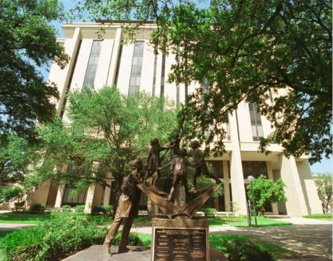
Some entering students have taken a considerable number of graduate hours in school psychology and related fields. The school psychology faculty believe there are so many exciting learning opportunities at A&M, both within and outside the EPSY Department, we do not want students to take courses that cover content previously mastered. On the other hand, we want to be sure that all graduates of our program possess both the scientific and theoretical perspectives, practice knowledge, and competencies necessary to fulfill the roles we anticipate for our graduates, as well as content covered in program examinations on completion of coursework (preliminary examinations) and licensure exams. The document titled "Minimum Course Requirements for Texas A&M University Doctoral Training Program in School Psychology" (available on the SPSY website and in this handbook) serves as a worksheet for students to complete, in consultation with their advisor.

If a student believes they have met a course requirement in previous undergraduate/graduate course work, the student can engage in the program’s course waiver process. All students admitted into the program are eligible to waive out of select required SPSY courses (see below), this includes currently enrolled students and admitted students entering the program with a bachelor’s degree, Master’s degree, or graduate coursework.
Decision to waive or transfer course. A course can only be used toward a single degree. This means the same course credits cannot be counted toward more than one degree. If the student has taken a graduate course and obtained a degree, they would be requesting a course waiver. If the student took coursework and transferred to TAMU without getting a degree, then the student can transfer up to 12 credits to the TAMU degree plan. Students should be aware that TAMU’s Office of Graduate and Professional Studies requires a minimum of 64 credit hours for a doctoral degree. Thus, waived courses may need to be replaced by electives in order to meet the 64-credit hour requirement. Exempting a course fulfills that course requirement and permits the student to take another course in its place.

The document titled "Minimum Course Requirements for Texas A&M University Doctoral Training Program in School Psychology" lists all course requirements; additional requirements may be added by the student’s Chair or committee. This form serves as a guideline for developing the doctoral degree plan required by the Office of Graduate and Professional Studies (OGAPS). The academic advising office is available to assist you with completion of the forms and will provide the current URL for accessing them.

For any student entering from an undergraduate program, as of Fall 2010 the completion of a degree plan for a Master’s in Education (M.Ed.) is required. Students who are required to complete their M.Ed. will need to talk to their Advisor in the Fall semester of their first year, file the degree plan in the spring/summer semester of their first year, and complete the requisite coursework by the end of Fall of their second year. If students follow this timeline, it is anticipated that students will receive their M.Ed. degree in December of their second year. Please keep in mind that students should work with the Academic Advisor to complete this process. Both the Degree Plan as well as information about completing it can be obtained from the Academic Advisor in Room 704; the form is available online and must be submitted online. Students are responsible for ensuring that their degree plan is approved and accepted by the Office of Graduate and Professional Studies (OGAPS). The Official University degree plan also includes the student's Advisory Committee members, along with their electronic approval; students will need to verify that their degree plan has been processed by all committee members.

Students will then need to progress to completion of the doctoral degree plan (a student cannot have two degree plans filed simultaneously). Students are required to complete this form by the end of the Fall semester of their second year, or if completing the M.Ed., by the end of the Spring semester of their second year. If you enter with a graduate degree, and you do not have a degree plan by Spring of your second year, you will be blocked by OGAPS from summer registration. By this time in a student's program, the student should have selected a doctoral Chair/ Advisor, and members of their doctoral committee; this may or may not be the same individuals for the M.Ed. Both the Ph.D. Degree Plan as well as information about completing it can be obtained from the Academic Advisor in Room 704; it is submitted on-line. Students are responsible for ensuring that their degree plan is approved and accepted by the Office of Graduate and Professional Studies (OGAPS). The Official University degree plan also includes the student's Advisory Committee members, along with their electronic approval; students will need to verify that their degree plan has been processed by all committee member prior to scheduling their proposal. Your Chair/Advisor will assist you in identifying appropriate members of your committee that meet the University requirements.

Although both chair and committee members can be changed, the Official University Degree Plan requires a constituted Advisory Committee at the time of filing. Once the Official University Degree Plan has been approved and filed, any subsequent changes in courses or committee may be made by filing a petition that outlines the changes with supporting reasons and is submitted to OGAPS. These forms can be accessed on-line, and the academic advising office will assist with this process.

Summary of the Major Steps

The following table can be printed out and used as a reminder of tasks to be completed by students and critical time frames. See also http://catalog.tamu.edu/graduate/academic-expectations- general-degree-requirements/degree-requirements/.

TIMELINE | STEP/PROCEDURE | APPROVAL/ DOCUMENTATION
Start of Program (prior to 1st semester; no later than New Student Orientation) | Meet with Advisor to establish PRELIMINARY PLAN for course of study
Fall of 1st year | Join professional organization(s) Obtain Liability Insurance  Complete CITI Training for use of human subjects in research  Think about/Talk to advisor about research projects and get involved or speak with other  program faculty about their current research | Copy of Liability Insurance cover page and CITI training completion form to Academic Advising Office
Spring of 1st year | Meet with Academic Advisor on steps for M.Ed. –File degree plan for M.Ed.** | Advisor OGAPS  M.Ed. Committee
Spring of 1st year | Establish portfolio on-line “myrecord”; develop/update curriculum vita (CV); get involved in research activities; complete self- evaluation | Advisor or other faculty  member; Program Advisor in Advising Office
Summer of 1st year/Fall of 2nd year | Apply for graduation (M.Ed.) ** Complete form for Annual Report Online | OGAPS  Program Advisor

Fall of 2nd year | Establish general scope/focus of dissertation | Advisor or other faculty member
 | Renew liability insurance | Copy of cover sheet for insurance to Advising Office
December of 2nd year | Get M.Ed. (graduation)  If in field experience, complete site evaluation form
Spring of 2nd year | Select TOPIC and Chair for dissertation; begin dissertation process; Establish DOCTORAL COMMITTEE and file PHD DEGREE PLAN  Establish time-table (roadmap) of degree completion | Chair and Advisory Committee; OGS
 | Register for PRAXIS II and Advanced Psych GRE; update portfolio on-line | Copy of results of PRAXIS and GRE to Academic Advising  Office
 | For LSSP (D2D): Pre-propose in March | SPSY Program Faculty
Every year | Renew liability insurance; update vita and portfolio on-line; renew CITI training as needed (every 5 years); complete self- evaluation and ARO; complete site evaluations each semester for every field  experience | Copy of insurance to Advising Office  Chair and Advisory Committee
Every year | Continue involvement with research; submit manuscript as co-author or author | Update CV and myrecord to reflect
Every year | Attend and present at professional  conferences | Update CV and myrecord to  reflect
Spring semester of year prior to applying for internship (usually year 3; LSSP Fast  Track will be year 2) | Pre-proposal presentation dates are scheduled by SPSY faculty in late March or early April; take/retake PRAXIS II or GRE Psych if needed | Copy of results of PRAXIS and GRE to Academic Advising Office if not already done
At least two weeks before prelims, proposal meeting | SCHEDULE preliminary examination (No later than 1st semester after completing  coursework/no earlier than within 6 credits of completing courses*) | Contact Advisory Committee members after approval by Chair; file date with OGAPS
Prior to Oct. 1 of year applying for internship (usually 4th year; LSSP (D2D) will be year 3) | Complete PRELIMINARY EXAMS; Hold PROPOSAL MEETING; Complete IRB and submit approved proposal for dissertation to OGAPS; apply for IRB approval | Chair and Advisory Committee; Paperwork and proposal to Academic Advising Office for OGAPS processing; OGAPS; IRB
Prior to Oct. 1 of  year applying for internship | Request letters of reference to be made ready  from faculty members; ensure that all practicum/ field experience evaluation forms involved in research activities; complete self- evaluation | Faculty members; field supervisors
Spring semester of year prior to applying for internship (usually year 3; LSSP Fast  Track will be year 2) | Pre-proposal presentation dates are scheduled by SPSY faculty in late March or early April; take/retake PRAXIS II or GRE Psych if needed | Copy of results of PRAXIS and GRE to Academic Advising Office if not already done
At least two weeks before prelims, proposal meeting | SCHEDULE preliminary examination (No later than 1st semester after completing  coursework/no earlier than within 6 credits of completing courses*) | Contact Advisory Committee members after approval by Chair; file date with OGAPS
Prior to Oct. 1 of year applying for internship (usually 4th year; LSSP (D2D) will be year  3) | Complete PRELIMINARY EXAMS; Hold PROPOSAL MEETING; Complete IRB and submit approved proposal for dissertation to OGAPS; apply for IRB approval | Chair and Advisory Committee; Paperwork and proposal to Academic Advising Office for OGAPS processing; OGAPS; IRB
Prior to Oct. 1 of  year applying for internship | Request letters of reference to be made ready from faculty members; ensure that all practicum/ field experience evaluation forms are completed and in your file; register with APPIC and complete all APPIC information | Faculty members; field supervisors
Prior to start of Internship | If non-APPIC, submit letter of expectations, document that requirements of CDSPP have  been met and have contract executed | OGAPS  Academic Advising Office
Before scheduling dissertation defense | COMPLETE STUDY/ collect/ analyze data; submit multiple drafts of chapters to Chair for EDITING/FEEDBACK. (Follow Thesis Format**)  EPSY requires that your committee receive the document four (4) weeks prior to the defense  TAMU/OGAPS sets the date for defense to be completed for each  graduation cycle | Chair and committee members
Usually during 1st week of classes for semester in which you plan to graduate– check with Advising Office for exact deadline dates or  check on-line | APPLY for degree (graduation) with OGAPS during the semester you will graduate  You must be enrolled in the semester in which you defend, but not the semester you graduate | OGAPS
While on Internship | Identify and apply for post-doctoral positions/jobs; begin process for LSSP or state certification
COUNT DOWN  At least 4 weeks before defense Last date for defense for graduation in a given semester of graduation is set by OGAPS. See OGAPS calendar for specific dates | After approval from Chair, SCHEDULE DEFENSE WITH ADVISORY COMMITTEE. Polished  final draft of complete dissertation is sent to all Advisory Committee members 4 weeks prior to defense date  Make appointment to CHECK FORMATTING with Thesis Clerk | Chair, Advisory Committee, OGAPS
At least 2 weeks before defense | Advisor and Committee members give feedback; MAKE CORRECTIONS IF NEEDED | Chair, Advisory Committee
At least 1 week before defense | REVISED copy to Advisory Committee
 | Hold defense: make any required changes. Submit corrected copy to Chair and then to Thesis Office | Chair, Thesis Office
Post-Graduation | Prepare for and take EPPP; obtain licensure. Keep the program posted so we can brag on you!!! | Director of Training

*Doctoral Students can apply for an exception to this rule. ** This is optional for students prior to 2010. ***Available from Academic Advisor, Copy Center on the Web
Course Requirements for SPSY

TAMU SPSY Required Courses Approved for waiver/transfer: The following courses may be waived if the student meets the requirements outlined by the School Psychology Division faculty provided. Courses not listed below are not eligible for course waivers/transfers regardless of circumstances.

Foundational
SPSY 610: Child Psychopathology
EPSY 621: Clinical Neuropsychology
EPSY 647: Life Span Development
EPSY 644: History & Systems
Assessment
SPSY 643: Academic Assessment & Intervention
SPSY 642: Behavioral Assessment and Intervention
SPSY 612: Individual Assessment of Children's Intelligence
SPSY 617: Assessment of Emotional Disturbance in Children
Research Methods & Statistics
EPSY 636: Techniques of Research
EPSY 622: Measurement and Evaluation in Education
EPSY 640: Statistical Analysis in Education Research I
EPSY 641: Statistical Analysis in Education Research II
Therapy & Consultation
SPSY 641: Child Therapy for School Behavior Problems
SPSY 644: Child Therapy Advanced Theory & Techniques
SPSY 628: Consultation Theory and Techniques
Practicum
SPSY 683: School-Based Practicum
Submission Deadline & Notification Timeline: Students are required to submit all course waiver information by July 1st. Students will be notified electronically by the faculty member assigned to that course by August 1st if they are approved or not for a course waiver for approved classes, with three exceptions. Notification for course waivers for SPSY 612, SPSY 641, and SPSY 617 will be September 1st.

Notification & Documenting Approved Course waivers: Once students are notified of faculty’s course waiver decisions students should request that faculty complete a course waiver form for each class that they have been waived out of document that a course wavier has been approved. The original completed course waiver form should be placed in student’s academic file in the EPSY Graduate Advising office by faculty. Faculty should also provide the student with a copy of the completed course wavier form for their personal records.

Foundational | Eligible for waiver? | Documentation of Prior Coursework/Licensure or Certification | Performance Based Assessment | Faculty Overseeing Process/Timeline for Submission & Notification
SPSY 610: Child Psychopathology | Yes | Grade of B or better in relevant course work (transcript)  Syllabus of relevant coursework | N/A | Faculty: Dr. Kahn  Submit: July 1  Decision: August 1
EPSY 621: Clinical Neuropsychology | Yes | Grade of B or better in Biological Basis of Behavior or relevant graduate coursework (transcript)  Course must be <5 years (transcript)  Syllabus of course for Biological Basis of Behavior <5 years old | N/A | Faculty: Dr. Hajovsky  Submit: July 1  Decision: August 1
EPSY 647: Life Span Development | Yes | Grade of B or better in relevant graduate course work (transcript)  Syllabus of relevant coursework | N/A | Faculty: Dr. Gagne (EPSY)  Submit: July 1  Decision: August 1
EPSY 644: History & Systems | Yes | Grade of B or better in Graduate course titled: History & Systems | N/A | Faculty: SPSY Faculty Advisor  Submit: July 1  Decision: August 1
Assessment | Eligible for waiver? | Documentation of Prior Coursework/Licensure or Certification | Performance Based Assessment | Faculty Overseeing Process/Timeline for Submission & Notification
SPSY 643: Academic Assessment & Intervention | Yes | Grade of B or better in relevant course work (transcript)  Syllabus of relevant graduate coursework | - Work Sample  - Exam | Faculty: Dr. Allen  Submit: July 1  Decision: August 1
SPSY 642: Behavioral Assessment and Intervention | Yes | Grade of B or better in relevant course work (transcript)  Syllabus of relevant graduate coursework | - Work Sample | Faculty: Dr. Allen  Submit: July 1  Decision: August 1
SPSY 612: Individual Assessment of Children's Intelligence | Yes | Grade of B or better in relevant course work (transcript)  Syllabus of relevant graduate coursework | - Work Sample  - WISC-V, DAS-2, KABC, and/or WJ Administration | Faculty: Dr. Hajovsky  Submit: July 1  Performance-based Assessment: TBD  Decision: Sept 1
SPSY 617: Assessment of Emotional Disturbance in Children | Yes | Grade of B or better in relevant course work (transcript)  Syllabus of relevant graduate coursework | - Work Sample  - Contrived Case Conceptualization | Faculty: Dr. Kahn  Submit: July 1  Performance-based Assessment: TBD  Decision: Sept 1
Research Methods & Statistics | Eligible for waiver? | Documentation of Prior Coursework/Licensure or Certification | Performance Based Assessment | Faculty Overseeing Process/Timeline for Submission & Notification
EPSY 622: Measurement and Evaluation in Education | Yes | Grade of B or better in relevant course work (transcript)  Syllabus of relevant undergraduate or graduate coursework in Research Design | N/A | Division Coordinator will send notification  Submit: July 1  Decision: August 1
EPSY 636: Techniques of Research  Students only required to take this course if they do not pass or do not complete the prescreening exam by the submission deadline. | Yes | N/A | 75% or better on prescreening exam | TBD-RMS Faculty  Division Coordinator will send notification  Test Date: TBD  Decision: TBD  Pre-screener: https://forms.gle/nvpS9rMRME1GnpDo6
EPSY 640: Statistical Analysis in Education Research I | Yes | Grade of B or better in relevant doctoral course work only (transcript)  Syllabus of relevant doctoral coursework in advanced statistical data analysis techniques for experimental and non-experimental design | N/A | Division Coordinator will send notification  Submit: July 1  Decision: August 1
EPSY 641: Statistical Analysis in Education Research II | Yes | Grade of B or better in relevant doctoral course work only (transcript)  Syllabus of relevant doctoral coursework in advanced statistical data analysis techniques for experimental and non-experimental design | N/A | Division Coordinator will send notification  Submit: July 1  Decision: August 1
Therapy & Consultation | Eligible for waiver? | Documentation of Prior Coursework/Licensure or Certification | Performance Based Assessment | Faculty Overseeing Process/Timeline for Submission & Notification
SPSY 641: Child Therapy for School Behavior Problems | Yes | Grade of B or better in relevant graduate course work (transcript)  Syllabus of relevant coursework | Exam | Faculty: Dr. Kahn  Submit: July 1  Performance-based Assessment: TBD  Decision: September 1
SPSY 644: Child Therapy Advanced Theory & Techniques | Partial; will audit select class sessions as required by instructor of record | Documentation of Licensure in mental health/counseling field (LPC, LPA, LSSP, LCSW, etc.)  Documentation of direct contact hours/professional development training in counseling  Grade of B or better in relevant course work (transcript)  Syllabus of relevant graduate coursework | N/A | Faculty: Dr. Kahn  Submit: July 1  Decision: August 1
SPSY 628: Consultation Theory and Techniques | Yes | Grade of B or better in relevant graduate course work (transcript)  Syllabus of relevant coursework | Work Sample | Faculty: Dr. Allen  Submit: July 1  Decision: August 1
Practicum
SPSY 683: School-Based Practicum | Partial; eligible to waive out of one semester only | - One of the following:  Documentation of Licensure/Credentialing as School Psychologist (LSSP/NCSP etc.)  Documentation of completion of school-based internship |  | Faculty: Dr. Riccio  Submit: July 1  Decision: August 1

Sequence of Courses
Because students enter the program with different backgrounds, students’ progress through their course work at differing paces. The section titled “What to expect” describes a typical sequence of courses for a student entering the program with a bachelor's degree in psychology. Prerequisite courses, including statistics, and core psychology courses should be scheduled early in the program. Although there is a mechanism to waive courses, there are some courses, that ALL students are required to take as part of their degree program.

All students are required to take SPSY 611 (Professional Practice, Legal, Ethical, and Credentialing Issues) during their first year, even if they have had a course on legal and ethical issues in professional psychology elsewhere. This wrap-around course (1 credit Fall, Spring, and Summer of year 1) orients students to our program and faculty and assist students in developing a social support network and sense of program belonging. In addition, it ensures that all students have the most current and updated information on legal issues guiding the practice of school psychology and more globally, health service psychology. This class also reviews the APA Code of Ethics and Standards for Practice and introduces an ethical decision-making format.

All students are required to complete the clinic practicum (SPSY 683 Field Experience: Child Therapy), as well as at least one semester of the SPSY 683 Field Experience: School based Externship. Students may request an alternate experience for the second semester of the school-based experience if they have prior professional experience working in school-based practice before entering the program (i.e., have already completed a year-long Specialist level school-based internship). If approved, they can choose to complete the second semester in an alternate setting. If there is any problem during their first semester of school-based externship, they will be required to complete a second semester of school-based externship to demonstrate competence.

Although not all courses must be taken in a prescribed order, students will want to be aware of the following course sequences:

Assessment Sequence:
SPSY 643 (Academic Assessment and Intervention)
SPSY 642 (Behavioral Assessment and Intervention)
SPSY 612 (Individual Assessment of Children's Intelligence)
SPSY 617 (Emotional Disturbance in Children)
SPSY 614 (Integrated Assessment Practicum)
SPSY 683 (Field Based Experience in Schools – 2 semesters/half-time AND any practicum that requires competency in assessment)

Therapy Sequence:
SPSY 610 (Child Psychopathology)
SPSY 641 (Child Therapy for School Behavior Problems)
SPSY 644 (Child Therapy Advanced Theory and Techniques)
SPSY 683 (Practicum in Child Therapy – 2 semesters)
SPSY 683 (Field Based Experience in Schools – 2 semesters/half-time)
*Please note, both the Assessment and Therapy sequences must be completed prior to School Based Field Experience

Research, Measurement, and Statistics Sequence:
* All entering students will complete a statistics placement test to determine if the student will be required to take EPSY 636 prior to EPSY 640.
*Students who have not successfully completed a course in research design with a B or better will need to take EPSY 636 (Techniques of Research). Please see Appendix.

All students will take the following (after any *courses needed)
EPSY 640 (Experimental Design in Education I)
EPSY 641 (Experimental Design in Education II)
EPSY 622 or 625 (Measurement and Evaluation in Education or Advanced Psychometric Theory)

One additional research methods and statistics course (e.g., EPSY 622 or 625, 630, 631, 642, 643, 650, 651 or other) must be completed as approved by the student’s Doctoral Chair/Committee SPSY 691 (Research). These hours are taken in conjunction with completion of the dissertation research requirement. These can be taken before finishing the above courses, but generally are not taken before the student’s doctoral degree plan has been filed and approved. SPSY 691 hours can be taken with any faculty member helping the student with his/her dissertation to recognize the efforts of these faculty members. Students are required to take 12 credits of SPSY 691 prior to graduation but can take additional credits as needed.

Consultation Sequence:
SPSY 643 (Academic Assessment and Intervention)
SPSY 642 (Behavioral Assessment and Intervention)
SPSY 628 (Consultation Theory and Techniques)
SPSY 638 (Systems Consultation and Prevention Science)
SPSY 683 (Field Based Experience in Schools – 2 semesters, half-time)

Additional Foundational Coursework
- Specific foundational coursework covering broad and general knowledge are not sequenced; specific additional coursework will be determined by the student’s advisor/Chair. One component of the minimum level of achievement (MLA) is the PRAXIS II School Psychology Examination, as well as the Advanced Psychology GRE to provide an objective measure of foundational knowledge in broad and general areas, as well as specific to the practice of school psychology. It is recommended that students’ complete foundational coursework prior to taking these exams. Both the PRAXIS II School Psychology Examination and Advance Psychology GRE must be completed and successfully passed by all students regardless of the student’s prior training, credentialing, or licensure. Students may not substitute any other professional certification or licensure exam for the PRAXIS II School Psychology Examination as evidence of MLA or to meet program degree requirements. Students who provide licensure documentation for the Licensed Psychological Associate (LPA) or the Licensed Professional Counselor (LPA) may be eligible to waive the Psych GRE.

Courses with Field Experiences* (in order usually taken):
SPSY 683 (Field Based Practicum: Child Therapy)
SPSY 628 (Consultation – class project)
SPSY 614 (Integrated Assessment)- Failure to complete 3 comprehensive evaluations during integrated assessment will require students to register for additional class credits of SPSY 683 to ensure appropriate supervision.
SPSY 683 (Field Based Experience in Schools) - Taken after assessment, therapy, and consultation sequence, usually in students’ third year; includes assessment, direct intervention, and consultation; students are referred to as ‘interns’ and are expected to accumulate 600 hours of school base experience across the two semesters. Failure to complete required activities will result in student taking additional class credits to ensure appropriate supervision.
SPSY 683 (Field Based Experience in Supervision) – All students are required to take the supervision class/experience, usually during their 4th year or the year prior to internship
SPSY 683 (Field Based Experience in …) -: Elective field experiences/externships can be taken at any site approved by the student’s Chair/Advisor as long as university supervision is arranged for in advance and the experience is approved by their Chair. Any external experience (also called externship) must be integrated with academic training and be taken with consideration of field experiences that are sequential, cumulative, and graded in complexity.
SPSY 684 (Professional Internship): Usually taken after school-based field externship, any elective field experiences, completion of all course work, and completion of all steps for candidacy (proposal and preliminary examinations). Internship should be at an APA-Approved Internship site. Students may elect to take internship before or after defending their dissertation but must have a proposal on file and have completed all preliminary examinations prior to applying for internship by October 1st. Students must complete internship prior to degree conferment, with the final evaluation and certificate/letter of completion received from the internship site.

*For all SPSY 683 field experiences, students need to complete registration documentation and a contract with the site will be executed to be signed by the University as well as the primary field supervisor. Background checks, fingerprinting, Tuberculosis Testing (TB testing) and vaccinations may be required for field experiences; school districts may require a student to be fingerprinted as part of the FAST system and Texas Department of Public Safety. Hospitals or medical facilities may require students to obtain certain vaccinations. Students are responsible for the cost of fingerprinting, background check applications, vaccinations or other requirements of field placement sites. The cost for fingerprinting begins at $50.

A student who is unable to complete the field experiences (e.g., English proficiency is not sufficient; do not meet requirements of site background checks) will not be able to complete the program. For all external and elective practica and externship, the student also will need to establish both on-site and university supervisors, provide a clear statement of the goals and objectives for the training they will be receiving, and ensure that there is a contract executed between the site and the university prior to beginning the experience. A form must be completed and signed off on by all parties, including the student’s Chair, prior to registration and verification of a contract/memorandum of understanding. For all field experiences, evaluations of students by supervisors, and evaluations of the sites by the students are required to be conducted each semester.

Practicum/Externship Registration

The practicum registration process including steps, dates, and forms that students need to complete prior to starting practicum are listed below or can be accessed in the elective practicum directory listed in appendix. All practica (required and elective), students must complete the pre-registration form. For elective practicum, as part of this preregistration process, students should provide the prospective supervisor with a syllabus from their University site supervisor and a copy of the practicum student evaluation form. The registration form is on the EPSY website but a sample form for how this can be completed can be found on the next page.

The practicum evaluation form is on the EPSY website. For elective practicum, the syllabus should be obtained from the faculty member who has agreed to serve as the university supervisor. The prospective supervisor, the university supervisor, and your doctoral chair need to sign the pre-registration form. For all external practica, a contract also must be executed with the site. You can initiate this process by:

- Checking with the advising office to determine if there is a contract in effect for the time period you will be there, If not, fill out the information on this google form: https://docs.google.com/forms/d/e/1FAIpQLSerVQgEMkFloO8EreK1wy0lrWuzTW0KhMtCAz3l2e7keHo5bA/viewform
- The advising office will enter the information in the portal for contracts. TAMU contracts will then create and obtain signatures for all contracts/agreements. You will still have to send the prac form to the advising office (on the previous page and found on epsy.tamu.edu under student services) with supervisor/faculty signatures.
- This needs to be done prior to the registration of classes in the semester before you’d like to begin the practicum and no later than 2 months before the start date of the practicum. Check for the exact date on the “Important Dates” notice each semester and in the practicum registration flow chart below.

You cannot begin the practicum experience until the contract/Memorandum of Understanding has cleared the contracts office at TAMU and the site. You will also need to document via an agreement between you and the supervisor(s) clearly articulating your time commitment, weekly and for what length of time. This form also clarifies the types of tasks you might be involved in during the practicum. Clarification in advance can avoid misunderstanding and miscommunication later. At the conclusion of the practicum experience, your site supervisor will complete and evaluate your competencies via the practicum evaluation form; you will not receive a grade until this is received. You will also be asked, each semester, to evaluate the site. The form for you to evaluate the site will be emailed to you by Training Director at the end of each semester. The Training Director will maintain a copy of the evaluations of your practicum site for quality check purposes.

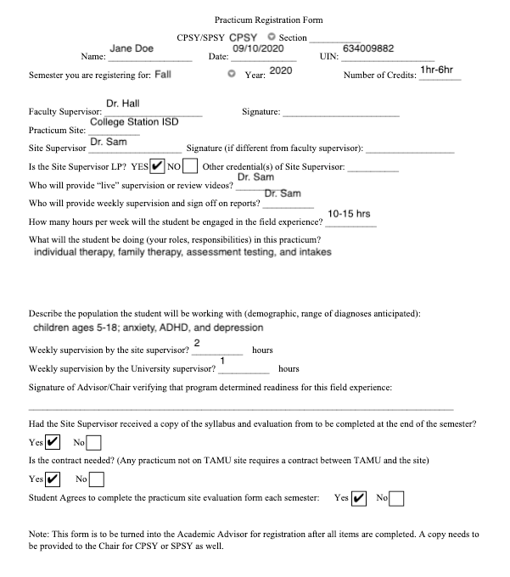

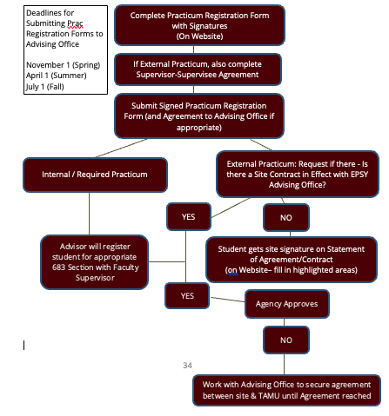
YES
NO

Elective Practicum/Externship Experiences

While elective practicum training may occur either on or off campus, selection of a particular site should be made in view of the skill(s) to be acquired in conjunction with the student’s Advisory Committee Chair. The student’s Chair must agree to the practicum considering what else the student is committed to complete during the same time, whether classes, required practica, or research. Ages and groups (demographics, disorder) will constrain options available, as will any geographic preferences. The tasks required of the student in the practicum setting should be clearly related to the skill to be acquired with appropriate supervision. Additionally, sites are chosen to ensure a relationship between working professionals and the faculty of the training program, as well as to provide adequate supervision of the student by faculty and other supervisory on-site personnel.

In keeping with both the philosophical goals of the School Psychology Program and the ethical standards of psychologists, all practicum activities are designed to conform to existing legal-ethical practices. Case studies and other records are maintained, and relevant discussions conducted, in such a manner as to ensure client confidentiality and to protect the rights and privileges of all parties involved. Students are expected to adhere to the rules and regulations of the settings in which they are in; any variation should be in the direction of more stringent adherence to ethical and legal requirements. The laws and regulations (e.g., HIPAA, IDEIA 2004, FERPA, etc.) pertinent to each setting must be followed in that setting. Students should always remember that they are professionals and must behave with honesty and integrity, and adhere to program, departmental, college, University, and APA/NASP ethical standards.

Professional behaviors include timeliness (e.g., reports, papers, and other documents completed in a timely manner; on time arrival to class, meetings, and practica settings; completion of course requirements in an appropriate time frame), use of feedback for reflective practice (e.g., accepts feedback from faculty, supervisors, and peers; provides constructive feedback), self-care in recognizing the need for and obtaining additional training in a given area, responsibility for one’s own behavior, and concern for the welfare of others. For practica/field-based experiences, appropriate attire, consistent with that of other professionals in the same setting is required and adherence to the specific policies and procedures (unless there is an ethical or legal issue involved therein) of that setting is expected. In conjunction with professionalism, all students are required to carry liability insurance with a statement of said insurance on file with the Academic Advisor’s office by the end of Fall semester of the first year and renewed annually. From APA CoA C-26: Practicum helps to realize the educational goals identified in the program’s curriculum plan and includes:

- Clear statement of goals and objectives for practicum training
- Documents outcome measures on how training meets these goals and objectives
- Identify how the practicum is clearly integrated with other elements of the program
  - including how academic knowledge is integrated with practical experience through forums led by psychologists for discussion of practicum experience
- Clear identification of how practicum training is sequential, cumulative, and graded in complexity
- How designed to prepare students for further organized training
- Program should document how the program ensures the quality of the practicum sites including regularly scheduled site reviews
- Identify the administrative methods used to ensure that practicum meet criteria and how students are matched to these sites
- Document how that feedback is used to address the progress, development and competencies of the practicum student
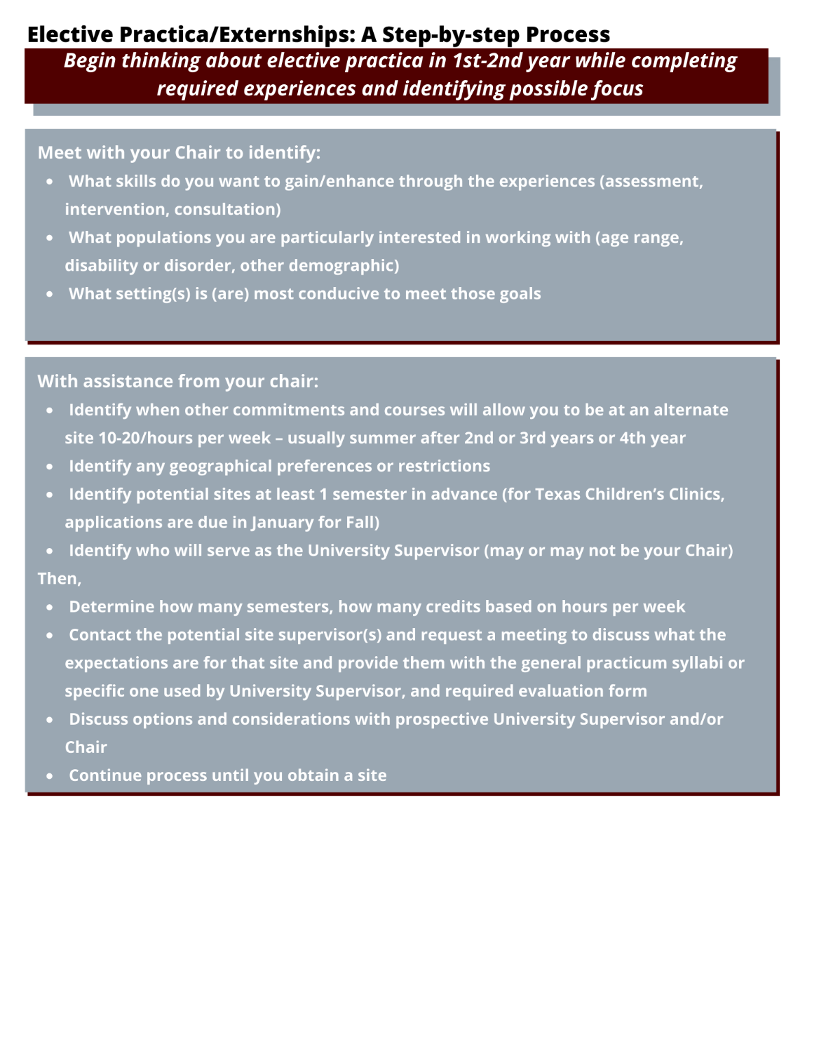
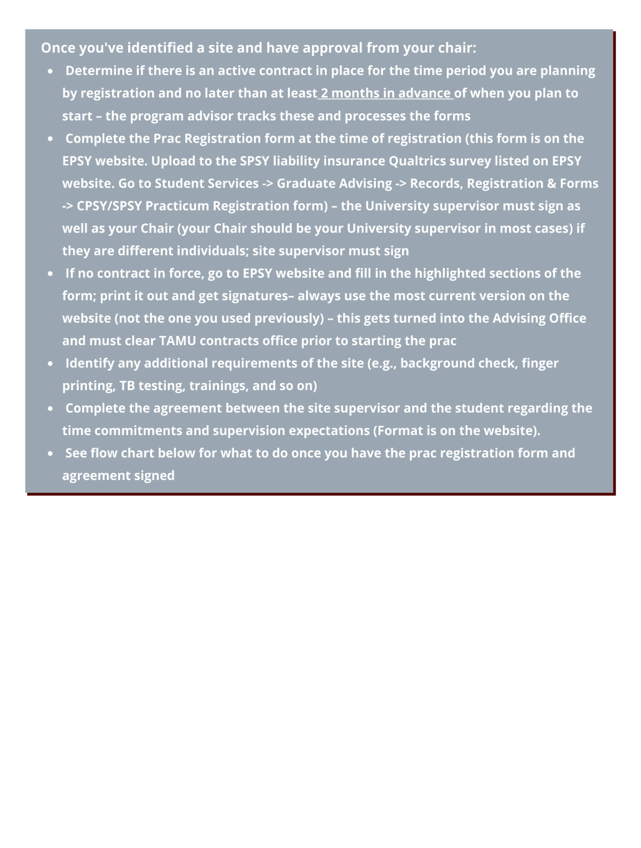

SPSY Research Expectations
Students are expected to join a faculty-led research team or become involved in a faculty-led research project by their second semester in the program. Students may wish to visit with different faculty members to determine what opportunities are available to them either through research teams or research projects beginning in their first semester of their first year, with increased involvement each year thereafter. Faculty projects and research teams focus on different research topics, and students are given the opportunity to participate in on-going research.

Each faculty member handles student involvement in research somewhat differently; however, students are expected to gain experience in presenting their own research and in publishing research as part of their involvement in faculty research. The goal of the research involvement is to give students hands-on experience in a range of research activities prior to the dissertation. The level of research involvement is expected to increase with years in the program and to be maintained through and after graduation.

Students are encouraged to complete the research, measurement, and statistics sequence by the end of the second year of study, so that they have the tools needed to participate meaningfully in various research activities. Students are required to take at least one advanced research and statistics course (e.g., multivariate statistics, hierarchical linear modeling, survey research, meta-analysis, qualitative methods, single subject, program evaluation, and so on) that may be important to their dissertation research or professional practice. It is the expectation that all students will co-author or author at least one publication and one conference presentation prior to graduation.

University Travel Documentation

Any student who is enrolled in the program (full time, part-time, in absentia, on internship, ABD) and driving 25 or more miles for a student organization event or to engage in research or observation organized by a member of the faculty must complete a travel form, accessible here: https://studentactivities.tamu.edu/app/form_travel/. An event or activity organized by the University is one that is initiated, planned and organized by a university faculty or staff member or by a recognized student organization and approved in accordance with applicable University requirements. An event or activity sponsored by the University is one that the University sponsors by providing funding or sending students to participate as official representatives of the University. Types of activities and events covered by this Rule include course-related field trips, activities of sponsored student organizations, recreational sports club trips, and meetings of academic organizations where a student is officially representing the University. On this form, you will indicate the type of travel you are engaging in, input your student information, and then designate the activity as required on the form including the routes to be taken. Students should follow the SAP 13.04.99.M1.01, Student Travel Procedures. This rule does not apply to student travel to engage in student teaching, internships, clinical rotations, practicums, observations, or research, unless the research or observation is organized by a member of the faculty. However, in these cases, students are encouraged to follow the safety provisions set out in this Rule and SAP 13.04.99.M1.01, Student Travel Procedures.

Core Requirements

The “Core” content is seen as required for all students in the program. If a student believes they have met a course requirement in previous graduate course work, the student meets with a faculty member in our Department who teaches the course in question. With faculty approval, students may exempt out of required courses based on previous course work or professional experience that is deemed to be equivalent to the required course (see section on Direct to Doctorate). Waived courses do not earn units and do not count toward the total units needed to graduate. Exempting a course does fulfill that course requirement and permits the student to take another course in its place (please see Appendix for list of approved courses that can be exempted or waived). Students entering with a Bachelor’s will need to obtain the Master in Education (M.Ed.) following completion of 36 credits, usually in December of the second year. Courses below designated √ are those courses most likely to be included on the M.Ed. degree plan.

Courses in Bold are taken by all students.

Basic Psychological Sciences Core  Note: The student must retake any course in which he/she receives a grade of “C” or below. | Hours | Semester Usually Offered/Taken
EPSY 647 Life Span Development | 3 | Fall of Year 1
SPSY 610 Child Psychopathology | 3 | Fall Year 1
EPSY 644 Histories of Psychology | 3 | Varies
EPSY 621 Clinical Neuropsychology | 3 | Summer Year 2
Total | 9-12
Research, Measurement, Statistics Core Note. Students receiving a C in EPSY 640 are required to retake the course. | Hours | Semester Usually Offered/Taken
EPSY 622 Measurement and Evaluation in Education (May instead take 625) | 3 | Fall or Spring Year 2 or 3
EPSY 636§ Techniques of Research | 3 | Fall/ Spring/ Su Year 1
EPSY 640 Experimental Design in Education I | 3 | Fall/ Spring Year 1 (Year 2 if need to take prerequisite coursework)
EPSY 641** Experimental Design in Education II | 3 | Spring/Fall Year 1 or after completion of EPSY 640
EPSY _____ One additional research  course (EPSY 625, 630, 631,642, 643, 650, 651, 690) | 3 | Varies
Total | 12-18
* A leveling course for students who have not had statistics or who do not successfully pass the statistics readiness exam (see Appendix Course waiver Process); prerequisite to EPSY 640.
§ A leveling course for students with no prior research courses. Students must complete the course waiver process to determine if this course may be waived.
** Requires prerequisites.

Professional School Psychology Core Note: The student must retake any course in which he/she receives a grade of “C” or below. | Hours | Semester Usually Offered/Taken
√EPSY 605 Effects of Culture,  Diversity, & Poverty on Children and Youth | 3 | Spring Year 2
√SPSY 611 Introduction to School  Psychology: Legal, Ethical & Credentialing Issues | 1+1+1 | Fall, Spring, Summer Year 1
√SPSY 612 Individual Assessment of  Children’s Intelligence | 4 | Spring Year 1
SPSY 614** Integrated Assessment Practicum | 3 | Spring Year 2
√SPSY 617** Emotional Disturbance in Children | 3 | Fall Year 2
√SPSY 642 Behavioral Assessment and Intervention | 3 | Spring Year 1
√SPSY 643 Academic Assessment and Intervention | 3 | Fall Year 1
√SPSY 641 Child Therapy for School | 3 | Spring Year 1
√SPSY 644** Child Therapy – Advanced Theory and Techniques | 3 | Summer Year 1
SPSY 628 Consultation: Theory and Techniques | 3 | Fall Year 2
SPSY 638 Systems Consultation and Prevention Science | 3 | Fall Year 2 or 3
SPSY 627 Culturally Responsive Interventions: Models for Making Cultural Adaptations to Interventions | 3 | Summer Year 2 or 3
SPSY 683C** Field Based Experience:  Child Therapy (2 semesters; must be approved by program) | 3+3 | Fall-Spring or Spring-Summer Year 2
SPSY 683D** Field Experience: Schools  (2 semesters; must be approved by program) | 6+6 | Fall-Spring Year 3
SPSY 683E Supervision Seminar and Field Experience (1 semester; must be approved by program) | 1 | Fall/Spring Year 4
SPSY 684** Internship in Professional  Psychology (yearlong; must  be approved by program) Internship should be an an APA accredited site as noted by APPIC (https://www.appic.org) | 1+1+1 | Fall, Spring, Summer Year 5
Total | 59

*Note: A, b, c, d, e for SPSY 683 is for clarification in this handbook only. They will be the same course number when you register, just with specific faculty.

Focus Areas

Focus Areas are an opportunity for students to personalize their degree plans by selecting themes or Focus Areas of coursework that cluster into specialty areas. The Focus Areas listed in this document and the courses associated with them serve only as suggestions. Students are encouraged to meet with their doctoral Chair/advisor to develop a Focus Area that meets their individual unique interests. Class titles and numbers may change over time. Search classes of interest through the class search option on Howdy using key words. A total of 12 hours of Focus Area courses is required. Focus Area courses may include 1 required School Psychology Professional Course and three elective courses or 4 elective courses. Students may do an elective practicum related to their area of focus and that can count as one of the 4 required courses.
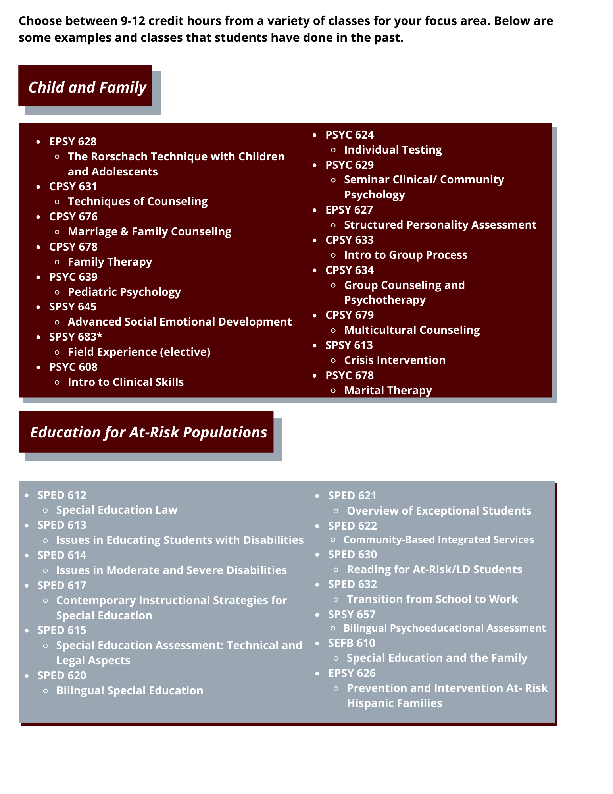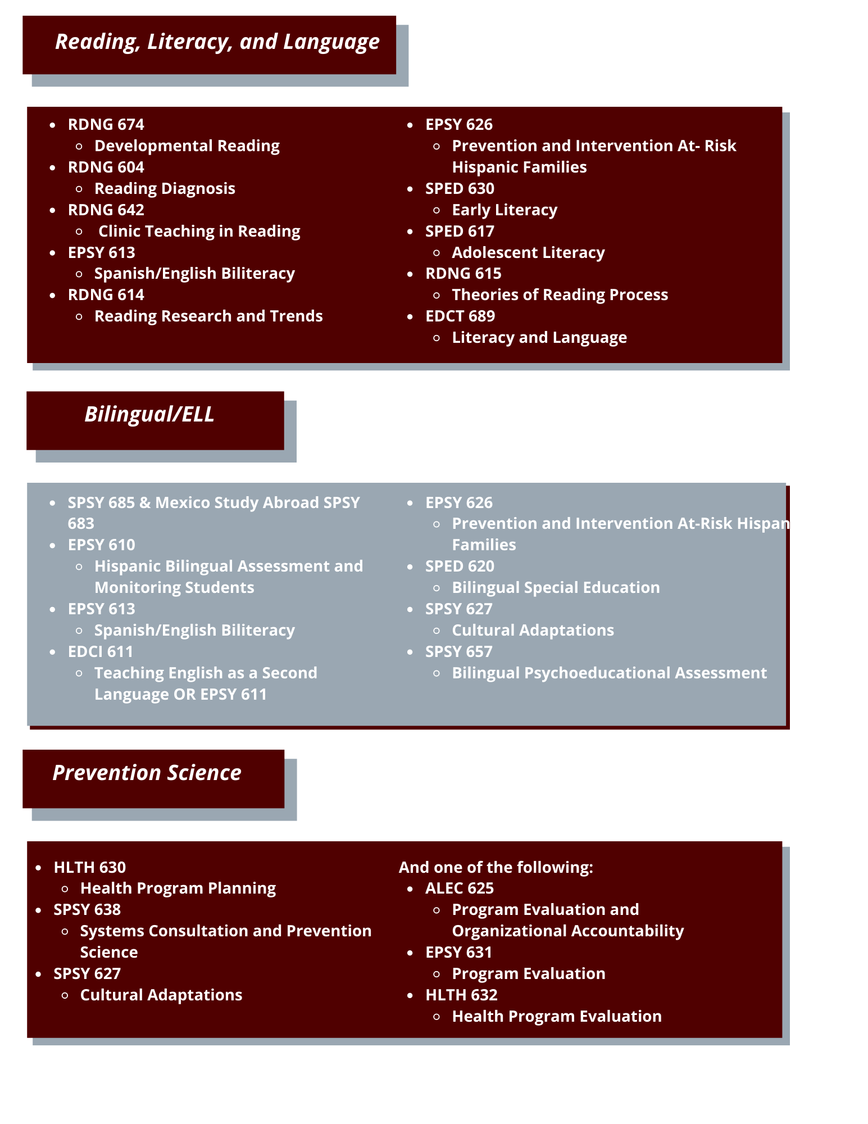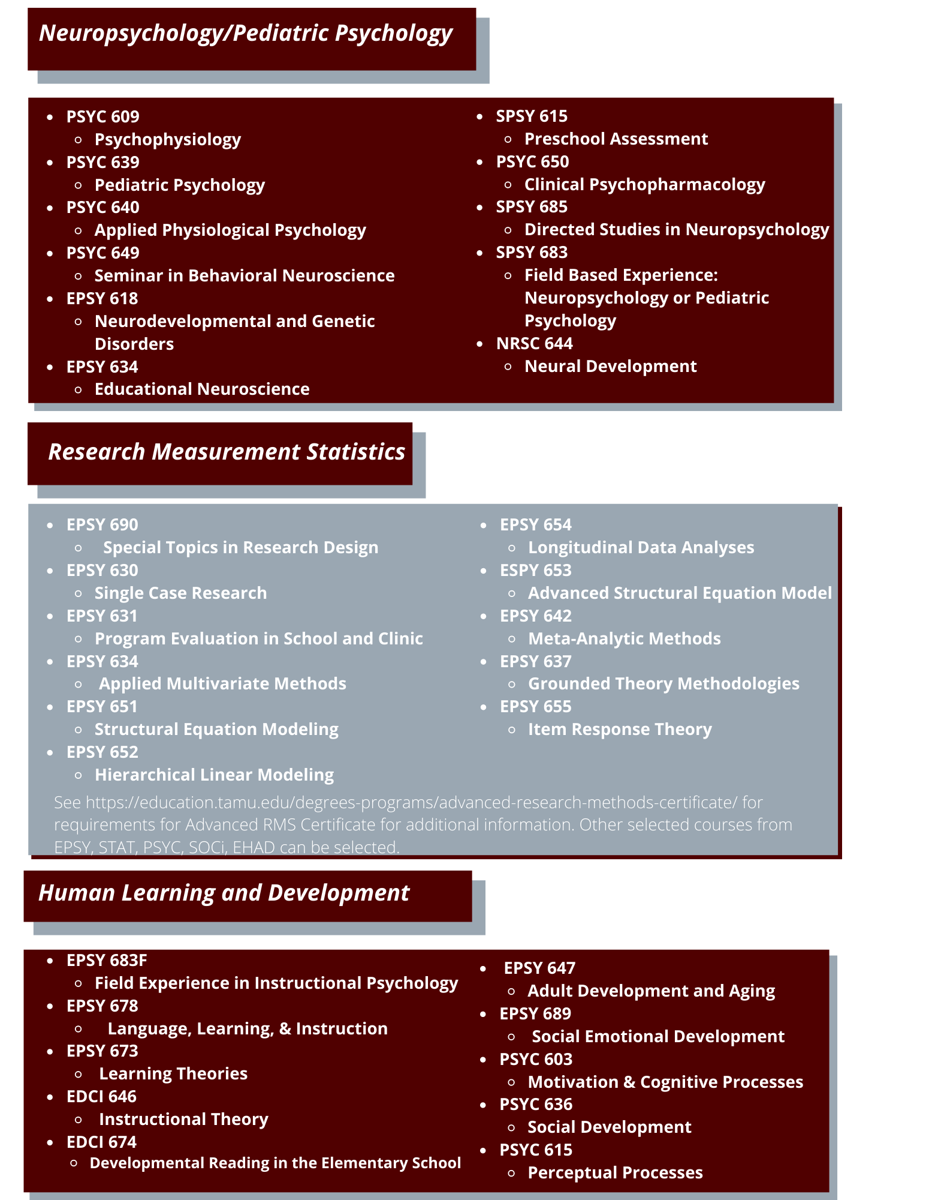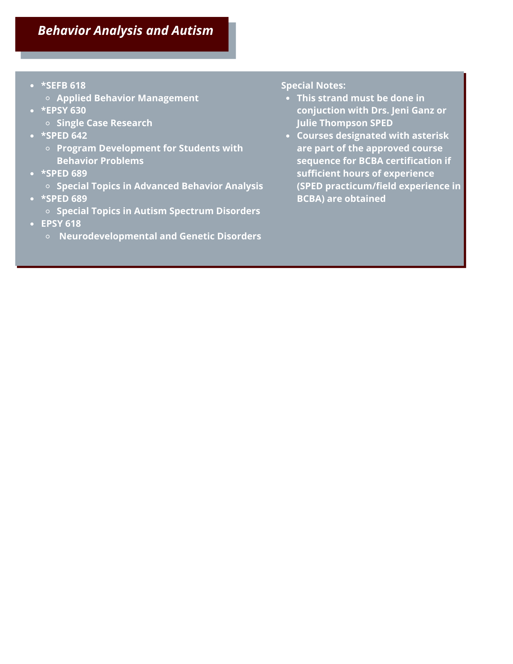

Additional Program Requirements

- For students entering from an undergraduate program (with Bachelor’s degree), 37 credits taken in the first year (Fall-Spring-Summer) and second year (Fall) are used to fulfill the requirements for the M.Ed.; for all students, the doctoral degree plan must include a minimum of 64 credits. SPSY 691 is for your research dissertation. Only 12 credits of SPSY 691 are required to be on the degree plan, but students can register for more at Chair discretion.
- Students should discuss and identify their major area of interest /Focus Area with their intended Chair and Advisory Committee prior to completion of the degree plan to ensure that there is an appropriate match of interests and expertise. Within each area of specialization, appropriate courses may be added as they are developed and identified. The Focus Areas and courses listed here are suggestions only! Students are expected to complete and file the doctoral degree plan by the end of their second year. Students entering with a Master’s degree will be blocked from registration for Summer of second year until a degree plan has been submitted and approved
- The student’s doctoral committee or the program faculty is always at liberty to require other such coursework as it deems necessary to remediate any deficiencies or to assist the student in reaching his/her career/educational goals.
- It is the intent of the program that students will develop basic competence in discipline specific knowledge as well as professional competencies in ethical and legal standards, professional values and standards, research, diversity, communication, assessment, intervention/treatment, consultation, and supervision/teaching.
- It is expected that students entering with a master’s or graduate degree will be able to waive hours in the above program. Students should review the Course Waiver process and course approved for exemption in the previous section. If this document does not answer their questions, students should contact the Division Coordinator and the faculty who teach comparable courses at TAMU.
- As required by the Department of Educational Psychology, students are required to present research papers at a state, regional, or national conferences. In addition, students are expected to submit manuscripts for publication. Involvement in research with at least 1 publication submitted and 1 conference presentation is a minimum expectation. The policy anticipates that all students will participate in research before completing work on a dissertation. The EPSY Research Expectations are provided in this Handbook. The student’s Chair and their Advisory Committee will monitor these activities in conjunction with the student. Research productivity will be reviewed annually by program faculty.
- Minimum levels of achievement (MLA) include GPA>3.0 consistent with OGAPS for all coursework on the degree plan; field supervisor ratings indicative of competencies in practice; obtaining the score required for licensure as LSSP (TX) or national certification on the PRAXIS II School Psychology examination; a score > 600 on the Advanced Psychology GRE; evidence of engagement in research and dissemination of new knowledge through conference presentation and publication; and initiation and conduct of original research (dissertation). Student year in the program is considered in relation to their level of achievement (i.e., the same expectations do not apply for first and fourth year students).

Year by Year Expectation for Degree Completion

General Notes
  - EPSY 640-641 is usually taken either Fall/Spring or Spring/Fall
  - SPSY 683 Field Experience: Child Therapy is taken either Fall/Spring or Spring/Summer – assignment is made by the faculty providing supervision
  - Students must have continuous enrollment (1 credit hour minimum) each semester, until graduation
  - One cannot begin post-doctoral hours (or call oneself a post-doc) UNTIL the doctoral degree is conferred. At TAMU, this only occurs with graduation dates (December, May, August)
  - If your internship does NOT end before the fall semester starts (this year August 26), and the documentation of completion is not received and grade assigned by that date, then you will NOT graduate in August. If you have applied to graduate, you can walk in August; however, your degree will NOT be conferred until December.
  - To waive out of or transfer credits for courses please see the course waiver section

This is based on a student coming in with a Bachelor’s degree. Courses in bold must be taken at the suggested time to stay in sequence. The shaded areas indicate other activities that students need to be engaged in; these are in addition to formal coursework and are discussed as part of SPSY 611.

FALL | SPRING |  | SUMMER
Year 1
- Obtain liability insurance (copy of cover page to Academic Advising office) & upload to the SPSY liability insurance Qualtrics survey listed on EPSY website. Go to Student Services Graduate Advising Records, Registration & Forms SPSY Liability Insurance
- Become involved with research project or activity
- Join professional organizations
- Establish file in ‘myrecord’ including vita, sample papers
- Complete self-evaluation form prior to annual review
- Complete CITI training for research involving human subjects
- File degree plan for M.Ed. in Summer (NOT required for those entering with a master’s degree of any kind)
- Complete Annual Report Online (ARO) form for APA
- Complete coursework indicated
SPSY 610: Child Psychopathology  SPSY 643: Academic Assessment & Intervention SPSY 611: Professional Practice and Credentialing (1) EPSY 647: Life Span Development |  | SPSY 612: Individual Assessment of Children  SPSY 641: Child Therapy  for School Behavior Problems or PSYC 637 Clinical Interventions I  SPSY 642: Behavioral Assessment and Intervention SPSY 611: Law (1) | SPSY 611: Ethics (1)  SPSY 644: Child Therapy Advanced Theory and Techniques
Plus, one of the following to be determined with the Assigned Advisor:  *EPSY 636 Research Design  EPSY 640 Experimental Design I | Plus, one of the following to be determined with the Assigned Advisor:  *EPSY 636 Research Design EPSY 641 Experimental Design II (or EPSY 640 if not taken in Fall) |  | Plus, one additional course to be determined with the Assigned Advisor:  EPSY 621: Clinical Neuropsychology (can be taken 1st or 2nd year) Another course depending on what is offered
Students with advanced standing may take SPSY 638: Systems Consultation and Prevention Science, SPSY 628: Consultation Theory and Techniques or another course if they waive out of one of the scheduled courses  and have met prerequisites | Students with advanced standing may take EPSY 605: Culture, Diversity; SPSY 614 Integrated Assessment, or Focus Area course if they waive out of one of the scheduled courses and have  met prerequisites
13 credits | 14 credits |  | 4-7 credits

In the second year, students will continue in many of the same activities. Half of the cohort will begin Therapy Practicum in the Fall and continue through Spring; half will begin in the Spring and continue through the Summer. In the Spring of Year 2, students generally take only 9 credits because of the two field (practica) experiences and scheduling issues of schools and clinic.

Note: For summer: If you enter with a Masters, Ed. S, or SSP, and have not filed the doctoral degree plan, you cannot register until the doctoral degree plan is approved per OGAPS

Year 2
- Apply for graduation for M.Ed. if applicable
- Engage in additional research activity leading to presentation and/or publication
- Begin work on dissertation research
- Renew liability insurance (cover sheet to Advising Office)
- Take Praxis II and Advanced Psych GRE by April 1st
- Update “myrecord” by March 1
- Complete self-evaluation and form for Annual Review Online (ARO)
- Establish doctoral committee and file Ph.D. Degree Plan
- If entering with a Masters/Specialist degree and intending to apply for internship in Year 3, pre-propose in March/April of the 2nd year, identify who will write letters of recommendation for internship, and ensure that Proposal and Preliminary Examinations are completed prior to Oct. 1 of the 3rd year
SPSY 617: Emotional Disturbance in Children SPSY 638: Systems Consultation and Prevention Science  SPSY 628: Consultation: Theory and Techniques  [SPSY 683: Field Based Experience:  Child Therapy (if Fall/Spring)] | SPSY 614: Integrated Practicum in Assessment SPSY 683: Field Based Experience: Child Therapy  EPSY 605 Culture, Diversity, and Poverty | EPSY 621: Clinical Neuropsychology if not taken earlier  SPSY 627: Cultural  Adaptations (3 hrs)  EPSY 644: Histories of Psychology (if needed)  [SPSY 683: Field  Based Experience: Child Therapy (if Spring/Summer)]
And/or 1or more of the following:  Next RMS course in sequence (EPSY 622 or 625 usually)  Focus Area course  ESPY 682 Internship (if you plan to apply for internship in Year 3) |  | Other RMS, Focus Area Course, Elective Practicum, or dissertation hours
12 credits | 9 credits | 6 credits for FT status

Year 3
- Engage in additional research activity leading to additional presentation and/or publication
- If entering with a master’s degree and intending to apply for internship in Year 3, proposal and written preliminary examinations must be completed no later than October 1
- Pre-propose dissertation study in March/April if applying for internship in Year 4
- Ask faculty/supervisor(s) for letters of recommendation for internship if applying for internship
- Write proposal and determine any additional components to written and oral preliminary examinations for your advisory committee and schedule proposal meeting to be held prior to Oct 1 of Year 4
- Update “myrecord” by March 1; complete self-evaluation and ARO form
- Renew liability insurance (cover sheet to Advising office)/upload to the SPSY liability insurance Qualtrics survey listed on EPSY website. Go to Student Services Graduate Advising Records, Registration & Forms SPSY Liability Insurance
- Identify and discuss possible external field experiences for Year 4
SPSY 683: Field Based Experience in Schools (6hrs) EPSY 634Any remaining required courses, RMS course (EPSY 622 or additional), Focus Area Course, or dissertation hours [SPSY 683: Supervision (only if entering with advanced standing and applying for internship in Year 3)] | SPSY 683: Field Based Experience in Schools (6 hrs) One other RMS (EPSY 622 or additional), Focus Area Course, or dissertation hours  SPSY 691: Research Hours [SPSY 683: Supervision (only if entering with advanced standing and applying for internship in Year 3 and not taken in Fall)] | SPSY 627: Cultural Adaptations (3 hrs) if not taken in summer Year 2  Any remaining required courses offered  RMS, Focus Area Course, Elective Field  Experience or dissertation hours
9-12 credits | 9-12 credits | 6 credits
Year 4
- Propose with completed preliminary examinations no later than October 1st
- Complete applications for internship sites (APPI Match process)
- EPSY 682 is required of all students at some point before they apply for internship
- Complete IRB for dissertation if not already done and fulfill any other requirements for candidacy
- Collect data, analyze data, and write final dissertation
- Engage in additional research activity leading to presentation and/or publication
- Update “myrecord”; complete self-evaluation and ARO
- Renew liability insurance
EPSY 682: Seminar in Internship Preparation (1) if applying for internship in year 4 SPSY 691 Research Hours RMS, Focus Area Course, elective practica or dissertation hours  SPSY 683 Supervision (1) | RMS, Focus Area Course, elective practica or dissertation hours  Work on Dissertation  [SPSY 683 Supervision (1) if not taken in Fall] | RMS, Focus Area Course, or dissertation hours Complete Dissertation, if possible, with defense prior to internship
9-12 Credits | 9-12 Credits | Up to 6 credits

Year 5
- Renew liability insurance (cover sheet to advising office)
- Complete internship with evaluations completed in time for August graduation
- Complete and defend dissertation if not previously done by June date determined by OGAPS; submit to thesis clerk
- Apply for LSSP or state certification as school psychologist; for LSSP, take Jurisprudence
- Engage in additional research activity leading to presentation and/or publication
- Update ‘myrecord’ including updated CV; complete self-evaluation; complete ARO form
- Begin studying for EPPP & Obtain post-doctoral position
- Graduate (date will be determined by date of defense and clearance by thesis office, as well as date cleared by internship site)
SPSY 684: Internship | SPSY 684: Internship | SPSY 684: Internship
1 credit | 1 credit | 1 credit

Please note: The advising office and program faculty will continue to assist you as you maneuver the licensing/certification process. In addition, the program is required to follow students for 10 years following graduation. Once you graduate you are invited to be added to the alumni listserv; position announcements are forwarded regularly as are general announcements. You also will be contacted regularly in conjunction with ARO (annually) and program self-study (2 and 5 years post graduation). At conferences, current students, graduates, and faculty try to get together – this information is posted on Facebook and shared via the student and alumni listservs.

Residence Requirements
A major purpose of the residence requirements for graduate degrees is to ensure that the student has an opportunity to benefit from the advantages of a university environment. These advantages include accessibility of library, laboratory, and other physical facilities, and the opportunity to participate in seminars and a variety of cultural activities. Equally important to the graduate student are the advantages of becoming acquainted with the faculty and other students on a personal and a professional basis. A student “in residence” is expected to devote most of his or her time and energy to graduate studies under the direction of the student’s advisory committee chair and the advisory committee. Another major purpose of the residence requirements for graduate degrees is to ensure that the faculty have the opportunity to properly evaluate the student and his or her development, to guide and direct his or her studies, and to determine competency. The minimum time required to qualify for an advanced degree varies with the ability and preparation of the student. A student may find it necessary to extend his/her studies beyond the minimum requirements. Please note that University policy does not allow more than four courses in a doctoral program by distance (online, electronic to group, or off-campus face-to-face).

Distance Education Restrictions
The Texas Higher Education Coordinating Board has specific rules and regulations related to Doctoral programs. One of these regulations is a limit of four (4) courses taken in a distance or online format. Unless the doctoral program is a Texas Higher Education Coordinating Board approved online degree. When scheduling courses and planning your degree plan, please be aware that only four distance education or online courses can be included in your degree plan. If you take more than four courses in a distance education or online format, these additional courses beyond the limit of four courses cannot count toward the 64-hour or 96-hour degree plan, and exceeding the limit would prevent you from graduating. Please see the link below for specific information: https://reportcenter.highered.texas.gov/agency-publication/guidelines-manuals/waar-de-approval-process-guidelines-final/

Course Time Limit
All requirements for doctoral degrees must be completed within a period of ten consecutive calendar years for the degree to be granted. A course will be considered valid until 10 years after the end of the semester in which it is taken. Graduate credit for course work more than ten calendar years old at the time of the final oral examination may not be used to satisfy degree requirements. A final corrected version of the dissertation in electronic format as a single PDF file must be cleared by the Thesis Office no later than one year after the final examination or within the 10- year time limit, whichever occurs first. Failure to do so will result in the degree not being awarded.

Hour Cap on Doctoral Degrees
Doctoral students have 7 years (21 semesters) to complete their doctoral degree without being penalized. During the 7 years, students who are otherwise eligible for in-state tuition will be charged as such, even if they accumulate more than 99 doctoral hours. After 7 years (21 semesters), any student accumulating more than 99 doctoral hours will be charged tuition at a rate equivalent to out-of-state tuition regardless of funding. Students who have been granted individual exemptions for the doctoral hour cap limit by the Texas Higher Education Coordinating Board and those students in programs that receive programmatic exemptions have 130 doctoral hours and 21 semesters before they are penalized with a higher tuition rate.

Student’s Advisory Committee
A graduate student at Texas A&M University benefits from the guidance and expertise of faculty members who agree to serve on their graduate advisory committee. The students’ committee approves courses, thesis, and dissertation proposals, conducts preliminary written and oral examinations for doctoral students, and administers the final examination required for all degrees. It is the student’s responsibility to form an advisory committee, in consultation with their selected chair. This is done by completing a degree plan, that is signed by the faculty members who agree to serve on the advisory committee.

Students in the Ph.D. program must select their chair and/or co-chair, form their advisory committees, and file their degree plans before the end of their fourth regular semester in residence, excluding summer semester. Registration for future semesters is blocked until the degree plan is on file. Doctoral advisory committees will consist of no fewer than four members of the graduate faculty. The student’s chair must be a full-time member of the department and program area, and at least one or more of the members must be from a department other than the student’s major department.

After receiving admission to graduate studies and enrolling, the student will consult with the

assigned faculty advisor concerning coursework and registration. The assigned faculty advisor may or may not serve as the chair or co-chair of the student’s dissertation committee.

Before the completion of 36 hours, a student should have met, consulted with, and chosen a faculty chairperson for his/her dissertation. The chair, in consultation with the student, will select the remainder of the advisory committee. Only graduate faculty members located on the campuses at College Station, Galveston, Texas A&M University-Temple Campus or Institute of Biosciences and Technology-Houston may serve as chair of a student’s advisory committee.
Other Texas A&M University graduate faculty members, including the Texas A&M University System graduate faculty, may serve as co-chair with an individual located at College Station, Houston, Temple or Galveston.

The committee members’ electronic approval on the degree plan indicates their willingness to accept the responsibility for guiding and directing the entire academic program of the student and for guiding all academic actions concerning the student. Although individual committee members may be replaced by petition for valid reasons, a committee cannot resign en masse. The chair of the committee, who usually has immediate supervision of the student’s research and dissertation has the responsibility for calling all meetings of the committee. The duties of the committee include guidance on the approved courses for the proposed degree plan, the research proposal, the preliminary examination, the dissertation format, and the final examination. In addition, the committee, as a group and as individual members, is responsible for counseling the student on academic matters, and, in the case of academic deficiency, initiating recommendations to the Graduate and Professional School.

Doctoral Portfolio (Electronic Format)
All doctoral students in EPSY have their academic performance reviewed by their Dissertation Committee Chair and other Committee Members, annually. This review takes place in the spring semester of each academic year.

Purpose

This annual review allows faculty to ‘keep track’ of how their doctoral students are moving along their academic work. It allows faculty to assess, for instance, what courses the student has taken, what grades the student has achieved, and whether the student has completed all university requirements for the doctoral degree (PhD or EdD). In addition to allowing faculty to have access to their students’ data, the new electronic format for the annual review will allow doctoral students to develop an electronic portfolio of their work: a place where they can upload papers, presentations, list their conference presentations, memberships in professional organizations, and research interests.

Procedures

The annual review of doctoral students – electronic format – will consist of the following steps:

  - Doctoral students feed appropriate information regarding their academic ‘products’, into

the Doctoral Student Portfolio. To access the portfolio, students need to:
    - Click on http://myrecord.SEHD.tamu.edu/
    - Click on the link "Login for Active TAMU Students"
    - (this will take students through the A&M NetID login process)
    - Once logged in, the student will be automatically taken to the front page of the "Student Data Portal"
    - Click on the link "Doctoral Student Portfolio/Review" (should be visible to all current G8 students)
    - Students are responsible for updating their information on a regular basis. They MUST HAVE input all pertinent information prior to the Annual Review date (usually in October). Once updated, a notification is automatically sent to the student’s faculty advisor and the EPSY Graduate Advising Office.
  - Faculty can click on individual students and see the various pages with information on the selected student, including the student’s portfolio. The faculty member’s TASK is to go to the REVIEW page and provide an assessment of the student. Space is available for faculty to provide written notes justifying the evaluation. A simple click on the appropriate button (SATISFACTORY or UNSATISFACTORY), and the review process (by the faculty chair) is complete.
  - The Graduate Advising Office will subsequently assess all faculty evaluations. Those cases marked as ‘unsatisfactory’ will be brought forth for discussion by the graduate faculty.
  - All doctoral students, at the end of the annual review, will receive an email stating the student’s progress rating as ‘satisfactory’ or ‘unsatisfactory’. In the case of an ‘unsatisfactory’ assessment, the student will receive specific comments and suggestions for improvement strategies.

Advance to Doctoral Candidacy

Preliminary Examination for Doctoral Students
Preliminary exam refers to all examinations that are prerequisite to the admission to candidacy. The student’s major department and their advisory committee may require qualifying, cumulative, or other types of examinations at any time deemed desirable. These examinations are entirely at the discretion of the department and the student’s advisory committee.

The preliminary examination is required. The preliminary examination for a doctoral student shall be given no earlier than a date at which the student is within 6 credit hours of completion of the formal coursework on the degree plan (i.e., all coursework on the degree plan except 681, 684, 690, 691, 692, 693, 695, 697, 791, or other graduate courses specifically designated as S/U in the course catalog). The student should complete the Preliminary Examination no later than the end of the semester following the completion of the formal coursework on the degree plan.

Preliminary Examination Format

The objective of preliminary examination is to evaluate whether the student has demonstrated the following qualifications:

- a mastery of the subject matter of all fields in the program;
- an adequate knowledge of the literature in these fields and an ability to carry out bibliographical research;
- an understanding of the research problem and the appropriate methodological approaches.

The format of the preliminary examination shall be determined by the student’s department (or interdisciplinary degree program, if applicable) and advisory committee, and communicated to the student in advance of the examination. The exam may consist of a written component, oral component, or combination of written and oral components.

The preliminary exam may be administered by the advisory committee or a departmental committee; herein referred to as the examination committee.

Regardless of exam format, a student will receive an overall preliminary exam result of pass or fail. The department (or interdisciplinary degree program, if applicable) will determine how the overall pass or fail result is determined based on the exam structure and internal department procedures. If the exam is administered by the advisory committee, each advisory committee member will provide a pass or fail evaluation decision.

Only one advisory committee substitution is allowed to provide an evaluation decision for a
student’s preliminary exam, and it cannot be the committee chair.

If a student is required to take, as a part of the preliminary examination, a written component

administered by a department or interdisciplinary degree program, the department or interdisciplinary degree program faculty must:

  - offer the examination at least once every six months. The departmental or interdisciplinary degree program examination should be announced at least 30 days prior to the scheduled examination date.
  - assume the responsibility for marking the examination satisfactory or unsatisfactory, or otherwise graded, and in the case of unsatisfactory, stating specifically the reasons for such a mark.
  - forward the marked examination to the chair of the student’s advisory committee within one week after the examination.

Preliminary Examination Policy

The preliminary exam consists of two portions, the written and oral exams. The Chair and Committee shall make determinations on his or her own requirements for the written portion of the exam. Any committee member chose his or her own format for the written portion of the exam if it is contained with the specified time period allocated by the committee. As examples but not limited to, less time, proctored writing, etc. The oral exam must be scheduled to occur after a suitable timeframe to allow grading the written portion.

Preliminary Examination Scheduling

Prior to commencing any component of the preliminary examination, a departmental representative or the advisory committee chair will review the eligibility criteria with the student, using the Preliminary Examination Checklist to ensure the student is eligible for the preliminary examination. The following list of eligibility requirements applies.

- Student is registered at Texas A&M University for a minimum of one semester credit hour in the long semester or summer term during which any component of the preliminary examination is held. If the entire examination is held between semesters, then the student must be registered for the term immediately preceding the examination.
- An approved degree plan is on file with the Graduate and Professional School prior to commencing the first component of the examination.
- Student’s cumulative GPR is at least 3.000
- Student’s degree plan GPR is at least 3.000.
- All English language proficiency requirements are satisfied.
- At the end of the semester in which at least the first component of the exam is given, there are no more than 6 hours of coursework remaining on the degree plan (except 681, 684, 690, 691, 692, 693, 695, 697, 791, or other graduate courses specifically designated as S/U in the course catalog). The head of the student’s department (or Chair of the Interdisciplinary Degree Program, if applicable) has the authority to approve a waiver of this criterion.

Report of Preliminary Examination
Credit for the preliminary examination is not transferable in cases where a student changes degree programs after passing a preliminary exam. If a written component precedes an oral component of the preliminary exam, the chair of the student’s examination committee is responsible for making all written examinations available to all members of the committee. A positive evaluation of the preliminary exam by all members of a student’s examination committee with at most one dissension is required to pass a student on his or her preliminary exam. The student’s department will promptly report the results of the Preliminary Examination to the Graduate and Professional School via the Report of Doctoral Preliminary Examination form. The Preliminary Examination checklist form must also be submitted. These forms should be submitted to the Graduate and Professional School within 10 working days of completion of the preliminary examination.

The Report of the Preliminary Examination form must be submitted with original signatures of the approved examination committee members. If an approved examination committee member substitution (one only) has been made, that signature must also be included, in place of the committee member, on the form submitted to the Graduate and Professional School. The original signature of the department head is also required on the form. After passing the required preliminary examination for the doctoral degree, the student must complete the final examination for the degree within four calendar years.
Otherwise, the student will be required to repeat the preliminary examination.

Retake of Failed Preliminary Examination
Upon approval of the student’s examination committee, with no more than one member dissenting, and approval of the Graduate and Professional School, a student who has failed the preliminary examination may be given one re-examination. Adequate time must be given to permit the student to address the inadequacies emerging from the first preliminary examination. The examination committee must agree upon and communicate in writing to the student, an adequate timeframe from the first examination (normally six months) to retest, as well as a detailed explanation of the inadequacies emerging from the examination. The student and the committee should jointly negotiate a mutually acceptable date for this retest. When providing feedback on inadequacies, the committee should clearly document expected improvements that the student must be able to exhibit to retake the exam. The examination committee will document and communicate the timeframe and feedback within 10 working days of the exam that was not passed.

Research Proposal
All doctoral degrees require a research proposal. The proposal must be approved by the advisory committee and the head of the major department. This proposal must be submitted to the Graduate and Professional School at least 20 working days prior to the submission of the request for the final examination. All research proposals are routed to the Office of Research Compliance and Biosafety for review and approval by the Graduate and Professional School prior to final approval. Compliance issues must be addressed if a graduate student is performing research involving human subjects, animals, infectious biohazards, and recombinant DNA. A student involved in these types of research should check with the Office of Research

Compliance and Biosafety at (979) 458-1467 to address questions about all research compliance responsibilities. Additional information can also be obtained on the website http://rcb.tamu.edu.

Admission to Candidacy
To be admitted to candidacy for a doctoral degree, a student must have:
- completed all formal coursework on the degree plan except for any remaining 681, 684, 690 and 691, 692, 791 or other graduate courses specifically designated as S/U in the course catalog,
- a 3.0 Graduate GPA and a Degree Plan GPA of at least 3.0 with no grade lower than C in any course on the degree plan,
- passed the preliminary examination,
- submitted an approved dissertation proposal,
- met the residence requirements.
The final examination will not be authorized for any doctoral student who has not been admitted to candidacy.

Final Examination for Doctoral Students
The candidate for the doctoral degree must pass a final examination by deadline dates announced in the “Graduate and Professional School Calendar” each semester. The doctoral student is allowed only one opportunity to take the final examination.

No un-absolved grades of D, F, or U for any course can be listed on the degree plan. The student must be registered for any remaining hours of 681, 684, 690, 691, 692, 791 or other graduate courses specifically designated as S/U in the course catalog during the semester of the final exam. No student may be given a final examination until they have been admitted to candidacy and their current official cumulative and degree plan GPAs are 3.00 or better.

The request to hold and announce the final examination must be submitted to the EPSY Graduate Advising Office a minimum of 15 working days in advance of the scheduled date. This will allow the advising office time to review the student’s degree evaluation and notify the student of any deficiencies, if applicable. Any changes to the degree plan must be approved by the Graduate and Professional School prior to the submission of the request for final examination. To reserve a room for the dissertation defense, the student must contact the EPSY main office. They will then complete the Request and Announcement of Final Exam form located on the GPS website.

The student’s advisory committee will conduct this examination. The final examination is not to be administered until the dissertation is available in substantially final form to the student’s advisory committee, and all concerned have had adequate time to review the document.
Whereas the final examination may cover the broad field of the candidate’s training, it is presumed that the major portion of the time will be devoted to the dissertation and closely allied topics. Persons other than members of the graduate faculty may, with mutual consent of the candidate and the chair of the advisory committee, be invited to attend a final examination for an advanced degree. A positive vote by all members of the graduate committee with at most one

dissension is required to pass a student on his or her exam. A department can have a stricter requirement provided there is consistency within all degree programs within a department. Upon completion of the questioning of the candidate, all visitors must excuse themselves from the proceedings.

Report of Final Examination
The student’s department will promptly report the results of the Final Examination to the GPS via the Report of Doctoral Final Examination form. These forms should be submitted to the Graduate and Professional School within 10 working days of completion of the final examination. The Graduate and Professional School must be notified in writing of any cancellations.

A positive evaluation of the final exam by all members of a student’s advisory committee with at most one dissension is required to pass a student on his or her final exam. The Report of the Final Examination Form must be submitted with original signatures of only the committee members approved by the Graduate and Professional School. If necessary, multiple copies of the form may be submitted with different committee member original signatures. If an approved committee member substitution (1 only) has been made, his/her signature must be included on the form submitted to the Graduate and Professional School.

All members must be in-person for the final defense. With approval (prior to submitting Request), up to one member (excluding Chair) may join via video conference. This conference must be set up by the student, as well as obtaining all committee member signatures prior to submission to the Graduate Advising Office.

Dissertation
The Graduate and Professional School is responsible for reviewing each dissertation to ensure that the format requirements of the University are met. Guidelines and electronic templates for the preparation of the manuscript are available in the Thesis and Dissertation Manual and online at http://GPS.tamu.edu. All manuscripts must be submitted electronically.

Pre-Defense Publication of Dissertation Material
A graduate student may publish material that subsequently will be used as part of the dissertation. A student should be aware of the copyright agreement that is signed when a journal (hard copy or electronic) accepts an article for publication. At that time, the student generally assigns rights to the journal as publisher. If the student has not retained the right to use the material in the dissertation, he/she must then obtain written permission from the copyright holder to include the material in the manuscript. If such permission is not obtained, or rights have not been retained, the copyrighted material cannot be included in the dissertation.

Use of Classified and Proprietary Information in Dissertation
Committee chairs are cautioned against allowing a student to use classified or proprietary information in electronic dissertations (ETDs), because these documents become available to the public upon submission to the Graduate and Professional School. The research conducted at Texas A&M University, as a Texas public institution, is ultimately for the benefit of the public. All ETDs are available on the Internet via the Texas A&M University Libraries. In addition, dissertations are published electronically by ProQuest (UMI) and are available from that

source. A temporary embargo, or delay in public release, is possible.

Letter of Completion
The Graduate and Professional School may issue a letter of completion for an individual student upon written request from the student. The letter of completion certifies that the student has completed all academic requirements for the degree and states the date the degree will be awarded. International students should contact International Student Services prior to requesting a letter of completion to determine how receiving it could affect the student’s visa status.

This letter may be requested anytime from the point the student has completed all requirements for the awarding of the degree and until five days prior to commencement. A student in a master’s thesis option or a doctoral program must have completed all degree requirements, including final clearance, to be eligible to request this letter.

PhD Graduation Rubric
Faculty will submit the form below to the Manager for Assessment and High Impact Practices
(Dean’s Office) upon successful completion of dissertation:

Student Name: Student UIN: Dept / Major:

Doctoral Student Evaluation
Learning Sciences PhD Degree
Faculty Name: Committee Role: Chair or co-Chair Member: Inside or Outside

DOMAIN | BELOW EXPECTATIONS | MEETS EXPECTATIONS | ABOVE EXPECTATIONS
Mastery of Degree Requirements Below Expectations: Meets Expectations: Above Expectations:  Not Observable: | Lacks the understanding of the foundational concepts, principles, and theories in the field; unable to synthesize material across courses or experiences. | Able to sufficiently articulate the foundational concepts, principles, and theories in the discipline; able to synthesize subject matter across courses  and experiences. | Effectively articulates theories, concepts, and principles germane to the discipline; exceptional ability to synthesize material across courses and experiences.
Teaching / Field Experience Below Expectations: Meets Expectations: Above Expectations:  Not Observable: | Lacks experience and expertise in teaching or field experiences; is unable to explain the subject matter in the discipline. | Has appropriate teaching or field experience; is able to explain the subject matter in the discipline. | Has varied teaching or field experiences; has developed advanced pedagogical skills necessary to effectively explain the subject matter in the discipline.
Reasoned Arguments Below Expectations: Meets Expectations: Above Expectations:  Not Observable: | Relies on own point of view or a single perspective to develop arguments; unable to integrate information; lacks the ability to develop critical arguments. | Uses a variety of sources to evaluate multiple points of view; analyzes and integrates information to conduct critical, reasoned arguments. | Synthesizes in-depth information from relevant sources; organizes and synthesizes evidence into meaningful patterns; states conclusions that are logical extrapolations  from the inquiry.
Communication  Below Expectations: Meets Expectations:  Above Expectations: Not Observable: | Demonstrates marginal written and oral communication skills. | Communicates well in both written and verbal forms. | Demonstrates a high level of competency in both verbal and written communication.
Technology  Below Expectations: Meets Expectations:  Above Expectations: Not Observable: | Lacks skills in using suitable technologies to communicate, collaborate, conduct research, and solve problems. | Demonstrates the ability to use appropriate technologies to achieve a variety of tasks, including communicating,  collaborating with others, conducting research, and solving problems. | Is proficient in using technologies to communicate with others, collaborate, conduct research, and solve problems.
Research  Below Expectations: Meets Expectations: Above Expectations:  Not Observable: | Unable to develop research plans or conduct research suitable for the discipline. | Can develop a research plan and conduct institutionally appropriate research. | Is proficient in developing clear research plans and conducting valid, theoretically consistent, and institutionally appropriate research
Ethics  Below Expectations: Meets Expectations: Above Expectations:  Not Observable: | Can recognize basic and obvious ethical issues but fails to grasp complexity or interrelationships. | Students can recognize ethical issues when issues are present in complex, multilayered contexts OR can grasp cross-relationships among the issues. | Students can recognize ethical issues when issues represent in complex, multilayered contexts AND can grasp cross-relationships among the issues.

Degree Being Pursued: Date Form Completed:

Graduation
A graduate degree is conferred at the close of each regular semester and 10-week summer semester. A candidate for an advanced degree who expects to complete his/her work at the
end of a given semester must apply for graduation by submitting the electronic application for a degree to the Office of the Registrar and by paying the required graduation fee to Student Business Services no later than the Friday of the fifth week of the fall or spring semester or the Friday of the first week of the second summer term. The electronic application can be accessed via the Howdy portal. A cancellation made after the application deadline will not result in a refund of the diploma fee. Graduate degree candidates who have completed all degree requirements will not be allowed to cancel their graduation application without approval from the Graduate and Professional School. A student should check the website of the Office of the Registrar at http://graduation.tamu.edu to determine the date and time of his/her graduation ceremony.

Student Rights and Responsibilities
Students’ rights and responsibilities at Texas A&M University are delineated online as part of Student Rules http://student-rules.tamu.edu/rights. These include protection of student’s rights to freedom of speech, expression, petition, and peaceful assembly; freedom from any form of discrimination on the basis of race, color, national or ethnic origin, religion, sex, disability, age, sexual orientation, or veteran status; right to personal privacy; and in regard to any disciplinary action, a fundamentally fair process.

Annual Review of Ethical, and Professional Expectations of Students
Expectations of graduate students at TAMU include a number of areas with additional information through OGAPS (http://ogaps.tamu.edu). In conjunction with these expectations, students in the SPSY program are expected to maintain high levels of performance in the following areas to meet the learning outcomes and minimum levels of achievement (MLA) for discipline specific knowledge and professional competencies:

- Academic performance. The expectation for academic performance is that the student maintain a grade point average (3.0; Student Rules 10.4.3) and continuous enrollment to meet the requirements set for good academic standing and as stated in the Graduate Catalog (see
http://catalog.tamu.edu/graduate/academic-expectations-general-degree-requirements/registration- academic-status/). Although not required in all courses to the same extent, it is expected that students will demonstrate the ability to communicate their knowledge through papers, articles, reports, and other forms of written expression, as well as oral expression. Although faculty are available for mentoring and guidance, students are expected to complete tasks with minimal assistance. The expectation is that students’ complete activities/assignments independently, with ongoing communication of these activities with faculty, UNLESS otherwise specified clearly by the faculty member and in the syllabus.

- Ethical behavior. Students will behave in accordance with the ethical standards of the American Psychological Association and the National Association of School Psychologists. The APA ethical code can be accessed at www.apa.org/ethics/code/. The NASP Principles for Professional Ethics can be accessed at https://www.nasponline.org/standards-and-certification/professional-ethics. They are also expected to adhere to the Aggie Honor Code, as promulgated by Texas A&M University.

Ethical behavior includes integrity. Plagiarism in any form is not acceptable. In all of your work you should use your own words to express your understanding whenever possible, being certain that you always give proper credit to the source. When you quote, paraphrase, or summarize another source, you must clearly indicate that you have done so following the rules and formats specified by APA (2010, pp. 169-174). In addition, you must avoid “paraphragarism,” (i.e., plagiarism via paraphrase, Gall, Gall, & Borg, 2007, p. 75), in which text from another source is used with only minor revisions. It is important to keep in mind that use of verbatim text from a printout (e.g., when a test is scored and the scoring program generates an interpretation) or of materials generated by an instructor is also plagiarism. The exception would be text that you are told to include in a report (e.g., assurances, specific wording preferred or provided by your supervisor that is to be included in a psychological report).

For information about how to avoid plagiarism, the following websites are suggested:
- Aggie Honor Rule\
https://aggiehonor.tamu.edu/Rules-and-Procedures/Rules/Honor-System-Rules
- Plagiarism, TAMU Library Guides:
https://library.tamu.edu/services/library_tutorials/academic_integrity/index.html
- Avoiding Plagiarism, TAMU University Writing Center:
https://writingcenter.tamu.edu/ClassroomWorkshops/Undergradute/Avoiding-Plagiarism
3) Professional standards and behavior. Students have an obligation and expectation to behave in a professional manner as befits a psychologist-in-training; this is one of the professional competencies required to be met prior to internship. Professional behavior includes timeliness (e.g., completion of tasks by due dates, being on time for class, meetings, or practica settings, completion of course requirements in designated time frames), communication with faculty and others, accepting constructive feedback from faculty or other supervisors, and behaving in a manner that is supportive of others, and not disruptive to the learning process (e.g., turning off cell phones in class or meetings), and deportment (attire, emotional control of frustration, handling conflict appropriately). Such professional behavior is exemplified by forming respectful relationships with faculty, staff, other students, other professionals in the community, and clients. Professionalism also includes reflective practice, the ability to work within various interdisciplinary systems, and with individuals from diverse backgrounds. Finally, professionalism includes the ability to deal effectively with stressful and ambiguous situations and to be able to resolve conflicts should they occur in various contexts.

4) Continuous and adequate program progress. One component of program progress is the attainment of specific clinical skills and competencies in the areas of assessment, intervention, consultation, and supervision, as well as increased competency in scientific knowledge and research methods. Many of the courses are sequenced and require completion of one course prior to enrollment in the next. Because of the professional nature of the training program, it is critical that students progress at a rate that is consistent with program guidelines. Grades of “Incomplete” are the rare exception and are given only under extraordinary circumstances, at the discretion of the instructor and approval by the Department Head other than for SPSY 683, 684, and 691. Based on TAMU Student Rules (10.5), an incomplete can only be given if the student is making adequate progress in the course, but is not able to complete specific requirements. When an incomplete is given, there should be a clear, written agreement on what the student needs to do to obtain a grade and the timeline for same. Students who fall behind in program sequences and activities will not meet program expectations for adequate progress and completion of the program in five (5) years. Students also are expected to make adequate progress in completing the dissertation process (pre-proposal, proposal, defense) and in applying for Internship. A finding of Unsatisfactory Progress may result in the student being blocked from further registration until such time as “progress” in the deficient area is demonstrated.

Student Safety Plan

Definition of an Emergency
When SPSY Program Faculty, in consultation with the student, believes there is a reasonable likelihood that a student is having a medically-related health crisis or will take or refrain from taking some action that places themselves or some other person in imminent danger.

Emergency Procedures for SPSY Program Faculty
If SPSY Program Faculty encounter an emergency while seeing the student, faculty should first triage the event. Program faculty have an ethical responsibility to assist with arrangements for the student to be seen immediately at a local hospital’s Emergency Department. If the event occurs on campus, program faculty will contact TAMU Campus police to help assist with the student and possible transport. Students in crisis are advised to seek emergency services through one or more of the following service agencies. If program faculty have general concerns about students, refer to the Division of Student Affairs “Concerning Behaviors ResponseGuide”. In addition, this CAPS resource can be helpful: https://caps.tamu.edu/concern-for-a-student/

Safety Resources
Campus
Name | Number | Address
University Police  (Non-Emergency) | (979) 845-2345 | upd.tamu.edu
University Police (Emergency) | 911 | 1111 Research Parkway  College Station, TX
Counseling and Psychological Services | 979.845.4427 | 471 Houston St  (Student Services Building, 4th floor)
TAMU HelpLine | 979-845-2700 | Student Services Building (4th Floor)
Student Health Services (Beutel) | (979) 458-8310 | 311 Houston St  (Across from All Faiths Chapel)
STUDENT BEHAVIOR: Offices of the Dean of Student Life | 979-845-3111 | Student Services Building lding #15
STAFF BEHAVIOR:  Human Resources | 979-845-3711 | 1255 TAMU  (General Services)
FACULTY BEHAVIOR: Dean of Faculties | 979-845-4274 | 1126 TAMU (YMCA 108)

Local
Name | Number | Address
MHMR Of Brazos Valley | 979-822-6467  888-522-8262  (24-hour emergency) | P.O. Box 4588  Bryan, TX
St. Joseph Regional Health Center | 979-776-3777 | 2801 Franciscan Dr.  Bryan, TX
College Station Medical Center | 979-764-5100 | 1604 Rock Prairie  College Station, TX
Baylor / Scott And White Hospital | 979-207-0100 | 700 Scott and White Drive College Station
Brazos County Family Violence Unit | 979-361-4300 (restraining orders) | County of Brazos  300 E 26th Street  Bryan, TX
Brazos County Sheriff | 979-361-4100 | 1700 Hwy 21 W.  Bryan, TX
Phoebe’s Home | 979-775-5355 | 2505 S College Ave  Bryan, TX
Rape Crisis Center | 979-731-1000 | P.O. Box 3082  Bryan, TX
Bryan/College Station Police | 911 (indicate psychological emergency) | 800 Krenek Tap Rd.  College Station, TX

State/National
Child Abuse Hotline | 800-252-5400 (24-hour)
National Suicide Prevention Lifeline | 800-273-8255  800-784-2433

For medical emergencies
Call 911 from a campus phone, or 911 from an off-campus phone or a cell phone. If a student is feeling ill, advise student to set up an appointment online or by phone at Student Health Services, A.P. Beutel Health Center.

For Mental Health Emergencies
When urgent, emergency, or crisis health situations occur with SPSY students, the SPSY Program Faculty must initiate the following steps immediately:
- Determine the student's needs.
- Program faculty may consider collaboratively determining the appropriate level of intervention (e.g., more frequent contact, referral to Counseling & Psychological Services (CAPS) or other outside agency)
- Discuss the referral with the student and why program faculty suggest the referral.
- Initiate contact with the agency if the student agrees or is in a state where they are unable to do so.
- Make sure the student and the referral agency connect with each other.
- Follow-up the student afterward

Immediately after handling an urgent/emergency situation (either by phone or in-person), program faculty will document crisis event. Faculty may coordinate with Peggy Brigman (EPSY Academic Advisor) to maintain confidentiality of records.

Intervening with a student who shows behaviors or make statements indicating a danger to self or others
- Determine whether or not the student is a danger to themselves or others. If you think they are a danger to themselves, but that the danger is not severe or immediate, consider alternatives. For example, if the student has no immediate plan of action, or says they do not think that they will kill themselves, but cannot stop thinking about it, utilize the intervention procedures outlined in the TAMU QPR gatekeeper training. Gatekeeper training is available to all faculty, staff, and students at TAMU.
- FERPA will dictate the appropriateness of sharing confidential and protected health information.
Therefore, when deemed appropriate faculty may consider engaging in all or some of the following:
  - Document steps to intervene or support and maintain confidentially.
  - Inform the students advisor/chair to develop a follow-up plan.
  - If the advisor/chair is the person engaged in the gatekeeper intervention, consider informing another faculty member (e.g., co-chair or required practicum supervisor).consider conferring about the situation at the SPSY
  - Faculty Executive meeting depending on the circumstances, especially if behaviors of concern escalate.
- If the faculty member does not feel comfortable engaging in the gatekeeper inquiries or the nature of the responses from the inquiry is concerning, the faculty member can walk with the student to Counseling & Psychological Services, or: Refer the student to the office location or online for an appointment at caps.tamu.edu. Emergency walk-in accommodations are available Monday-Friday 9 a.m. to 4 p.m.
- For behavior that is concerning and should be brought to the attention of the Special Situations Team, you may fill out a report at tellsomebody.tamu.edu. For URGENT but NON-CRISIS situations during working hours, walk the student to CAPS. After working hours, call the HelpLine at (979) 845-2700.
- If you decide that the student should go to an emergency department and they agree, then you need to inform the student of what will happen. Hopefully the student will voluntarily admit themselves to the emergency department. If not, call local or campus police. For mental health emergencies, state that you are seeking help due to a mental health emergency, and request to have the person transported to an emergency department. Provide emergency department staff (e.g., ask for the charge nurse) with your description of the situation. If the student declines emergency care, contact CAPS or the HelpLine for recommendations. Again, document and report concerns per university rules.
- If faculty anticipate that a student (or facaulty/staff member) may be a danger to self or others during an in-person interaction, those concerned may consider reaching out to campus police for assistance (e.g., having a plain clothes officer available outside of the meeting room).
- If faculty engages in concerning behaviors, Dean of Faculties | (979) 845-4274 or tellsomebody.tamu.edu or resources for additional support.
- Faculty who engage in risk inquiries or interventions are not considered the student’s or faulty member’s mental health provider and are not obligated to be available at all times to engage in these tasks. It is up to individual faculty members to engage in their ethical obligations per APA and NASP to ensure the safety of students and others if they are made aware of a safety concern.

Emergency Phone Calls from Another Student Regarding the Well-Being of a Different Student
If faculty receives a phone call or messaging regarding an emergency of a different student in the program, this situation is the most difficult because there are many unknowns. Obviously, a faculty member should try to obtain as much information as possible which would include the following:
- What is the person’s name and location?
- Try to get specific (addresses) or general (outdoors) information.
- What is the person’s phone number?
- Has the person called any MHMR Emergency Services?
- Has the person had contact with any other agencies?

If faculty are able to determine where the person is located, then faculty can call the sheriff or police. Ask for another faculty member or supervisor to assist you in making additional phone calls while you keep the person on the phone. If you are alone, you may have to put the person on hold so that you can make another phone call. You should try to get as much information before doing this in case the person hangs up. If your efforts fail, try to convince the person to go to an emergency department. You should also give the person names of agencies that he/she/they can call. Document any communication and maintain confidentiality of records.

Zoom Meeting Session Checklists:

The most important tasks are listed below:
- Ensure FERPA compliant for Zoom. Ensure there is a waiting room and have to log in prior to accessing the meeting.
- Turn off all notifications on your computer to reduce distractions and ask the student to do the same.
- Faculty and students should obtain permission if zoom sessions are recorded.
- Check to see where students are located in the event support is required. In the event immediate support is needed, faculty will identify potential available resources in the surrounding area.
- Provide emergency/crisis resources that the students may utilize, including local, state and national resources.
- Should technical difficulties arise during the zoom session, program faculty will provide alternative means of communication (e.g., phone, email).

Harassment, Discrimination, and Sexual Misconduct
When alleged or suspected discrimination, sexual harassment or retaliation is experienced or observed by or made known to an employee (faculty and student employees), the employee is responsible for reporting all information. View TAMU systems regulations for consequences. Failure to report violates Texas state law. Employees should not wait to report conduct until it becomes severe, pervasive, or persistent harassment. Report on-campus cases to the Department of Civil Rights and Equity Investigations at civilrights@tamu.edu| 979.458.8407

REPORTING ONLINE & ANONYMOUS REPORTING
To report concerning behavior, including harassment and discrimination, you may fill out a form at tellsomebody.tamu.edu. The Department of Civil Rights and Equity Investigations reviews reports to determine appropriate action.

REPORTING INCIDENTS OF HATE/BIAS
Individuals may use the online report form found at stophate.tamu.edu to report hate/bias incidents.

Appendix

  - School Psychology Research Experience Expectations for Ph.D. Students
  - Annual Evaluation of School Psychology Students (description)
  - Annual Evaluation Form
  - Practicum Evaluation by Student
  - Practicum Evaluation by Supervisor
  - Required information for approval of non-accredited sites for internship.
  - Conference Calendar (2022-23)
  - Elective Practicum/Externship Experiences
  - Elective Practicum Directory

School Psychology Research Experience Expectations for Ph.D. Students
Adapted from Department of Educational Psychology research experience expectations for Ph.D. students approved 10/6/97 and General Department statement of student learning outcomes for the doctoral degree excerpted from academic master plan, teaching and learning roadmap (2008-2009), approved by president January 2010.

Values
Within the School Psychology program, the school psychology faculty believe scientific inquiry (i.e., research) is the most powerful and prominent method for creating new knowledge and testing extant theories. The skills and attitudes of scientific inquiry are also essential to the development and delivery of sound professional services, and directly benefit the clients and constituencies served. Some Ph.D. students will go on to become researchers and teachers, others will go on to become clinicians, administrators, program evaluators. Each professional role requires the skills and attitudes of scientific inquiry.
We value research as a tool for identifying and solving problems in theory and application. To this end, doctoral students must develop the ability to independently conduct research and to use the methods of scientific inquiry to evaluate information in their field. They must become informed consumers, able to critically evaluate theoretical models and insights, research evidence, and the assumptions, arguments, and interpretations of scholarly discourse. This is true for scientist and scientist-practitioner models.
We also value the dissemination of research (e.g., through professional conferences and journals) and new knowledge that contributes to our understanding of important theoretical and/or practical issues and questions in the area of inquiry. This implies both that students are well versed in the knowledge base in their specialty area, and that they have developed facility with all aspects of the research process. It implies that our graduates should be able to function as researchers both independently and collaboratively. These values guide the following expectations, outcomes, and evaluation procedures.

Expectations
Doctoral programs should be designed to foster, and advisors should ensure that students have continuous involvement in, research from the beginning of the doctoral program. Involvement in ongoing research projects should present the student with a variety of research roles representing increasing levels of expertise and responsibility as the student progresses. Student research involvement should promote the development and integration of the full spectrum of research skills, including: identifying research needs; formulating research questions; developing a sound design; choosing or creating appropriate procedures and measurement instruments; carrying out procedures, treatments, and interventions with fidelity; collecting, analyzing, and interpreting data; and presenting findings and conclusions cogently in both oral and print forums.
Emphasis should be placed on the development of the spectrum of research skills that have relevance for the student's probable professional activities. Where programmatically applicable, this includes opportunities to develop research skills that can be applied in roles of expert clinician, program administrator, or other practitioner in addition to pure or theoretical research opportunities.

Learning Outcomes
A student who graduates with a Ph.D. from School Psychology will be able to:

- Communicate effectively.
- Teach and explain the subject matter in their discipline.
- Use appropriate technologies to communicate, collaborate, conduct research, and solve problems.
- Apply a variety of strategies and tools, use a variety of sources, and evaluate multiple points of view to analyze and integrate information and to conduct critical, reasoned arguments.
- Develop clear research plans, conduct valid, data‐supported, theoretically consistent, and institutionally appropriate research and effectively disseminate the results of the research in appropriate venues to a range of audiences.
- Choose ethical courses of action in research and practice.

Responsibilities
Research mentoring should be provided over the length of the program of study, engaging the student in critical dialogues and providing the guidance needed to move from apprentice to expert researcher. It is fair to view the dissertation as evidence of competency to engage in independent research only if it is preceded by extended and multiple opportunities for guided instruction and practice with feedback. The Department expects graduate faculty to provide meaningful, guided opportunities for students to experience all phases of the research enterprise, from problem conceptualization to dissemination. Faculty performance in teaching is evaluated, in part, on the basis of faculty performance in fostering graduate students' development as researchers.

Evaluations
Students' research involvement and evolution should be reviewed annually by the student's doctoral committee and/or program committee, which should provide the student written feedback about his/her progress toward meeting the research expectation. The School Psychology program’s expected annual progress benchmarks in the area of research and their annual review process are outlined in this document. Prior to submitting a dissertation proposal, the student must provide evidence of accomplishment as a researcher in all phases of research, from conceptualization to dissemination. Such evidence includes presentations at meetings of professional associations and authorship-level involvement in scholarly publications. This may be documented by coursework, competencies, exams, or program evaluations of candidate work (please consult program guidelines for details in these relevant areas).
Dissertation proposals will be evaluated on the basis of their potential to advance knowledge and understanding by addressing issues and questions of theoretical and/or practical significance. Both the proposal and the dissertation itself provide evidence that the student has successfully completed the “research apprenticeship” phase and acquired the knowledge and skills needed to function as an independent scholar or scientist-practitioner.

Annual Evaluation of School Psychology Students
- All students will be evaluated in May each year they are enrolled in the program by all program faculty.

- Face-to-face meetings will only be held for second year students and at request of the student or major advisor; students should plan to be present at the meeting. All school psychology faculty members including each student's individual advisor, will participate in the annual review process. In cases where students have an advisor who is not a school psychology faculty member, evaluations will be sequenced so that advisors need to attend only that portion of the meeting dealing with their students.

- Review will cover specific content areas (e.g., assessment, therapy, consultation, research) as well as general discussion regarding a student's progress, and professional/ethical behavior. The objectives identified in the begining of the handbook will provide a general framework for the review process; competencies for entrance to the field as adapted from APA documents will be considered within the context of these objectives (see form below). In addition, review will consider adequate progress toward degree completion in a timely manner.

- Students will be responsible for uploading information onto http://myrecord.cehd.tamu.edu each year by March 1st for review purposes. This will include uploading of documents to demonstrate skills and abilities specific to objectives and may include de-identified clinical reports (pre- approved as de-identified by supervising faculty), papers completed for courses, paper presentations or in-service presentations made in class or at conferences, vita, etc. For second year students, the meeting will consist of discussion of progress based on this information. The input of faculty and student will then be summarized by the Advisor online and shared with the student. Faculty will be responsible for filling out an evaluation form on each student after review of documents provided by the student and discussion. The summative evaluation will then be shared with the student by written letter with an opportunity for the student to respond to the comments/concerns of faculty.

- Each year, a decision will be made as to whether satisfactory progress is being made by that student; this will be included in the Advisor’s summary statement in mydocreview as well as in the letter from the DCT. In cases where this is not felt to be the case, the program faculty will apply one or more of the sanctions listed.

- In addition to regular annual review, any student may receive a formal evaluation by program faculty if so, requested by his/her Advisor or by any member of the school psychology faculty. Any student, including those on internship, can be evaluated at any time if concerns of faculty or staff are sufficient to warrant immediate review. Practicum evaluations will be distributed via docusign by requesting the Director of Clinical Training to send to supervisors.

Practicum Evaluation Form – Completed by Student

Practicum Site: Semester:

Primary Supervisor: Credential(s) of Primary Supervisor: _________

University Supervisor (if not Primary):

Live Supervision completed by: ________________________________________________________

If this was an elective practicum check here:

Activities engaged in during this practicum experience (check all that apply):
Assessment
_______ | Functional Behavioral Assessment (FBA) |  | _______ |  | Progress monitoring
_______ | CBM and Benchmarking in conjunction with RTI |  | _______ |  | Clinical Interviews (Student, Parent, Teacher)
_______ | Standardized Assessment (Cognition, Achievement) |  | _______ |  | Classroom Observation
_______ | Standardized Assessment (Personality, Psychological) |  | _______ |  | Specialized assessment (Autism, Neuropsychological, Bilingual)
_______ | Professional Report Writing |  | _______ |  | Provided feedback to client/parents/ARD committee
_______ | Conducted Risk Assessment
Direct Intervention
_______ | Preparation of Intake Report and Treatment Plan |  | _______ |  | Individual Therapy/Counseling
_______ | Development of intervention plan (e.g., BIP) |  | _______ |  | Family Therapy/Counseling
_______ | Termination Report/Summary Report |  | _______ |  | Group Therapy/Counseling
Consultation/Interprofessional-Interorganizational
_______ | Teacher Consultation (academic) |  | _______ |  | Teacher Consultation (behavioral)
_______ | Conjoint Behavioral Consultation |  | _______ |  | Triadic Consultation (Home-Medical-School)
_______ | System level Intervention (specify:____________________) |  | _______ |  | Presentation of In-Service or Community Presentation: (specify: _________________)
_______ | Interaction with professionals outside of psychology (e.g., SLP, medical) |  | _______ |  | Other:___________________________
Supervision (of others)
_______ | As GA for a course |  | _______ |  | As part of Supervision Practicum
Client information (circle or indicate number of clients or NA)
Age ranges | Early Childhood (3-5) Childhood (6-11) Adolescence (12-17) Adult (18-25) Adult over 25 years | Racial/ Ethnic |  | ____ African American ____ Hispanic  ____ Asian/Pacific Islander ____ White  ____ Biracial/Bicultural
SES level | Very low Low Middle Upper | Sex |  | ____ Female _____ Male  ____ Transgender
_______ | Sexual orientation/gender identity focus | Diagnoses (list) |  | _______________________________________
Activities that you engaged in, or were to have engaged in, during this practicum experience (check all that apply):

Considering these activities and this practicum setting and supervision, please rate each of these on a 4-point scale (check appropriate box):

 | Not at All | Somewhat | Appropriate/ Adequate | Exceeds Expectations
Appropriateness of Setting

Consistency with Ethical and Legal Guidelines

Reasonableness of Policies

Appropriateness of Clients

Numbers of Clients

Appropriateness of Tasks Assigned

Use of Evidence-Based Practices

Individualization of Experience

Opportunities for Skill Expansion

Opportunities for Personal Growth

Opportunities for Professional Growth

Opportunities for Cross-Disciplinary or Interdisciplinary Interaction

Availability of Resources

Preparation for Work in School or Other Setting

With regard to supervision, which of the following model(s) was utilized in supervision (check all that apply):

Developmental (more intense in the beginning with more independence encouraged over time)
Behavioral (appropriate approximations of skills reinforced; correction provided when needed)
Process-Oriented focus on Personal Development (discussion of your behavior and how that relates to you as a person and your interactions)
Process-Oriented focus on Professional Development (focus on increasing skills and professional presentation)
Other (please specify):

Which method(s) of supervision were employed (check all that apply):

Live Supervision Videotape Audiotape Review: Case Notes

____ Review: Intake Report ___ Review: Evaluation Report ___ Review: Consultation Report

____ Review: Counseling Termination Report ____ Other: ___________________

To what extent was supervision provided electronically (i.e., not face-to-face): ______%

Means of Supervision:
Individual Group Combination

Considering supervision and this practicum setting, please rate each of these on a 4-point scale relative to how appropriate/adequate (check appropriate box):

Primary Supervisor: _____ Site ____ University

 | Not at All | Somewhat | Adequate/ Appropriate | Exceeds Expectations
Frequency and Intensity of Supervision
Supervisor was Knowledgeable in Areas Needed for Experience
Supervisor was Effective in Managing Issues
Supervisor Provided Timely Feedback on Products (notes, reports, etc.)
Supervisor Encouraged Growth and Independence
Supervisor was Available and Accessible
Supervisor Addressed not only Case Specifics, but Assisted in Generalization of Skills
Supervisor Treated you with Respect
Supervisor Provided a Safe Environment for Learning New Skills
Supervisor Modeled Adherence to Legal and Ethical Standards
Supervisor Provided Ongoing Feedback, Positive and Critical

Faculty Supervisor if not the Primary Supervisor but Provided Regular Supervision:

 | Not at All | Somewhat | Adequate/ Appropriate | Exceeds Expectations
Frequency and Intensity of Supervision was Sufficient
Supervisor was Knowledgeable
Supervisor was Effective in Managing Issues
Supervisor Provided Timely Feedback on Products (notes, reports, etc.)
Supervisor Encouraged Growth and Independence
Supervisor was Available and Accessible
Supervisor Addressed not only Case Specifics, but Assisted in Generalization of Skills
Supervisor Treated you with Respect
Supervisor Provided a Safe Environment for Learning New Skills
Supervisor Modeled Adherence to Legal and Ethical Standards
Supervisor Provided Ongoing Feedback, Positive and Critical

Identify the strengths of this site/experience: __________________________________________________________________________________________________________________________________________________________________________________________________________________________________________

What suggestions do have for this practicum that would improve the experiences of future students?
____________________________________________________________________________________________________________________________________________________________

Would you recommend this site to other students for training in:

Assessment YES NO Direct Intervention YES NO
Consultation YES NO

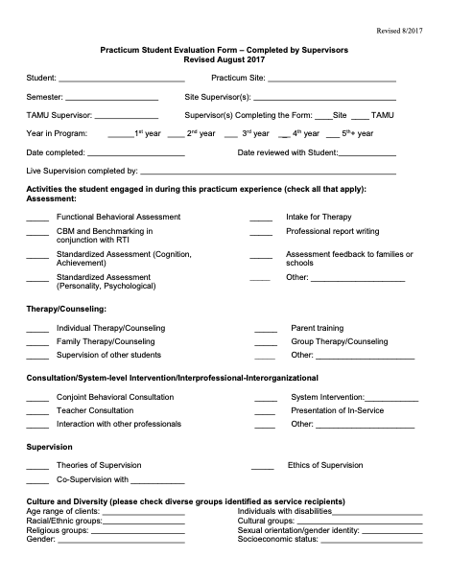
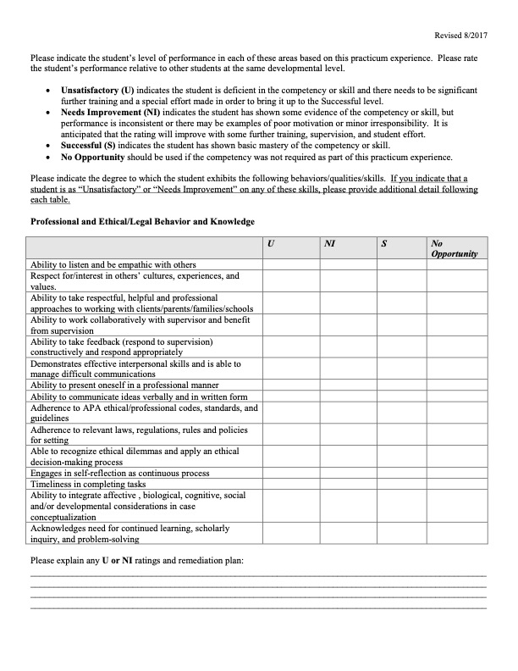
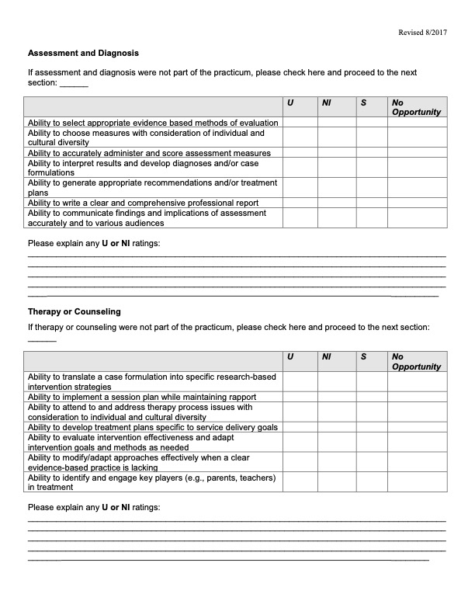
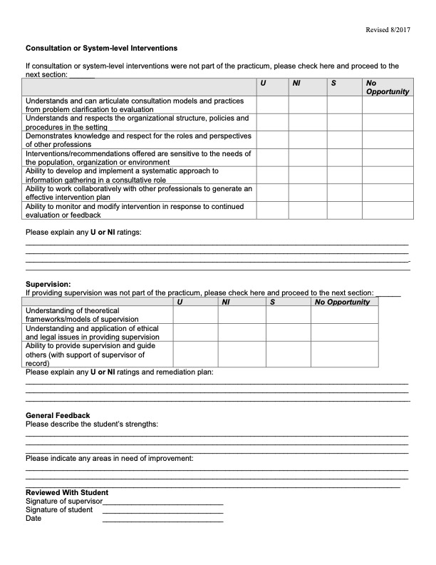

Required Information for Approval of Non-accredited Sites (even if APPIC member)

- Prior to approval of a non-accredited site, you will need to provide to the Director of Training the following information. Please note for APPIC sites not yet accredited, you will need to have provided this information prior to Oct. 1st of the year you are participating in the Match. If you are not participating in the Match, you will need to provide this information by May 15th to begin the non-accredited internship in August of that year.

- Documentation of the credentials of the supervisors is required. Only sites which employ two licensed psychologists, who agree to be involved in direct supervision of the intern, are considered acceptable. A copy of the supervisors’ licenses and CV/resume are needed for documentation.

- A description of the scope of service, population served (i.e., primarily children, adolescents, and families), and training activities to be provided (i.e., to include assessment, intervention, and consultation) in order for the program to fully determine the nature and appropriateness of the training activities as part of a planned, programmed sequence of training experiences is required .
- The internship has to include a minimum of 1750 hours to meet the requirements for licensure in most (but not all) states.

- The internship has to have at least two or more interns engaged in training at the same time or arrange for regularly scheduled and documented training activities at nearby sites to provide professional development to a group of interns.

- The intern is required to submit a log of all activities for each semester of internship, which will be reviewed by the Director of Clinical Training.

  - The site agrees to provide at least two hours per week of regularly scheduled individual supervision, as well as at least two additional hours per week in group supervision, a licensed psychologist. Limitations are placed on the extent to which supervision could be provided electronically (less than 50%).
  - It was agreed that all reports, documentation, activities are signed off on (co-signed) by a licensed psychologist supervisor for the intern.
  - All recipients of services by the intern (and the intern is designated as such) are advised of the intern’s status and the name/contact information of the supervising licensed psychologist.
  - The evaluation form for the intern must include all the profession-wide competencies and elements as delineated by the APA Commission on Accreditation. Evaluations must be completed at least twice over the course of the internship year.
  - Interns demonstrate competency at the appropriate level as determined by the internship site and their ability to meet the demands of the setting in terms of assessment, intervention, consultation, and in-service presentation for staff or parents. Interns can upload sample de-identified products into the mydocreview portal for review by program faculty as part of the annual review process.
  - In order to receive a grade of Satisfactory for internship, the student activity logs, evaluation by supervisor(s), and a final letter of successful completion of the internship have to be received prior to grades being submitted. The site is also to provide a certificate to the student.

Professional Conference Calendar
2024–2025
(Note: Key to acronyms is at the end!)
Conference Conf. Dates Location
Texas Association of School Psychologists (TASP) | 11/7-9/2024 | Allen, TX
Texas Psychological Association (TPA) | 11/8-9/2024 | Fort Worth, Tx
Association for Behavioral and Cognitive Therapies (ABCT) | 11/14-17/2024 | Philadelphia, PA
Learning Disabilities Association (LDA) | 10/24-26/2024 | Dallas, TX
Council for Exceptional Children (CEC) | 03/12-15/2025 | Baltimore, MD
National Association of School Psychologists (NASP) | 02/18-21/2025 | Seattle, WA
American Psychological Association (APA) | 08/7-9/2024 | Seattle, WA
Association of Positive Behavior Support (APBS) | 03/6-9/2024 | Jacksonville, FL
Association for Psychological Science (APS) | 5/23-26/2024 | San Francisco, CA
American Academy of Child and Adolescent Psychiatry (AACAP) | 10/14-19/2024 | Seattle, WA
National Academy of Neuropsychology (NAN) | 11/6-9/2024 | Austin, TX

Elective Practicum/Externship Experiences
School Psychology Doctoral Program
Texas A & M University

While practicum training may occur either on or off campus, selection of a particular site should be made in view of the particular skill(s) to be acquired in conjunction with the student’s Advisory Committee Chair. The student’s Chair must agree to the practicum in light of what else the student is committed to complete during the same time period, whether classes, required practica, or research activities. For example, a practicum experience in the psychological testing of children could be offered in a setting such as a school district, psychological clinic, community agency, hospital, or developmental/child study center. Which ages and groups (demographics, disorder) will constrain options available, as will any geographic preferences or restrictions. The tasks required of the student in the practicum setting should be clearly related to the skill to be acquired with appropriate supervision. Additionally, sites are chosen to ensure a relationship between working professionals and the faculty of the training program, as well as to provide adequate supervision of the student by faculty and other supervisory on site personnel.
In keeping with both the philosophical goals of the school psychology program and the ethical standards of psychologists, all practicum activities are designed to conform to existing legal-ethical practices. Case studies and other records are maintained, and relevant discussions conducted, in such a manner as to ensure client confidentiality and to protect the rights and privileges of all parties involved. Students are expected to adhere to the rules and regulations of the settings in which they are in; any variation should be in the direction of more stringent adherence to ethical and legal requirements. The laws and regulations (e.g., HIPAA, IDEIA 2004, FERPA, etc.) pertinent to each setting must be followed in that setting. Students should remember that at all times they are professionals and must behave with honesty and integrity, and adhere to program, departmental, college, University, and APA/NASP ethical standards.
Professional behaviors include timeliness (e.g., reports, papers, and other documents completed in a timely manner; on time arrival to class, meetings, and practica settings; completion of course requirements in an appropriate time frame), use of feedback for reflective practice (e.g., accepts feedback from faculty, supervisors, and peers; provides constructive feedback to faculty, supervisors, and peers), self-care in recognizing the need for and obtaining additional training in a given area, taking responsibility for one’s own behavior, and concern for the welfare of others. In addition, for practica/field-based experiences, appropriate attire, consistent with that of other professionals in the same setting is required and adherence to the specific policies and procedures (unless there is an ethical or legal issue involved therein) of that setting is expected. While this may vary from site to site, generally it is best to err on the side of dressing conservatively. In conjunction with professionalism, all students are required to carry liability insurance with a statement of said insurance on file with the Academic Advisor’s office by the end of Fall semester of the first year and renewed annually.
From APA CoA C-26:
Practicum helps to realize the educational goals identified in the program’s curriculum plan and includes:
- Clear statement of goals and objectives for practicum training
- Documents outcome measures on how training meets these goals and objectives
- Identify how the practicum is clearly integrated with other elements of the program – including how academic knowledge is integrated with practical experience through forums led by psychologists for discussion of practicum experience
- Clear identification of how practicum training is sequential, cumulative, and graded in complexity
- How designed to prepare students for further organized training
- Program should document how the program ensures the quality of the practicum sites including regularly scheduled site reviews
- Identify the administrative methods used to ensure that practicum meet criteria and how students are matched to these sites
- Document how feedback is used to address the progress, development and competencies of the practicum student

As with required practica, students must complete the pre-registration form. As part of the process, they should provide the prospective supervisor with a syllabus and a copy of the practicum student evaluation form. The registration form is on the EPSY website; the evaluation form is on the EPSY website and will be distributed to you by the Director of Clinical Training via Docusign. The syllabus should be obtained from the faculty member who has agreed to serve as the university supervisor. In any situation where doctoral level/licensed psychologist supervision is not available on site, the University supervisor is responsible for primary supervision. The prospective supervisor, the university supervisor, and your doctoral chair need to sign the pre-registration form. For all external practica, a contract also must be executed with the site. You can initiate this process by:
- checking with the advising office to determine if there is a contract in effect for the time period you will be there, and if not, completing the following google form so signatures can be routed through the advising office and TAMU contracts
  - https://docs.google.com/forms/d/e/1FAIpQLSerVQgEMkFloO8EreK1wy0lrWuzTW0KhMtCAz3l2e7keHo5bA/viewform

This needs to be done prior to the registration of classes in the semester before you’d like to begin the practicum and no later than 2 months before the start date of the practicum. Check for the exact date on the “Important Dates” notice each semester. You cannot begin the practicum experience until the contract/Memorandum of Understanding has cleared the contracts office at TAMU and the site. You will also need to document via an agreement between you and the supervisor(s) clearly articulating your time commitment, weekly and for what length of time. This form also clarifies the types of tasks you might be involved in during the practicum. Clarification in advance can avoid misunderstanding and miscommunication later on. At the conclusion of the practicum experience, your site supervisor will complete and evaluate your competencies; you will not receive a grade until this is received. You will also be asked, each semester, to evaluate the site. The form for you to evaluate the site is will be distributed to you by the Training Director at the end of each semester and a copy will be filled for quality check purposes.

Elective Practicum Directory

How to use this directory
An attempt has been made to include all practica that students engaged in for the past 10 years, some of which are not currently available but may be available in the future. These are grouped by type of setting: schools, community service agencies, hospitals, and private practices.
